

**University Workshop Series**

**Power Platform and AI Builder**

**Hands-on Training Lab**

**Glendon Thaiw**

Technology Specialist,

Azure and Business Applications



# Environment Set up

**Step 1**: Import AIBuilderLabSolution_1_0_0_0 solution to the Microsoft Power Platform Environment.

This will create 3 Microsoft Dataverse Tables:

1. Object Detection Product
2. Health Feedback
3. Online Shopping Intent

From the Power Platform Portal, click on **Solutions** on the left sitemap

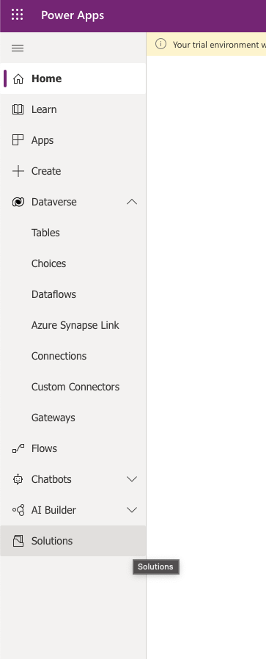

Click on **Import**

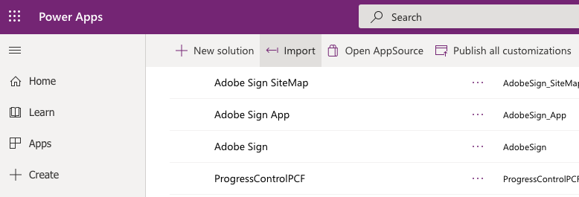

Click on **Browse** and locate the zip file “AIBuilderLabSolution_1_0_0_0.zip”

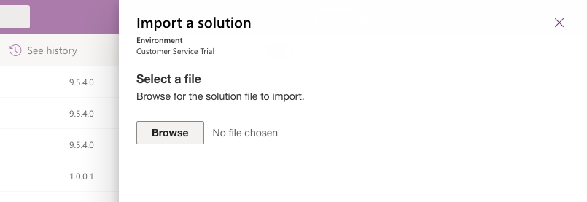

Wait for 5-10 minutes to allow the solution to be imported into your environment.

**Step 2**: Populate your newly created tables from Step 1 with sample data

Table: Object Detection Product

On the left sitemap, click on **Dataverse** > **Tables**

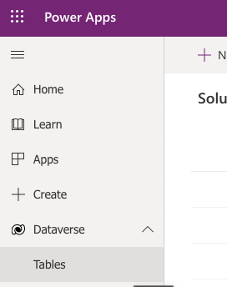

Locate the table **Object Detection Product** and click on it

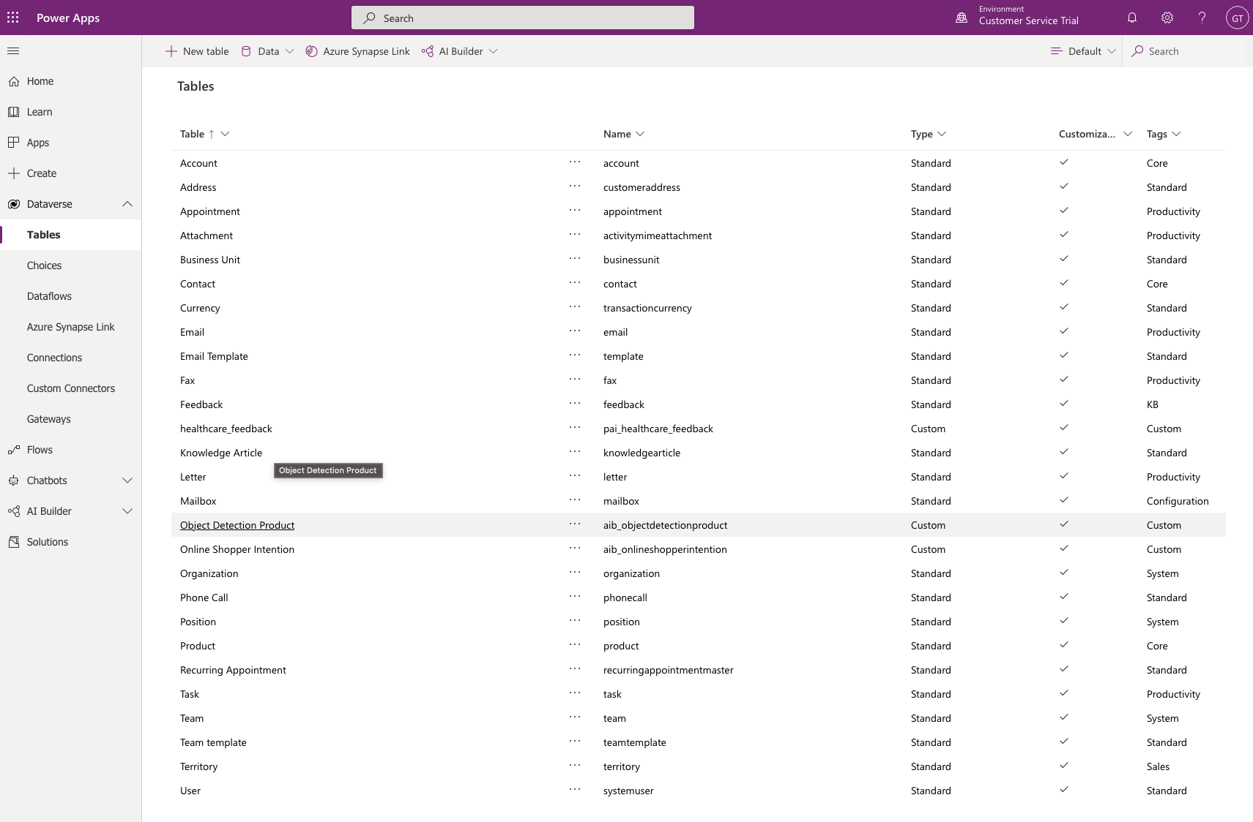

On the top bar, click on **Data** > **Get** **data** > **Get data from Excel**

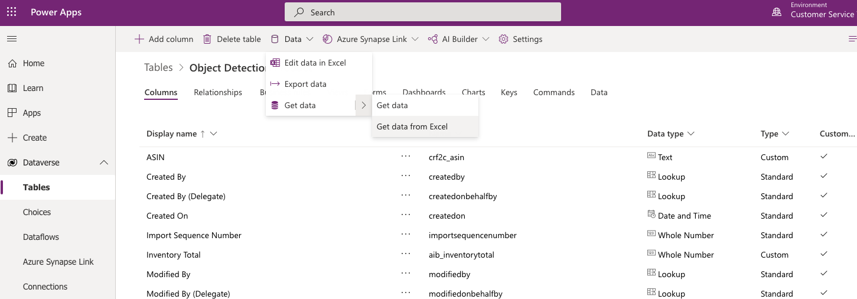

Click on **Upload** and locate the sample data file Lab Data/ObjectDetection/aib_objectdetectionproducts.csv.

After a couple of minutes, click **Import** at the top right

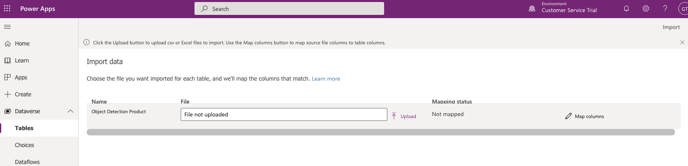

After a couple of minutes, your data should be imported successfully

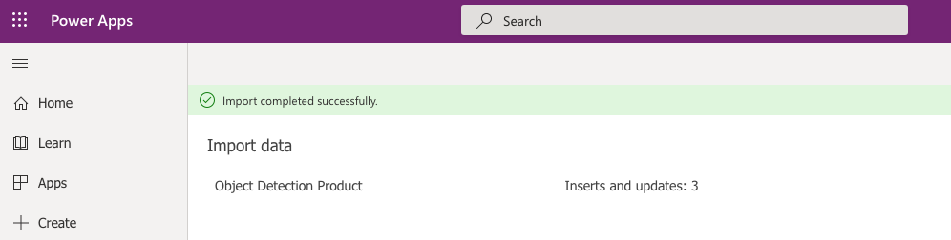

Verify that your table has been populated by navigating to the Data tab for the table Object Detection Product

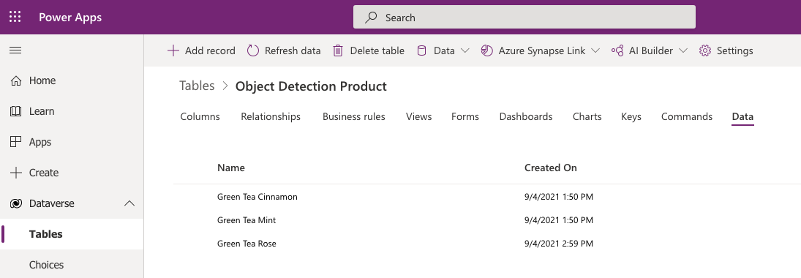

# 

# Model Building

# Object detection Model

Object detection lets you count, locate, and identify selected objects within any image. You can use this model in PowerApps to extract information from pictures you take with the camera, or load into an app.

In this lab, we will build and train a detection model and build an app that uses the detection model to identify objects from available images.

**Note:** If you are building the first model in an environment, click on Explore Templates to get started.

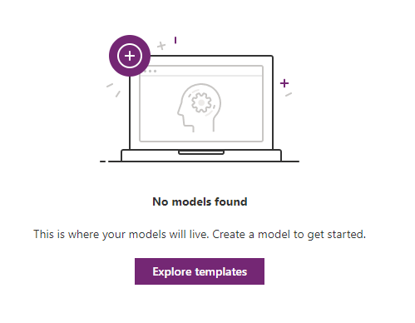

# Exercise 1

In this exercise we will build and train the Object Detection model for three varieties of tea.

1. In PowerApps maker, expand AI Builder and select Build. Select Object Detection.

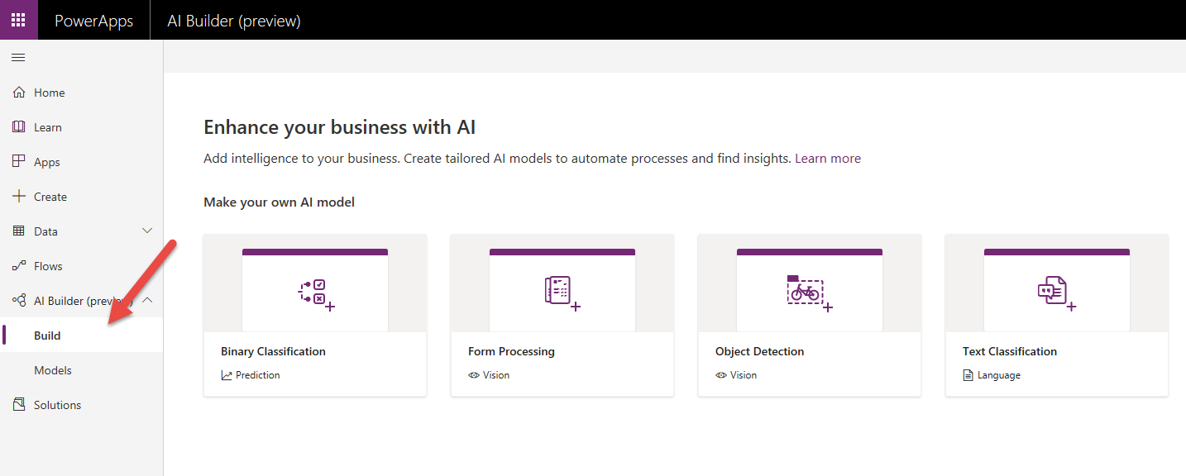

1. Name your model Green Tea Product Detection **and** because you are working in a shared environment also make sure to include your name as part of the model name. This will make it easier to find later. Click create.

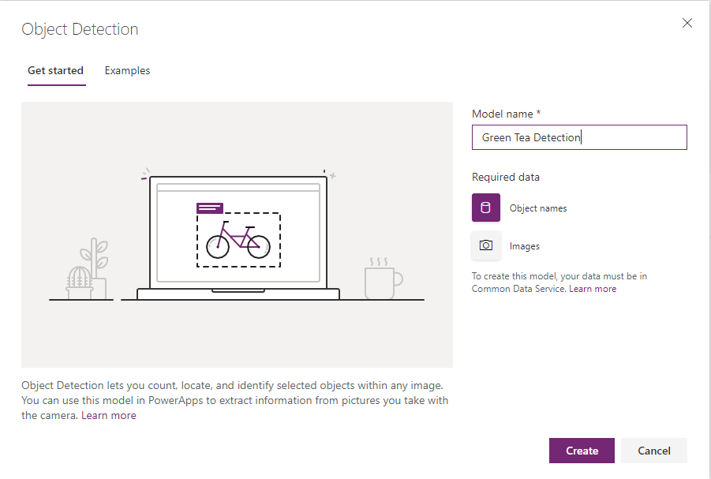

1. Your screen should now look like the image here.

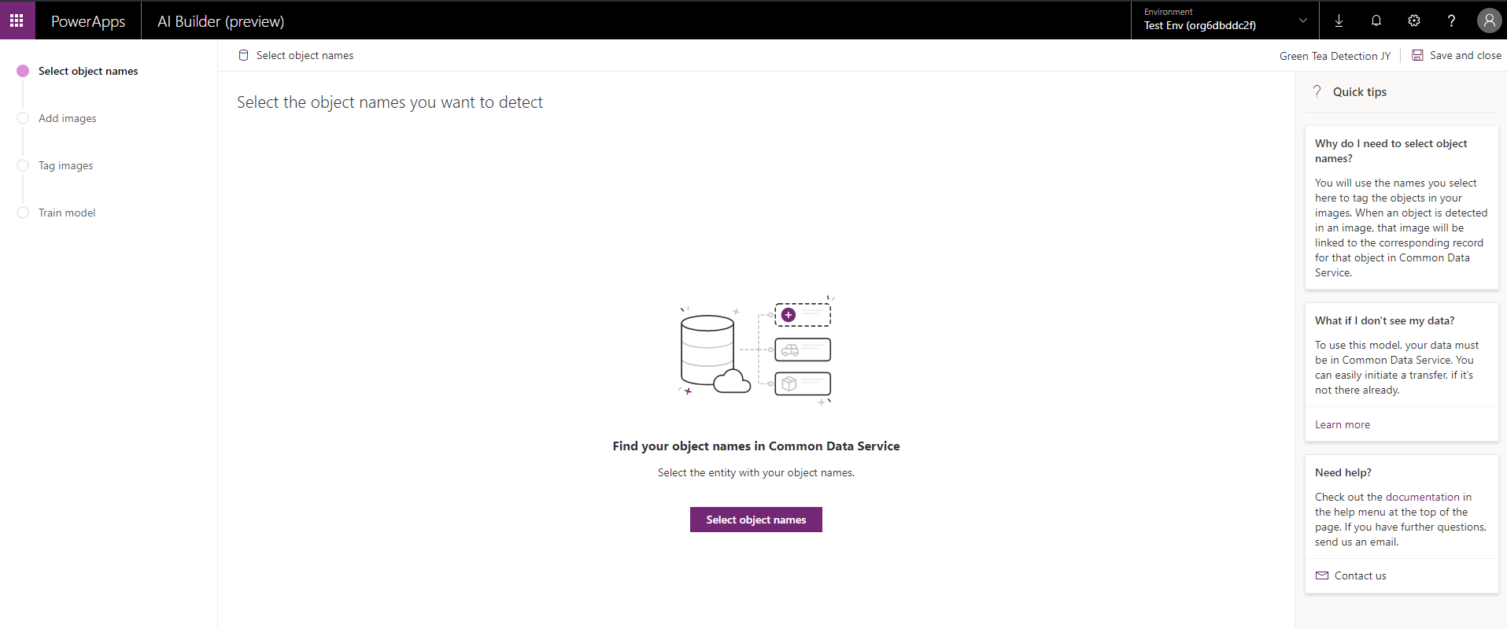

1. Notice the progress indicator on the left. Those are the steps we will follow now to build and train our model.

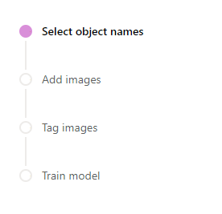

1. We are now going to define the objects we are tracking. Click on the Select object names.

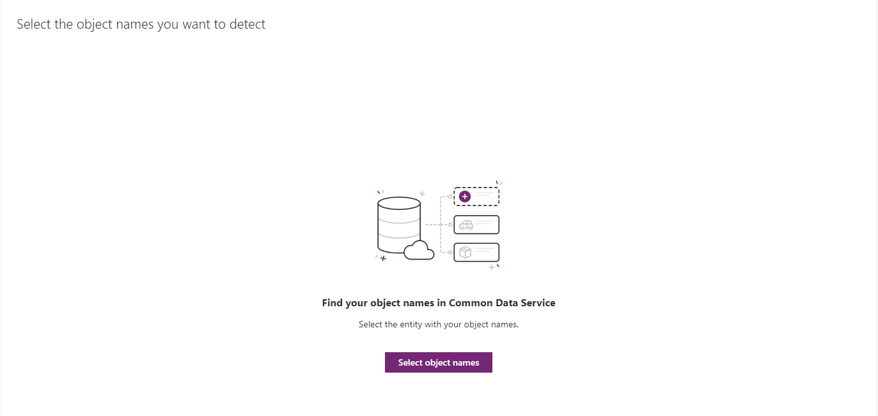

1. From the entity list, select Object Detection Product.

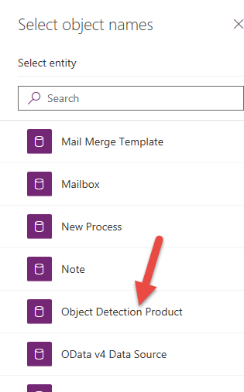

1. Select the Name field and click Select field.

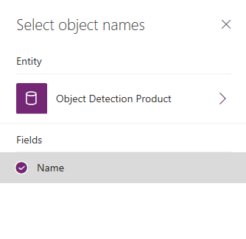

1. Select the tea items and click Next.

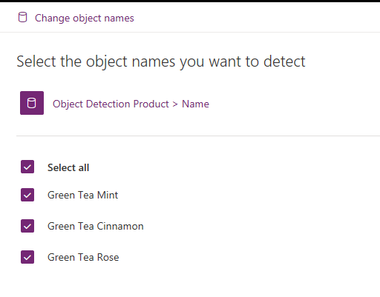

1. Notice the progress indicator has moved forward to the Add images step.

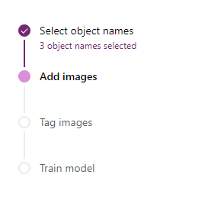

1. Click add images.

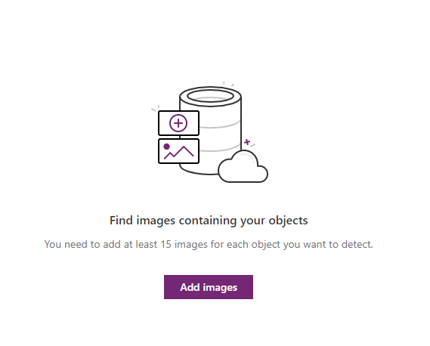

1. Select images from the set provided. You will need enough images to provide 15 samples for each type of tea we are tracking.

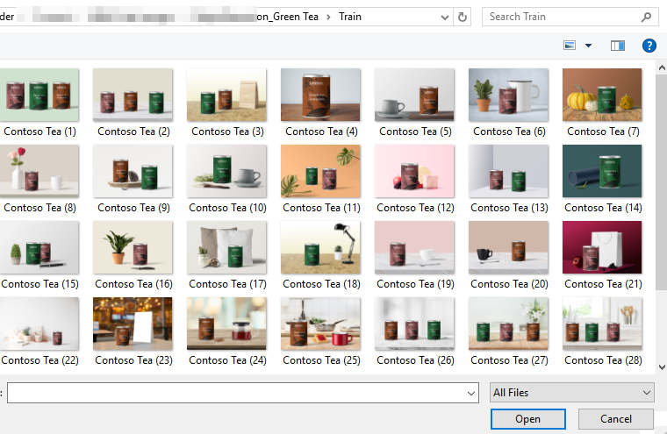

1. Approve the upload of images. Click Upload images. After the upload completes, click Close.

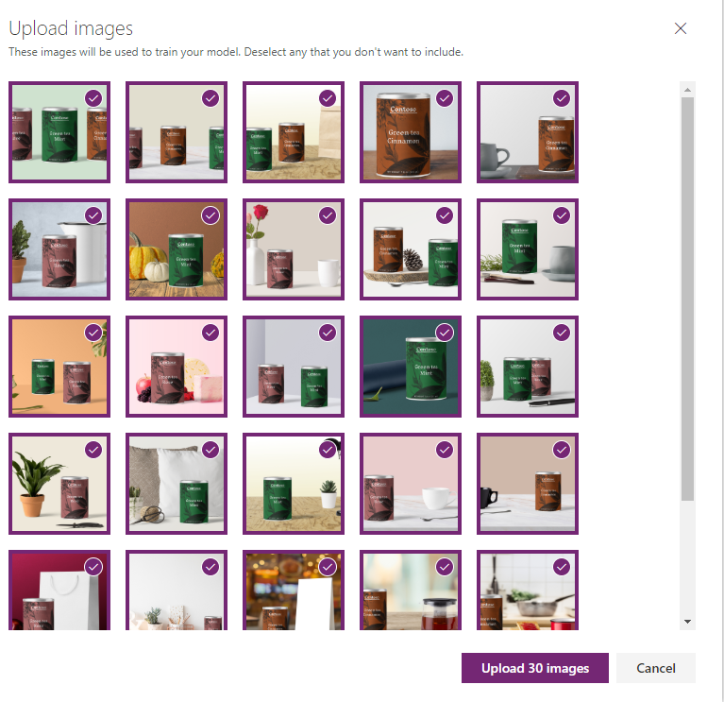

1. Click next to begin tagging the images.

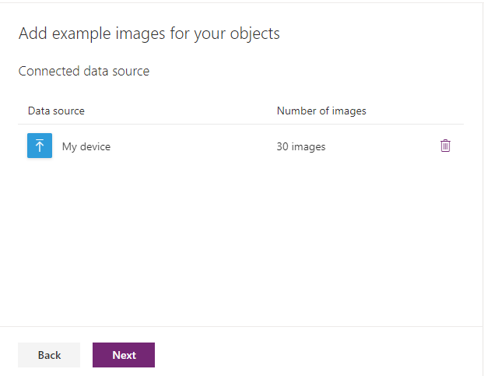

1. Select the first image to begin tagging.

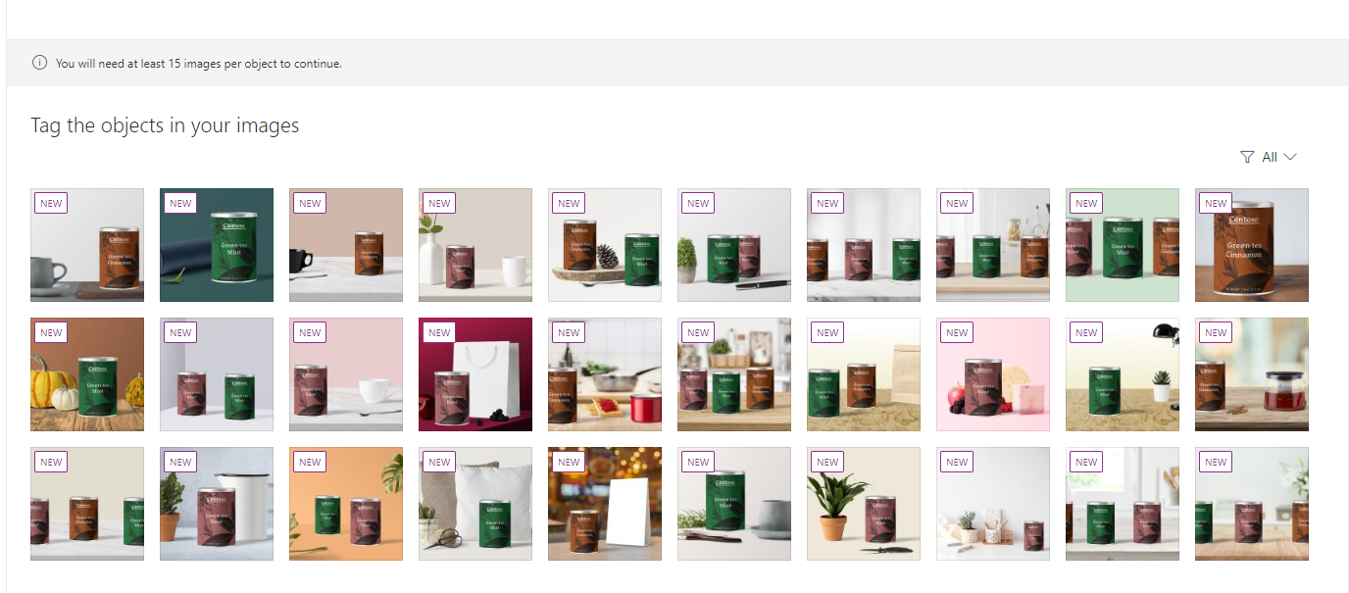

1. Hover over the image, near an item you wish to tag. A dotted-lined box should appear around the item. It has been detected as a single item that can be tagged.

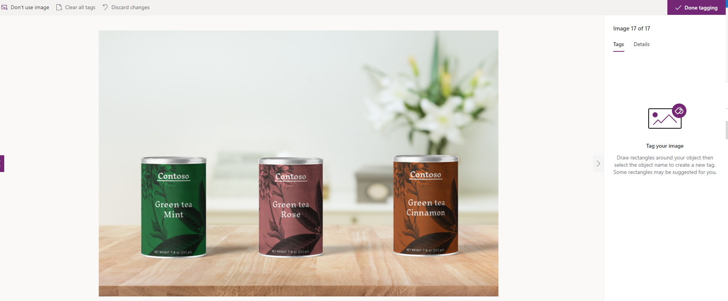

1. Click on the item and select the matching object name.

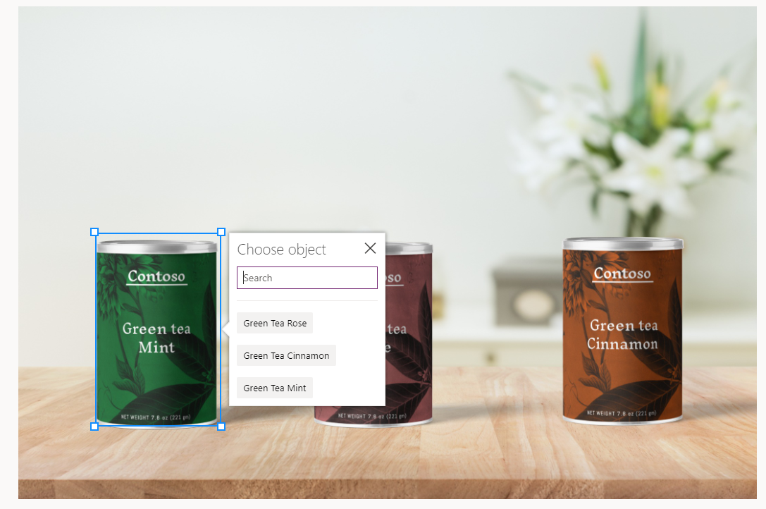

1. If the pre-defined selector is not accurate, as in the below example, you can drag the container to draw it to accurately tag the item.

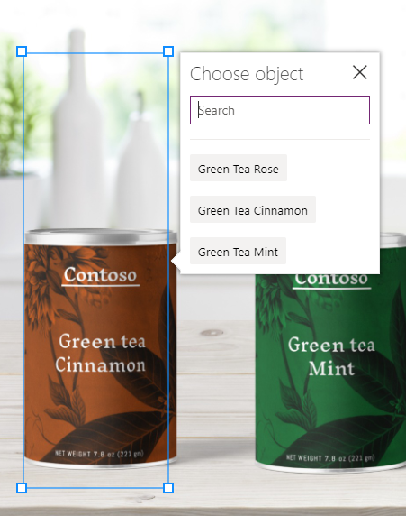

1. Do this for each item in the image and for each image in your set. When you have tagged all of the images you uploaded click Done Tagging in the top right of the screen.

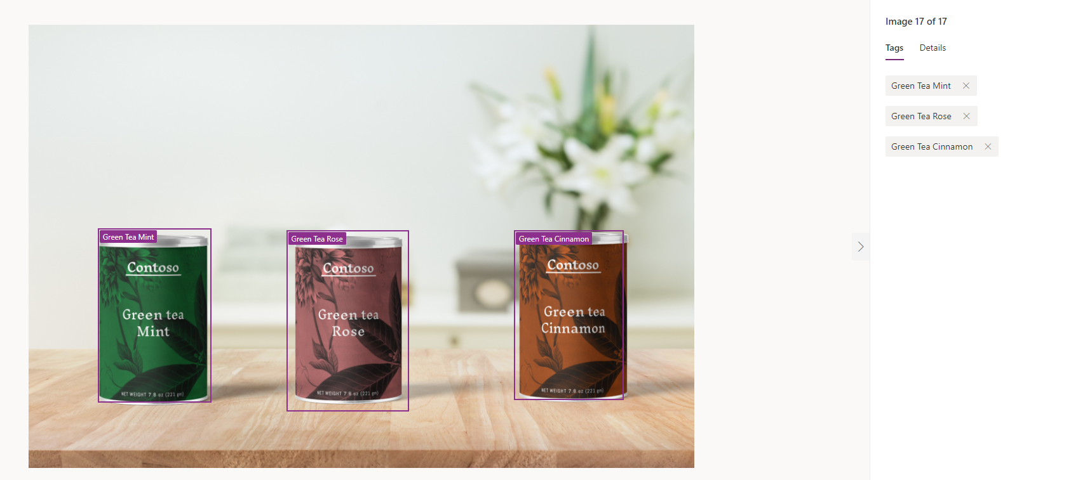

1. Once you have completed tagging, you will get a summary of the tags. If you haven’t tagged enough for analysis, you will need to load and tag more examples.

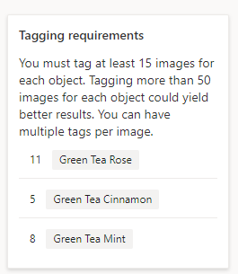

1. Once you have defined enough tags for training the model, you will be allowed to initiate the training. Click Next.

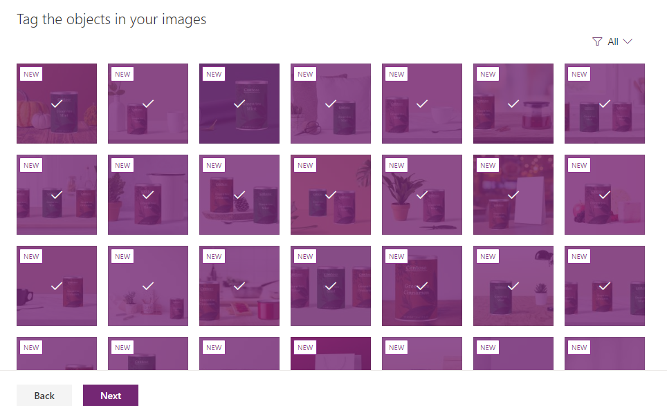

1. Click Train.

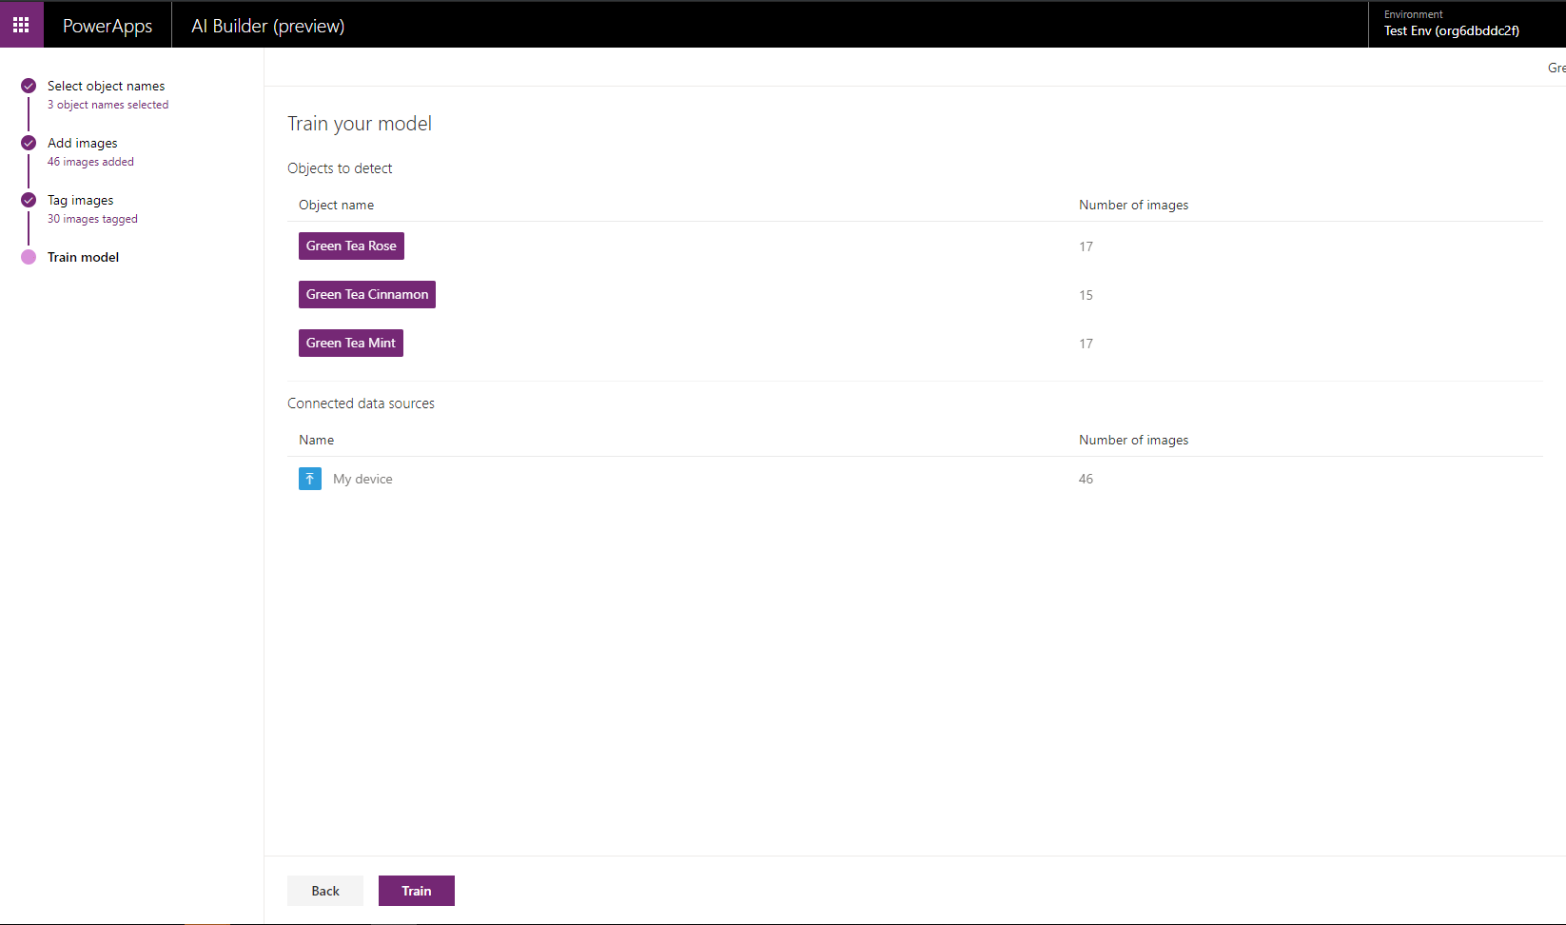

1. The training takes a few moments.

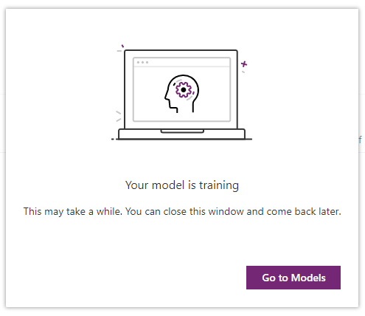

1. Navigate to the saved model view and confirm your model has completed training.

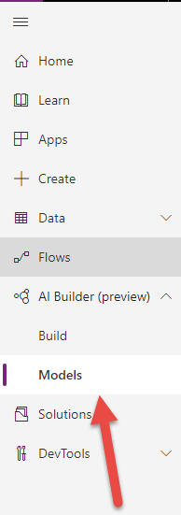

1. Select the model you just made.

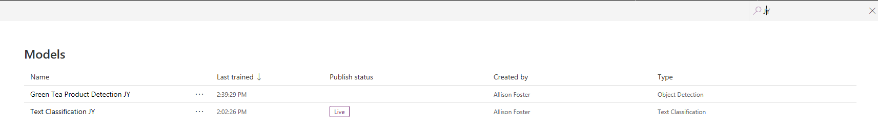

1. Select Quick test.

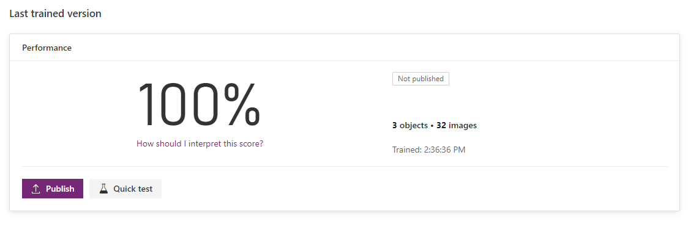

1. Upload or drag and drop one of your test images to be analyzed.   
     
   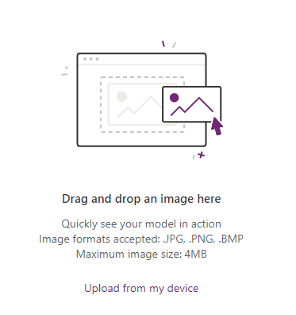
2. You will see the analysis and level of confidence for the match.

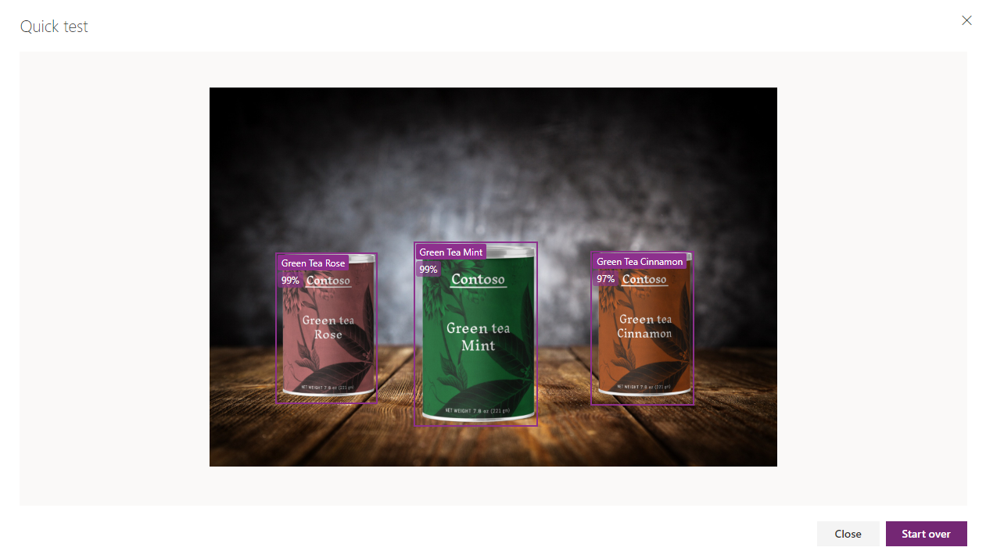

1. Upload an image you know will not match. You will see the analysis and level of confidence for the match.

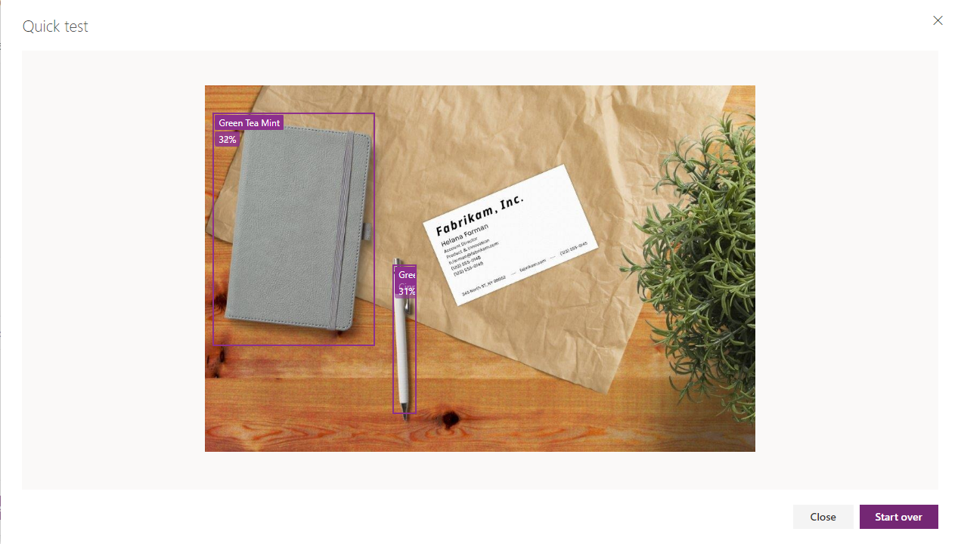

1. Click close.
2. Publish your model.

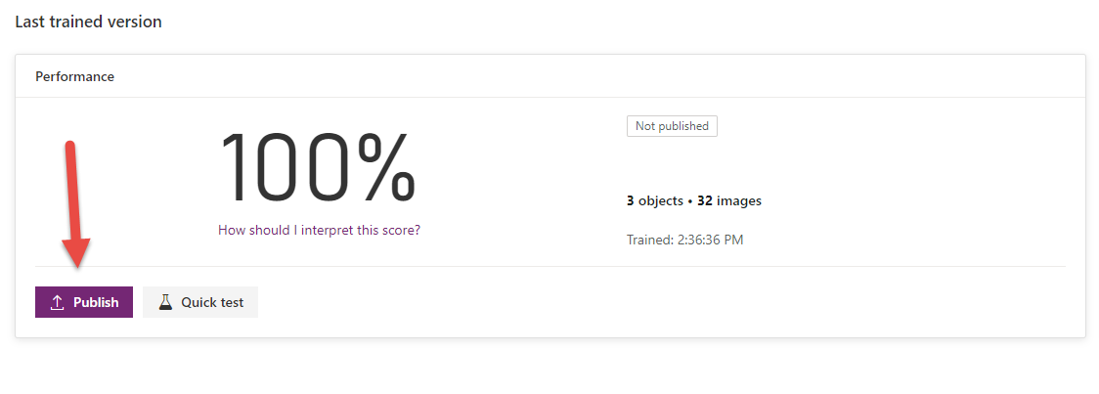

# Form Processing Model

Form processing identifies the structure of your documents based on examples you provide to extract text from any matching form. Examples might include tax forms or invoices.

In this lab we will build and train a model for recognizing invoices. Then we will build a tablet app to show the detection in action and digitize the content.

**Note:** If you are building the first model in an environment, click on Explore Templates to get started.



# Exercise 1

1. From the left navigation expand **AI Builder** and select **Build**. Select **Form** **Processing**.

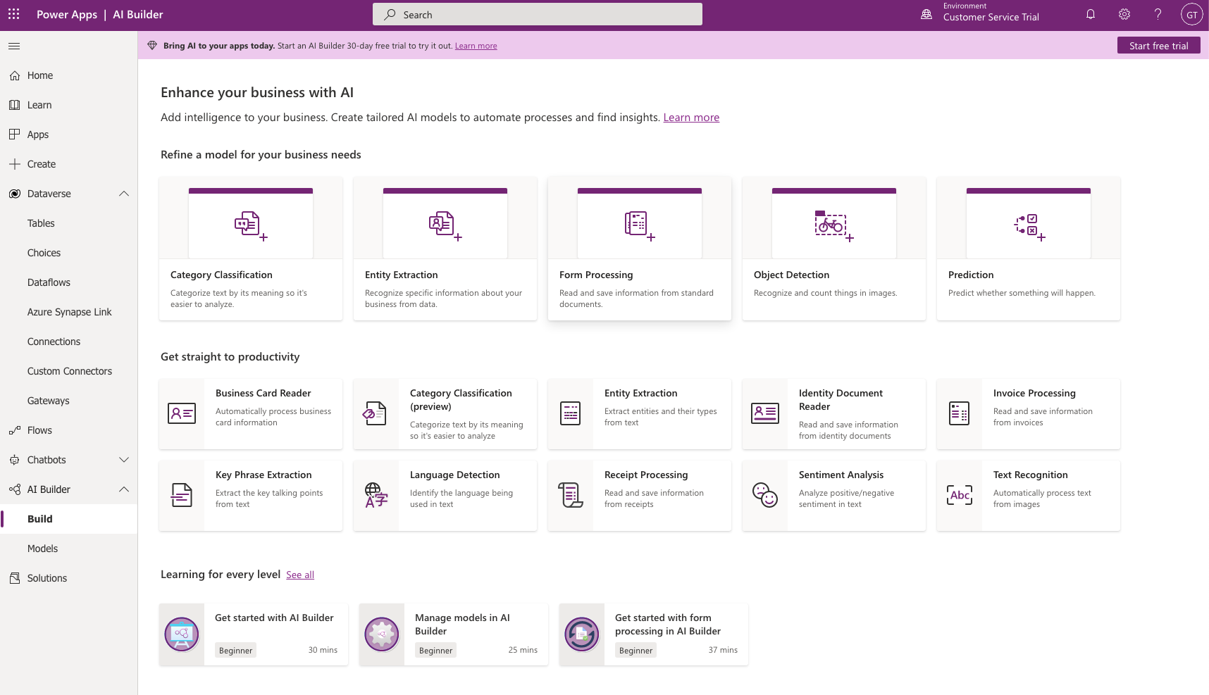

1. Name your model. Because you are working in a shared environment make sure to include your name as part of the model name. This will make it easier to find later. Click create.

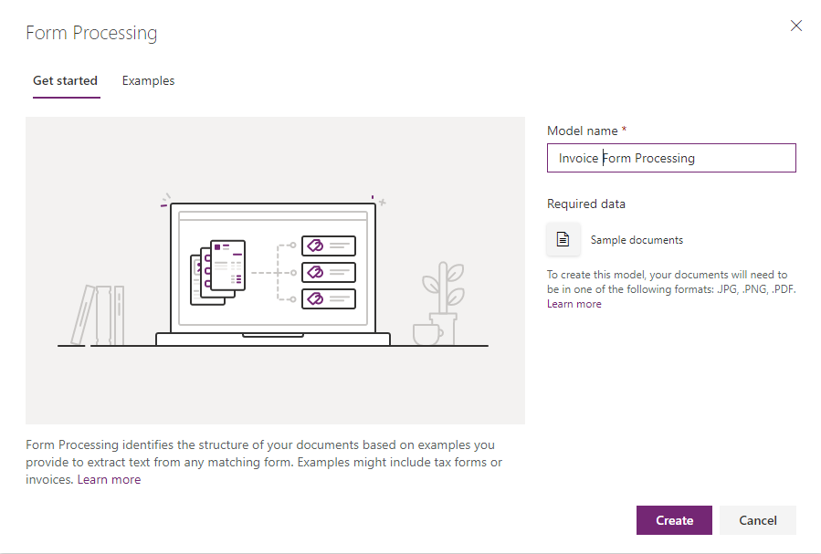

1. Your screen should look like the following image. Select **+ Add**.

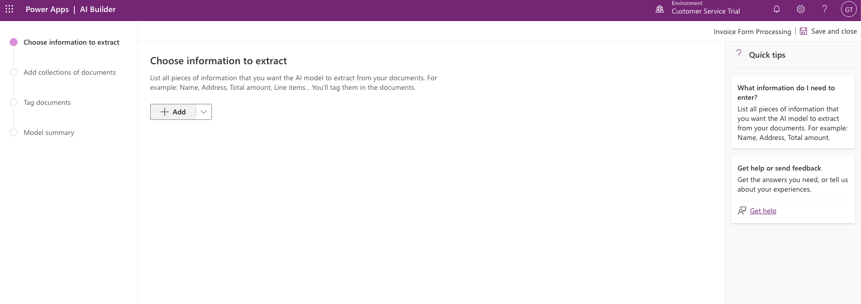

1. Select the **Field** Type and click **Next**

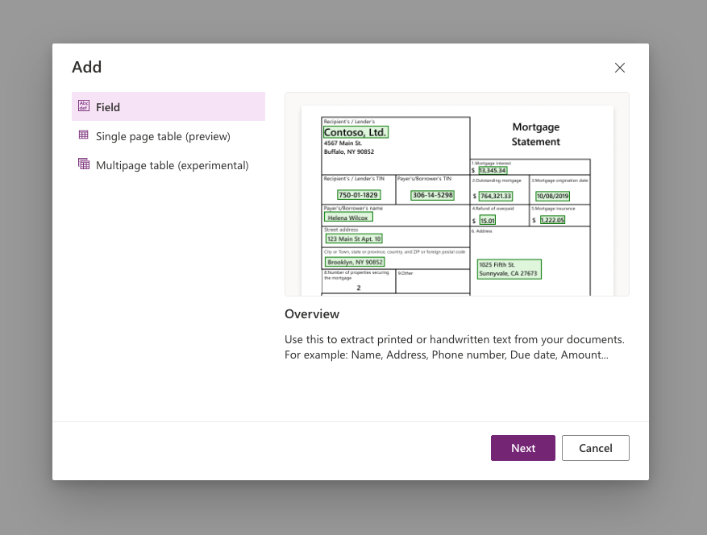

1. Enter a field name of “Invoice Name” and click **Done**

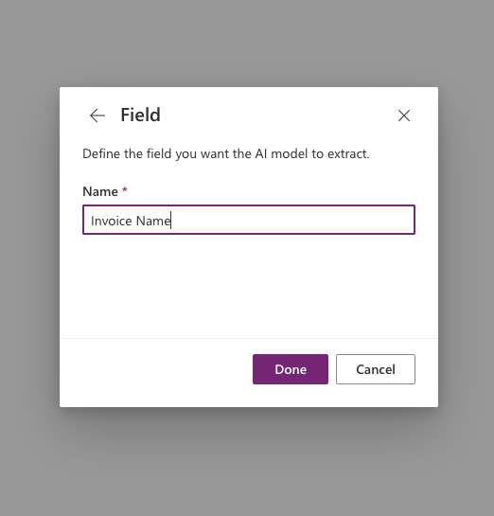

Your screen should look like the following image.

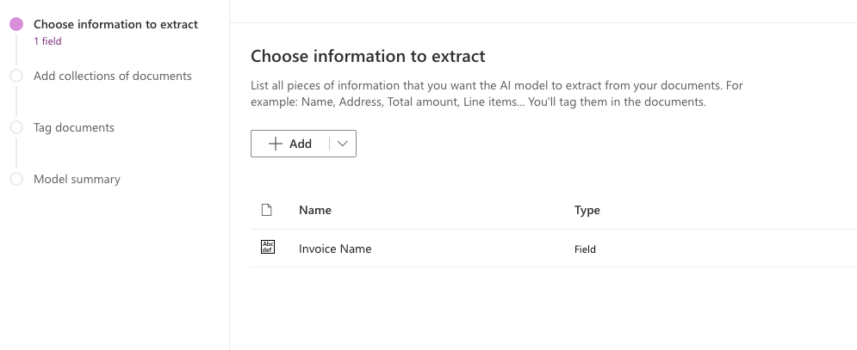

1. Repeat this process for the following 3 fields:  
   1) Due Date  
   2) Total

Click on **Next**

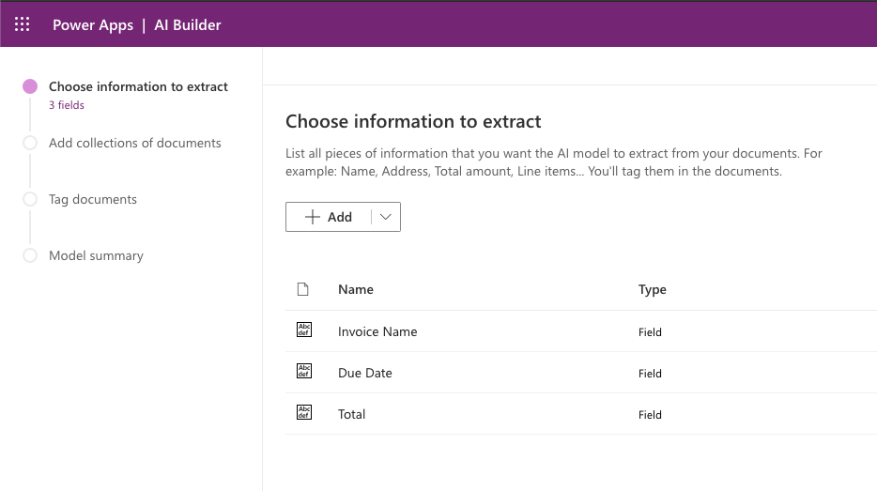

1. Click on **New collection** > **Collection 1** > **Add documents**

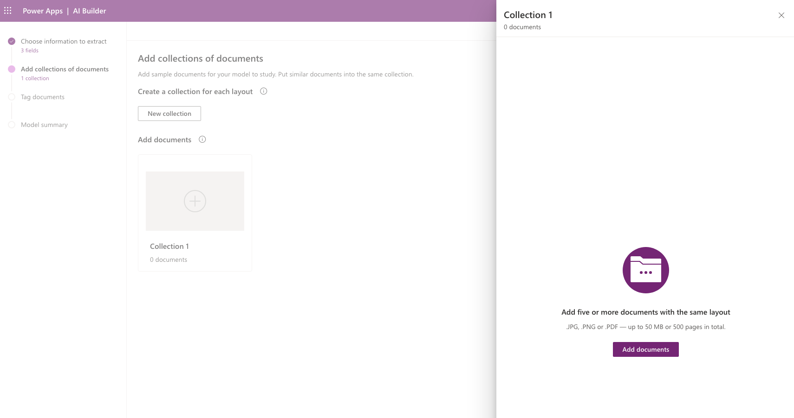

1. Select **upload from local storage** and add all documents from the Train folder. You must have at least five documents to train the model.

Select **Upload 5 documents**.

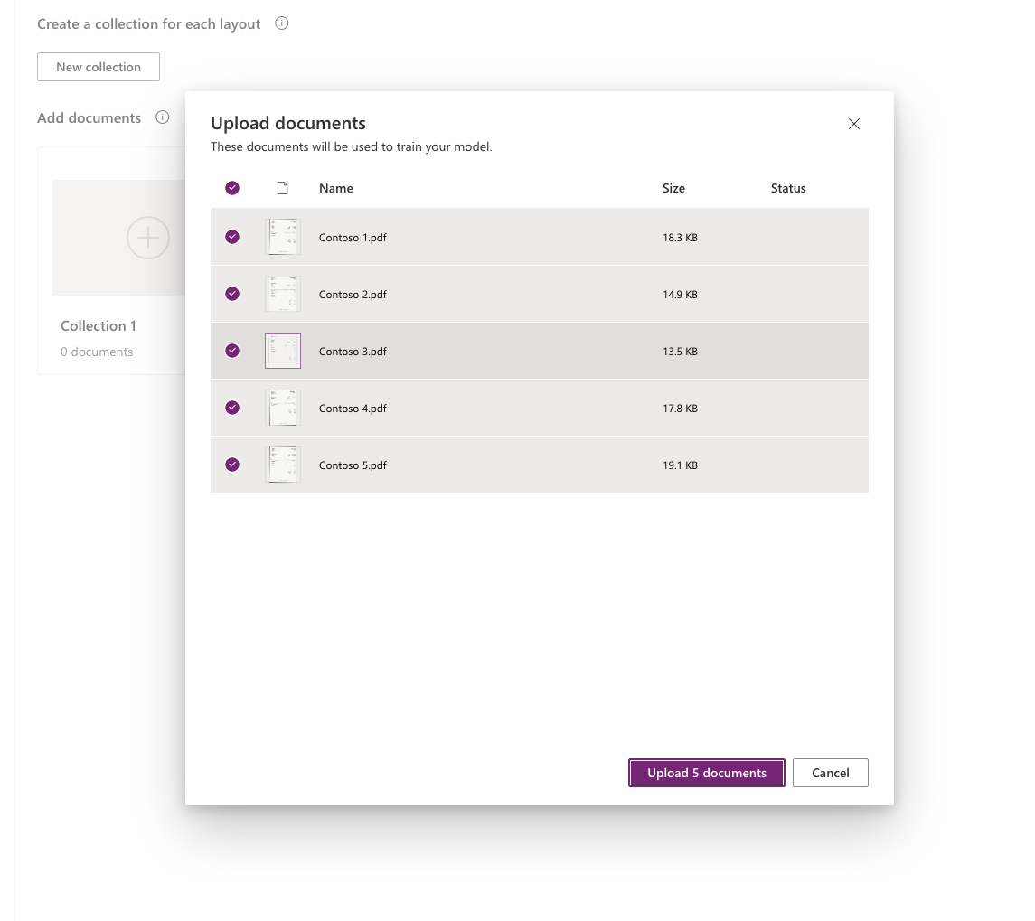

1. Confirm the selection and click **Analyze**.

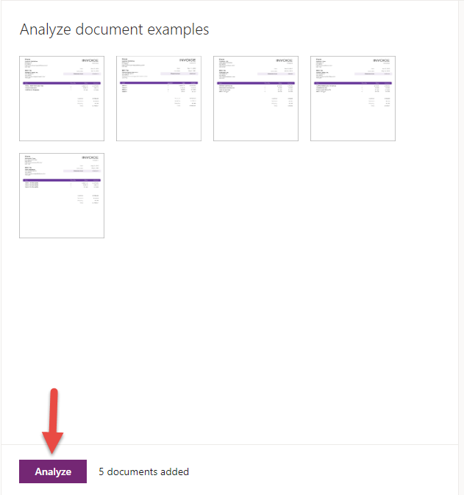

1. After a couple of minutes, begin tagging your documents.

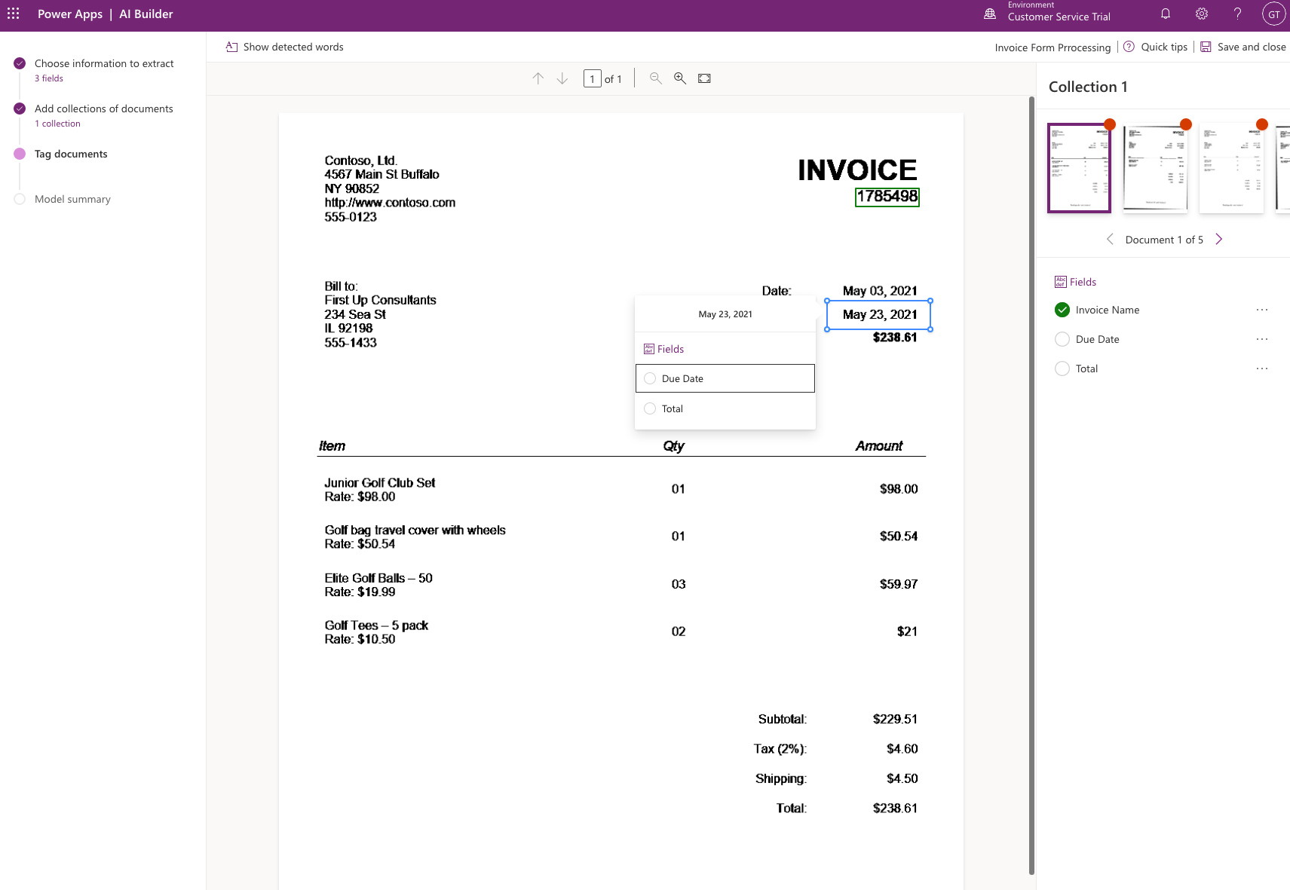

1. Once you have confirmed the fields, click Done.

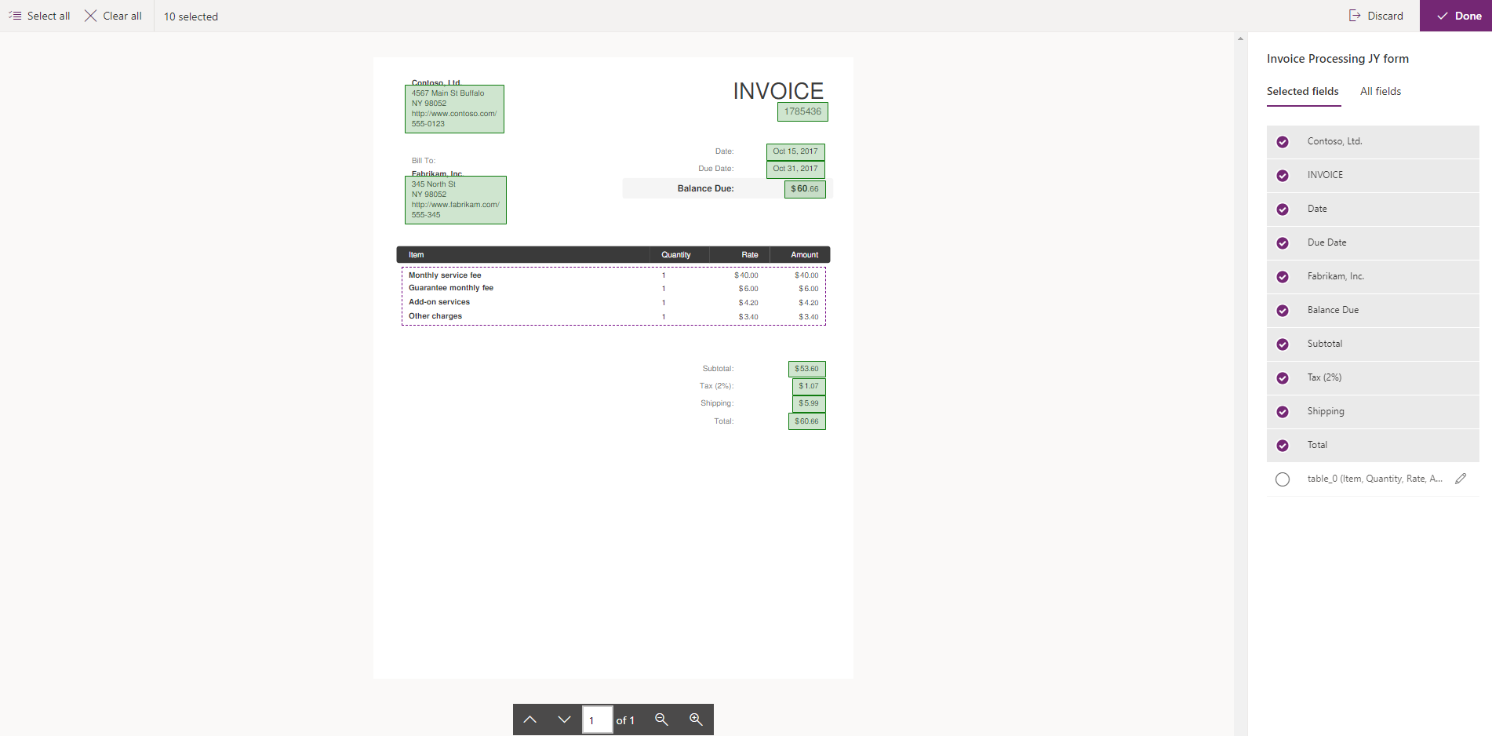

1. Train your model.

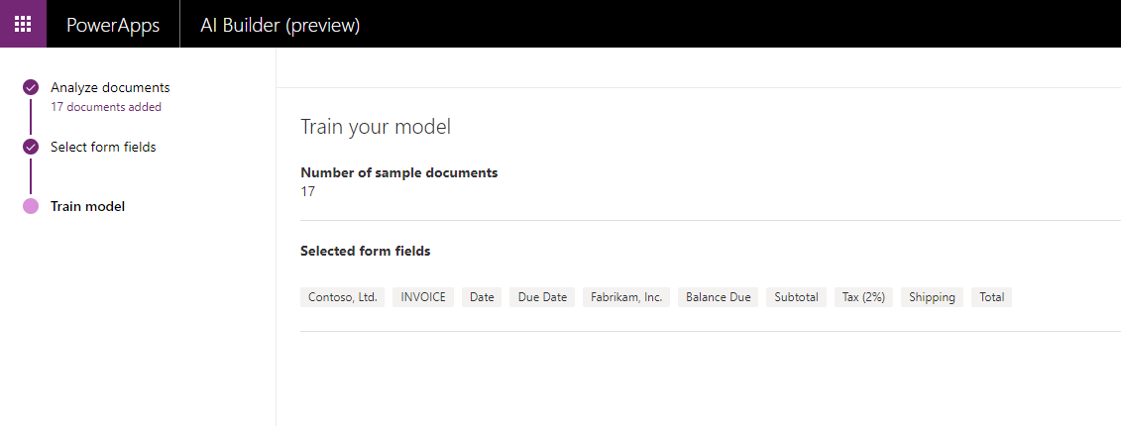

1. Locate and open your saved model. If you need help finding it, type your name into the search box.

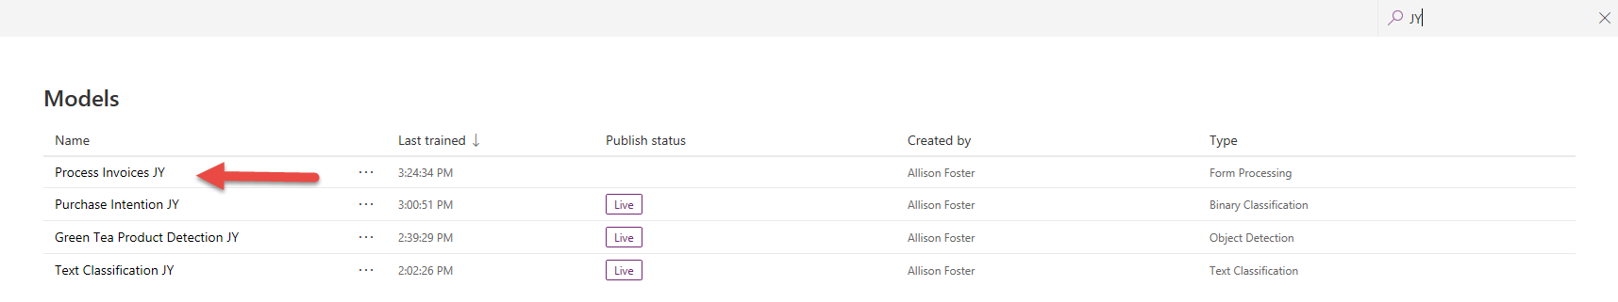

1. Review the results of the trained model.

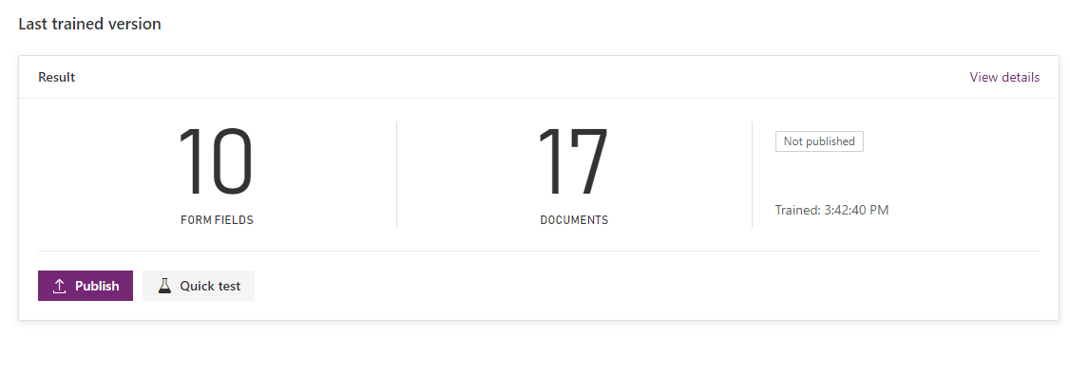

1. Perform a test with the test invoice.

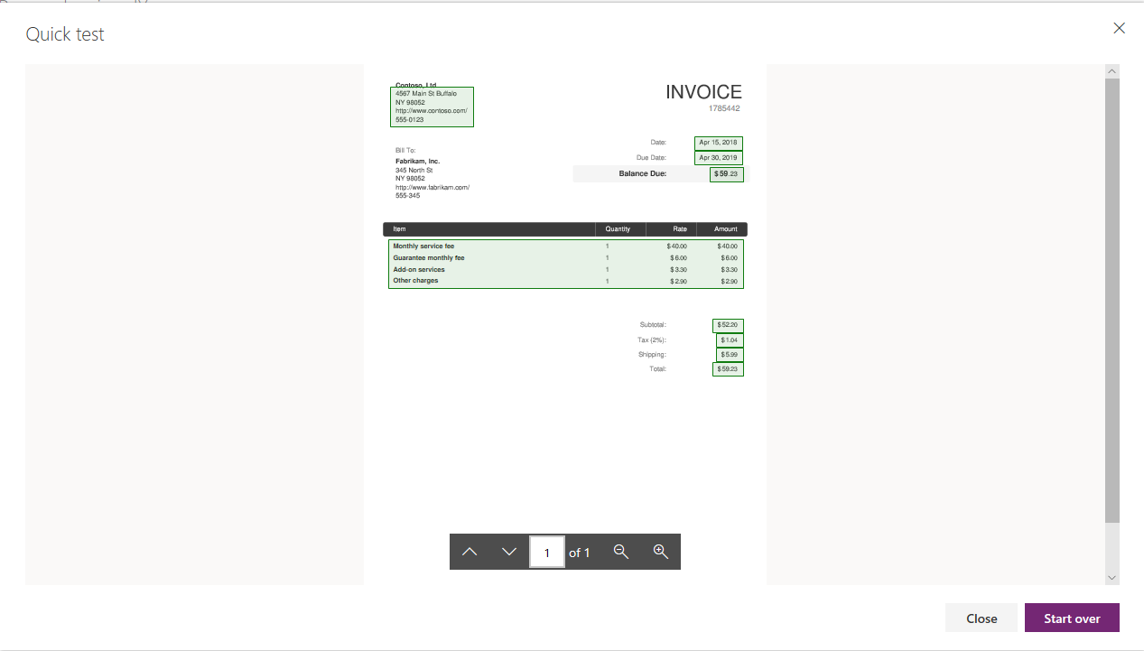

1. Perform a test with another image or document.

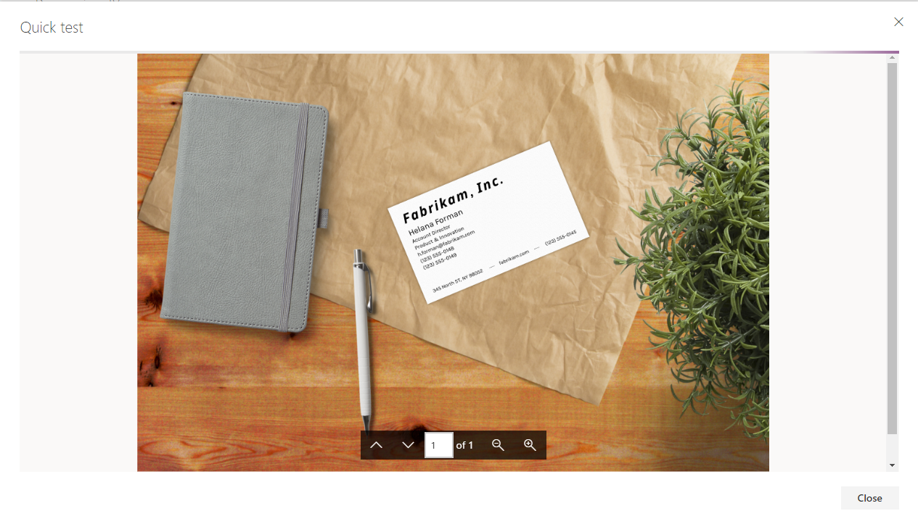

1. Publish the model.

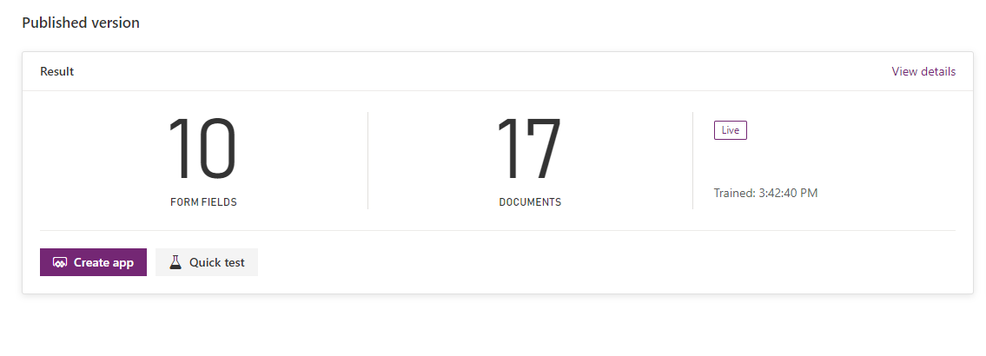

# Using our AI Models through Power Apps

# Building an Online Shopping Assistant Application with Object detection Model

In this section, we will make use of our Object Detection Model previously created to build an Online Shopping Assistant Application using Canvas App.

# End Product

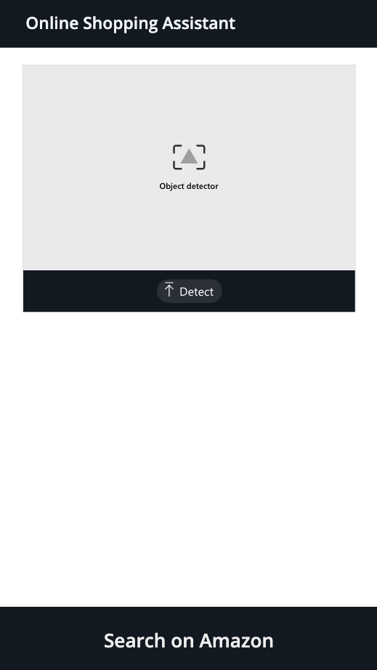 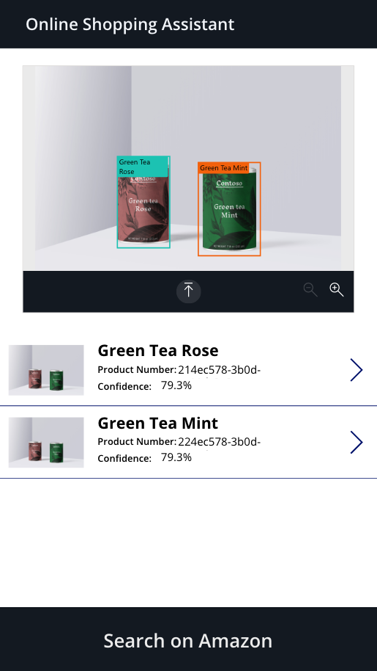 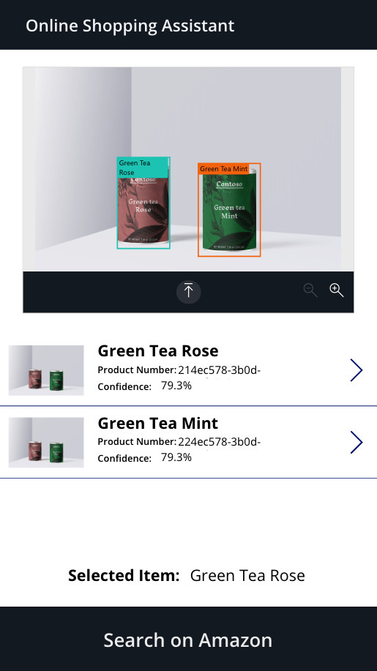

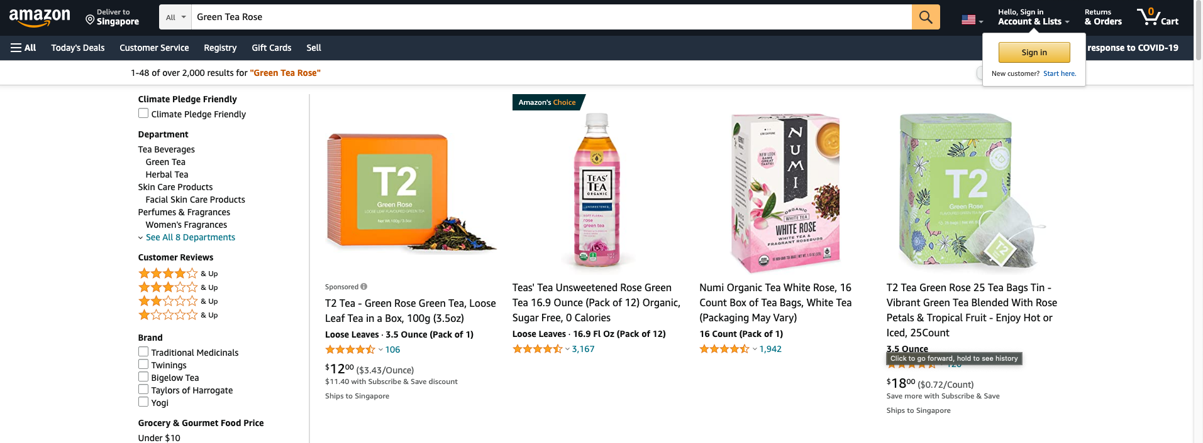

# Step by Step Instructions

We will now create a canvas app you can use for detecting the items that have been trained in our model. The product will be detected from the image and you will be able to adjust on-hand inventory for the item.

1. Navigate to Apps, and select Create an app, then select Canvas. If asked, grant permission for the app to use your active CDS credentials.

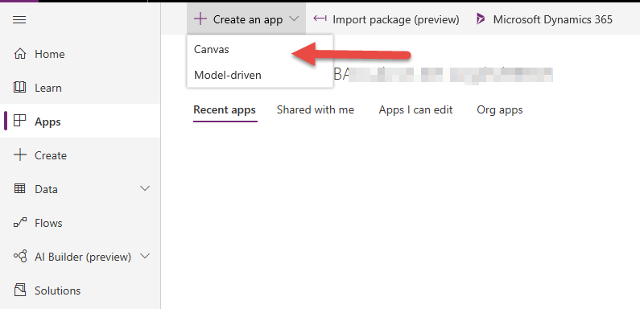

1. Enter a name for your App and select the Phone format.

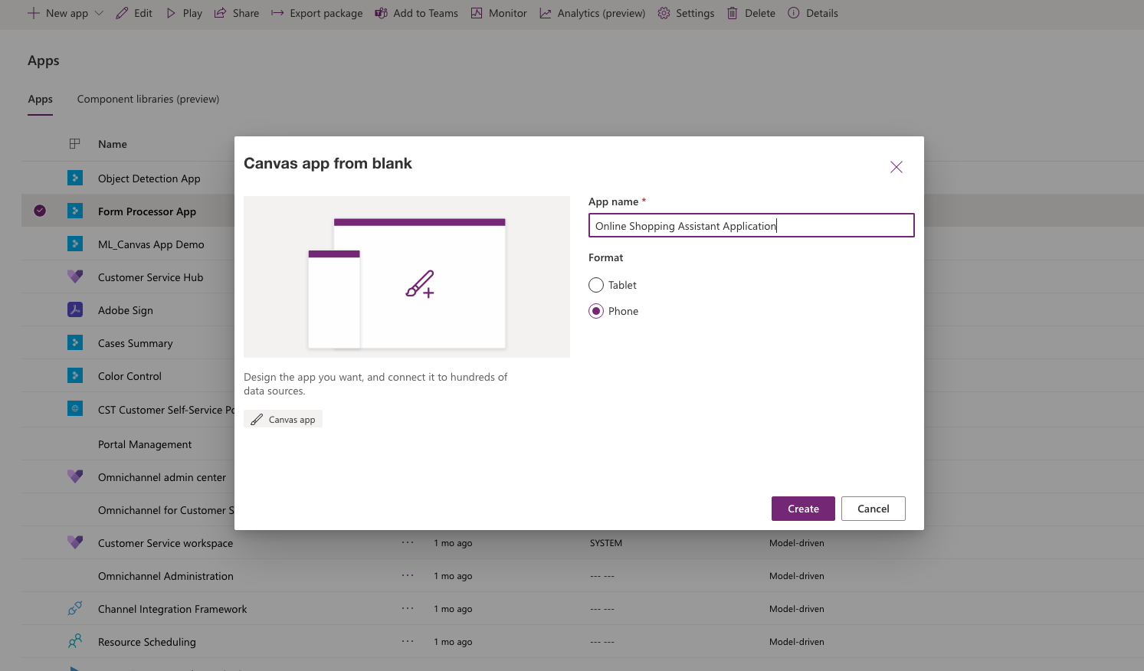

1. On the maker canvas, select the Insert tab in the ribbon and expand AI Builder. Select Object detector to place this control on your app.

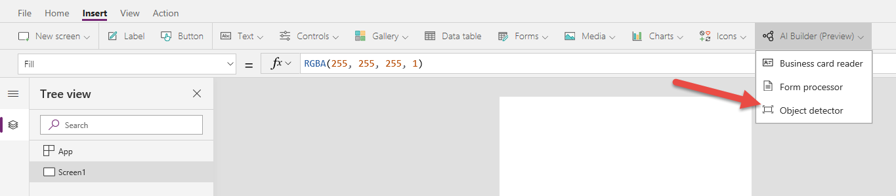

1. Select the AI model you built.

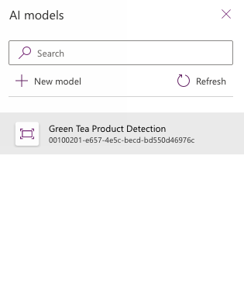

1. Resize the control to better use the space.

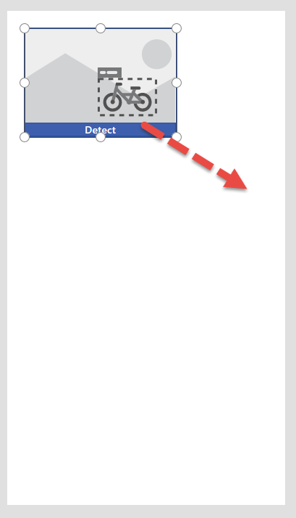

1. Make sure to leave room for more items we will be placing soon.

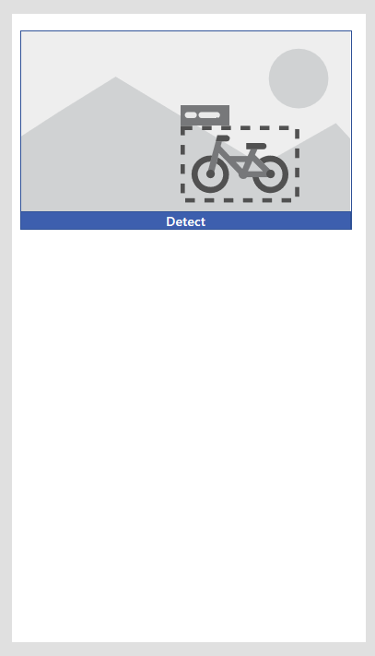

1. Play your app.

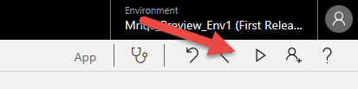

1. Click on Detect.

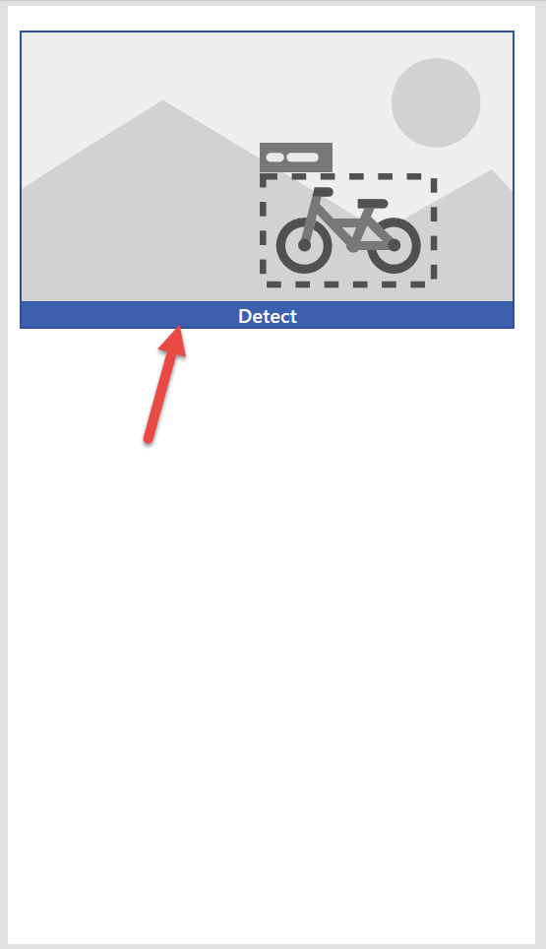

1. Choose one of your test images and click Open.

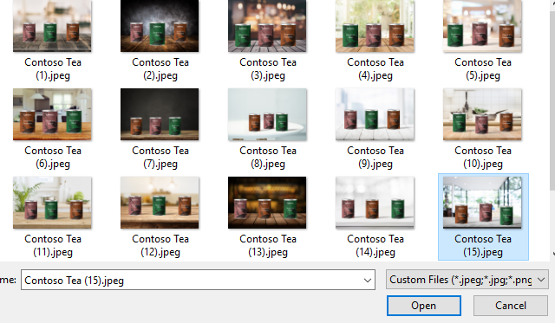

1. The image will now be analyzed.

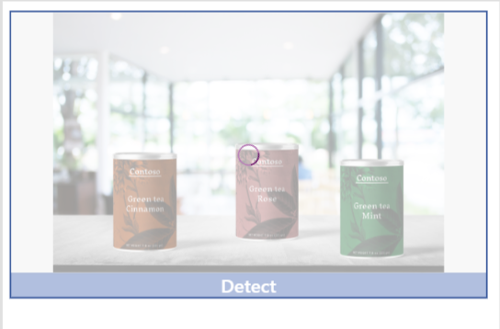

1. Our model has detected each tea in the image.

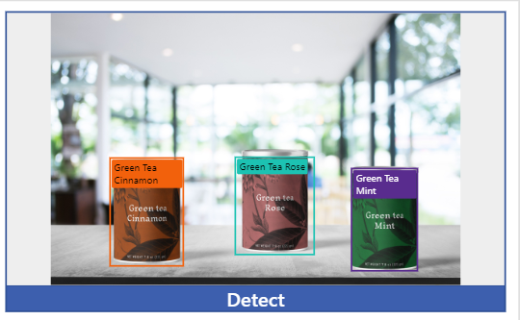

1. Exit the app player.

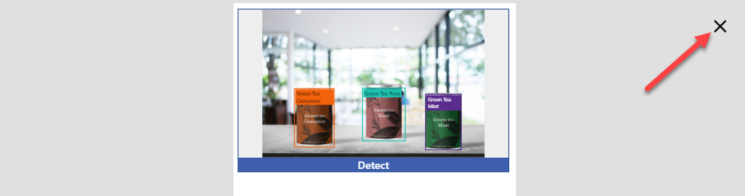

1. We will start building our Navigation Bar. Insert a Label from the top bar

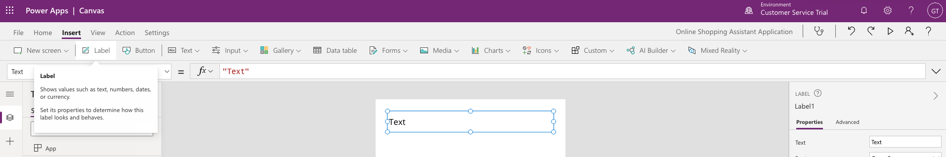

1. Click on the newly created Label and click on Color in the right side panel. Click on Custom and change the Hex value to 131921

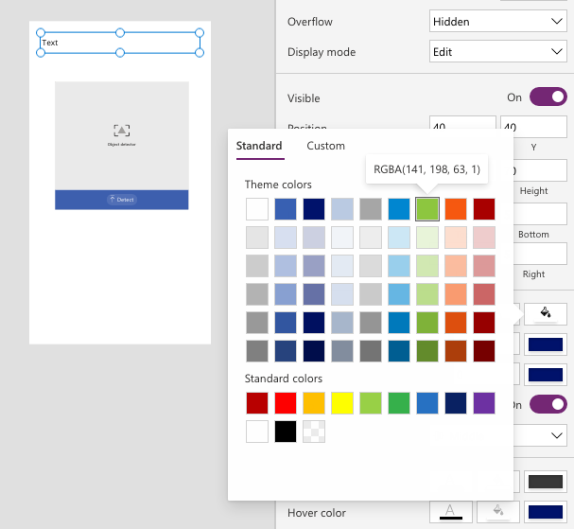

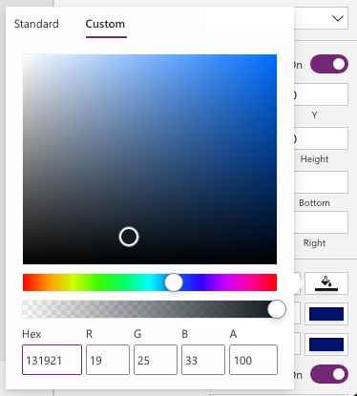

1. Create another label and change its “Text” to “Online Shopping Assistant Application”. Change the font color to white.

Your application should look like the following image

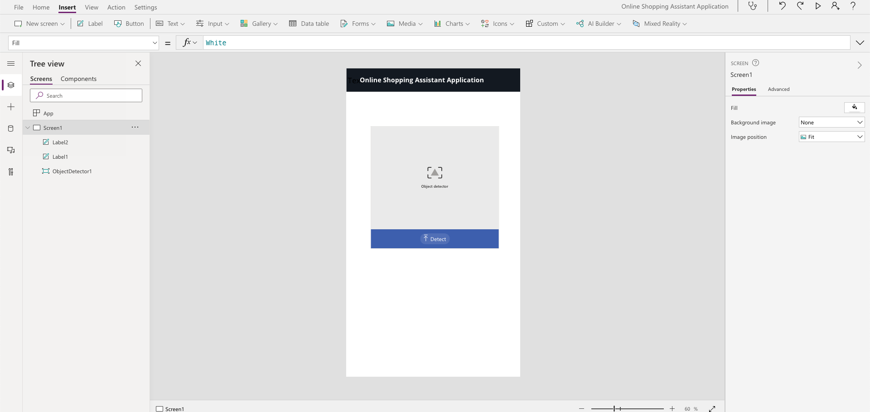

1. Now, let’s change the color of our Object Detection component to match our Navigation bar. Click on the Object Detection Component, click on background color > Custom and change the hex value to 131921

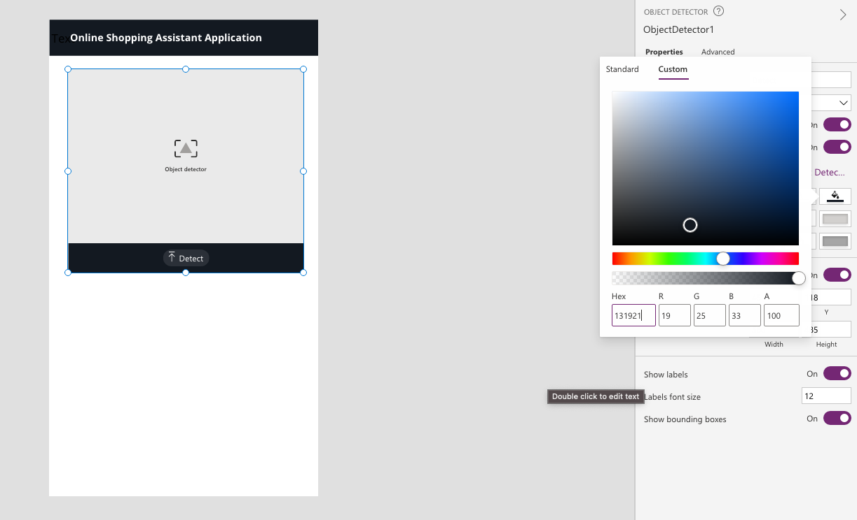

1. Add a Gallery by navigating to Gallery > Vertical.

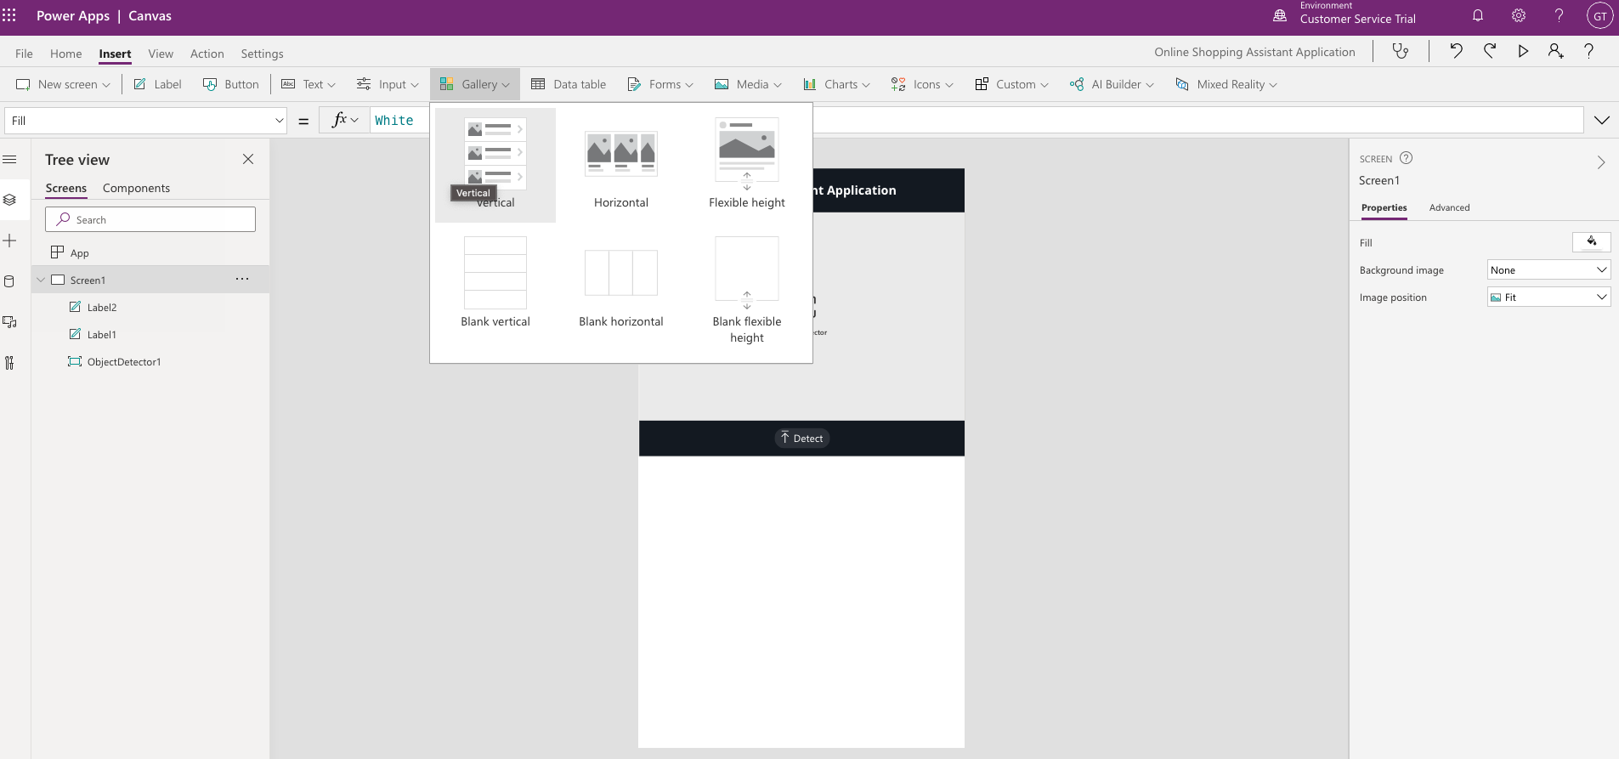

1. Search for the data source of “Object Detection Products” that was previously created.

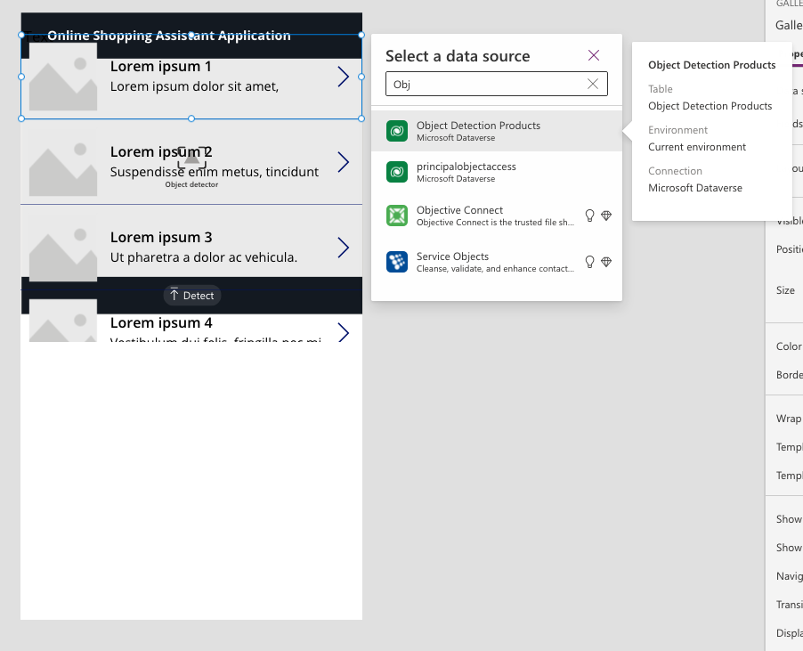

1. Space out the components evenly by dragging the Gallery component beneath the Object Detection component.

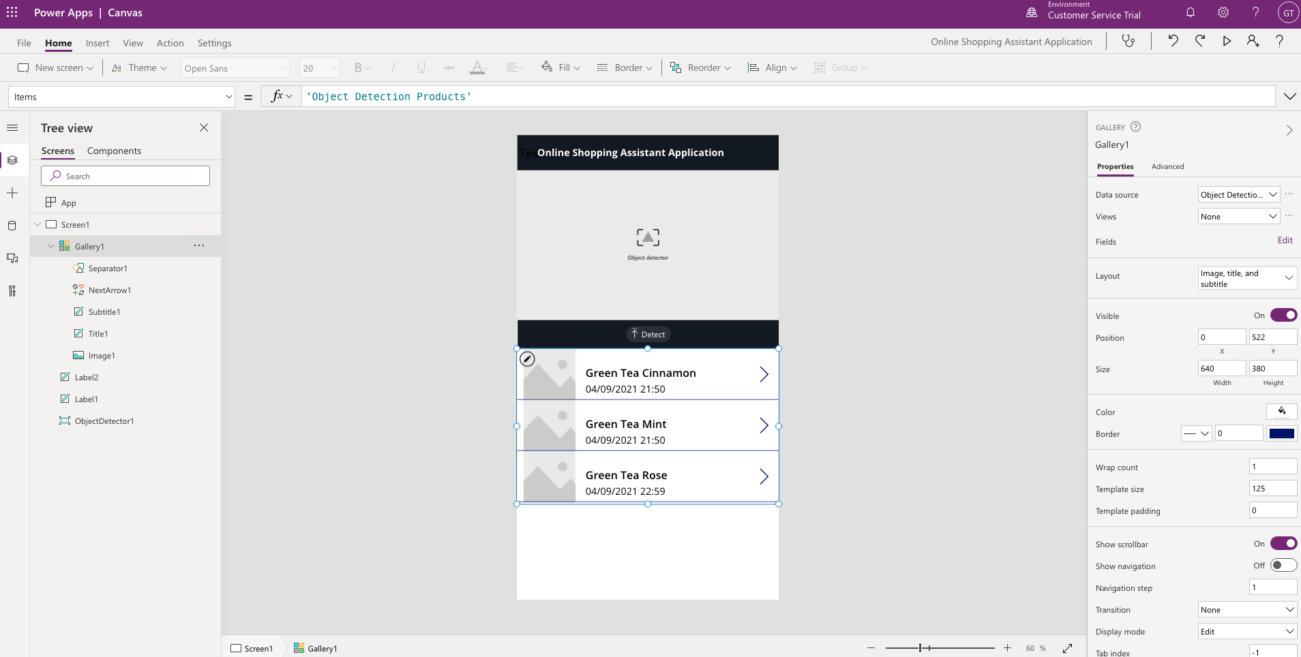

1. Click on Gallery1 on the sitemap and change the Fx formula of Items from “Object Detection Products” to ObjectDetector1.Results

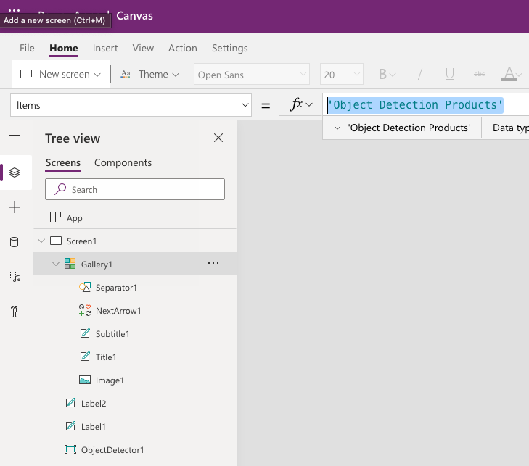

The items in your Gallery should be populated with the data from your Object Detector Component

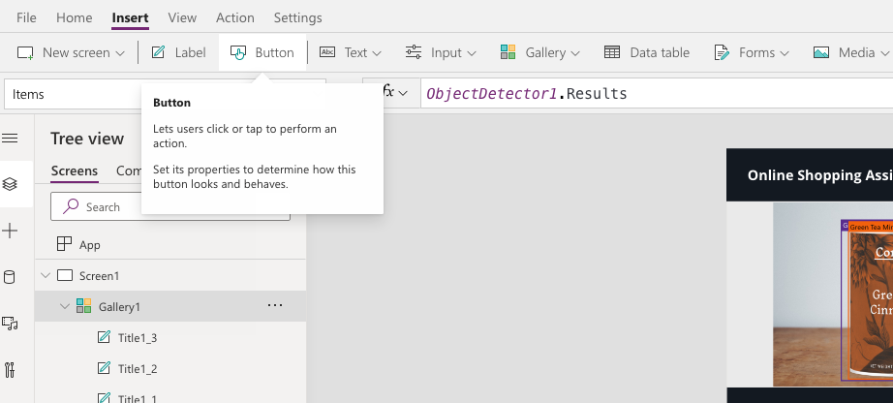

1. Click on the pencil icon in your gallery to start adjusting the display of individual items in your gallery. We will start by displaying the image from the Object Detector component in the gallery.

Click on the Image in the Gallery, and change the Fx formula of Image from SampleImage to ObjectDetector1.OriginalImage

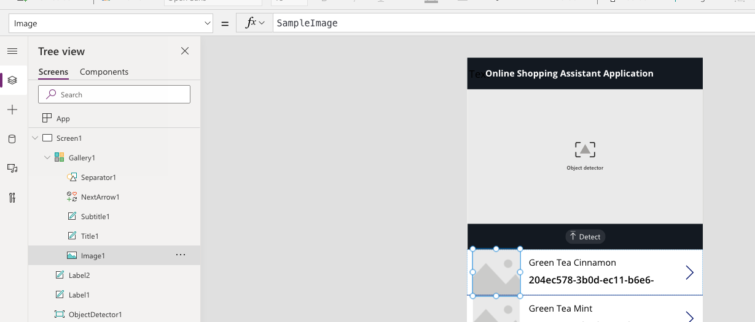

The image displayed will be changed into a blank image. Don’t worry – that is the correct behaviour as we have not captured an image with our object detector Component.

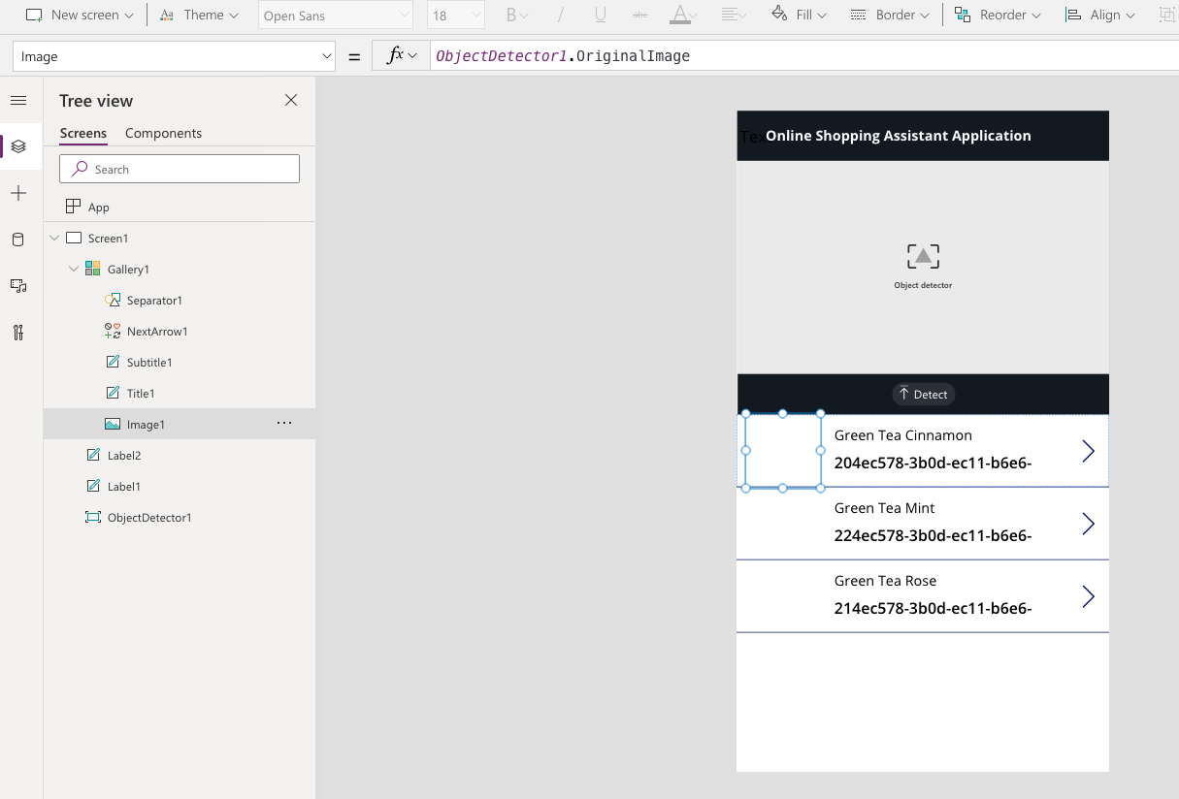

1. Arrange the individual components of the gallery to match the following image

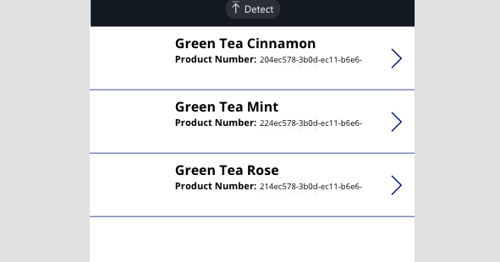

1. Add an additional Label, and change the Fx formula of “Text” from Text to ThisItem.Confidence. You should see a decimal number like the following of 0.8564677.

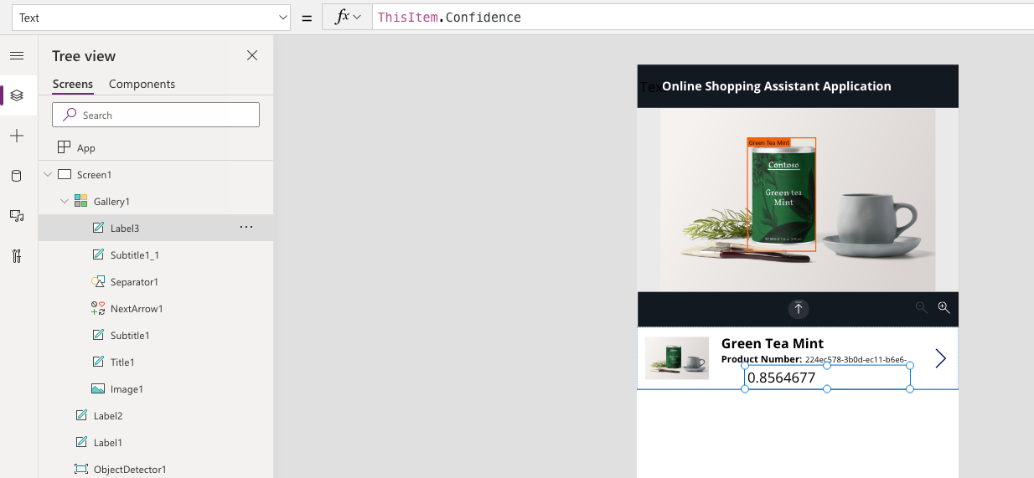

1. Let’s convert this decimal number into a presentable percentage by changing the Fx formula from ThisItem.Confidence to Round(ThisItem.Confidence,3) * 100.

Arrange the individual components neatly such that it looks like the following image.

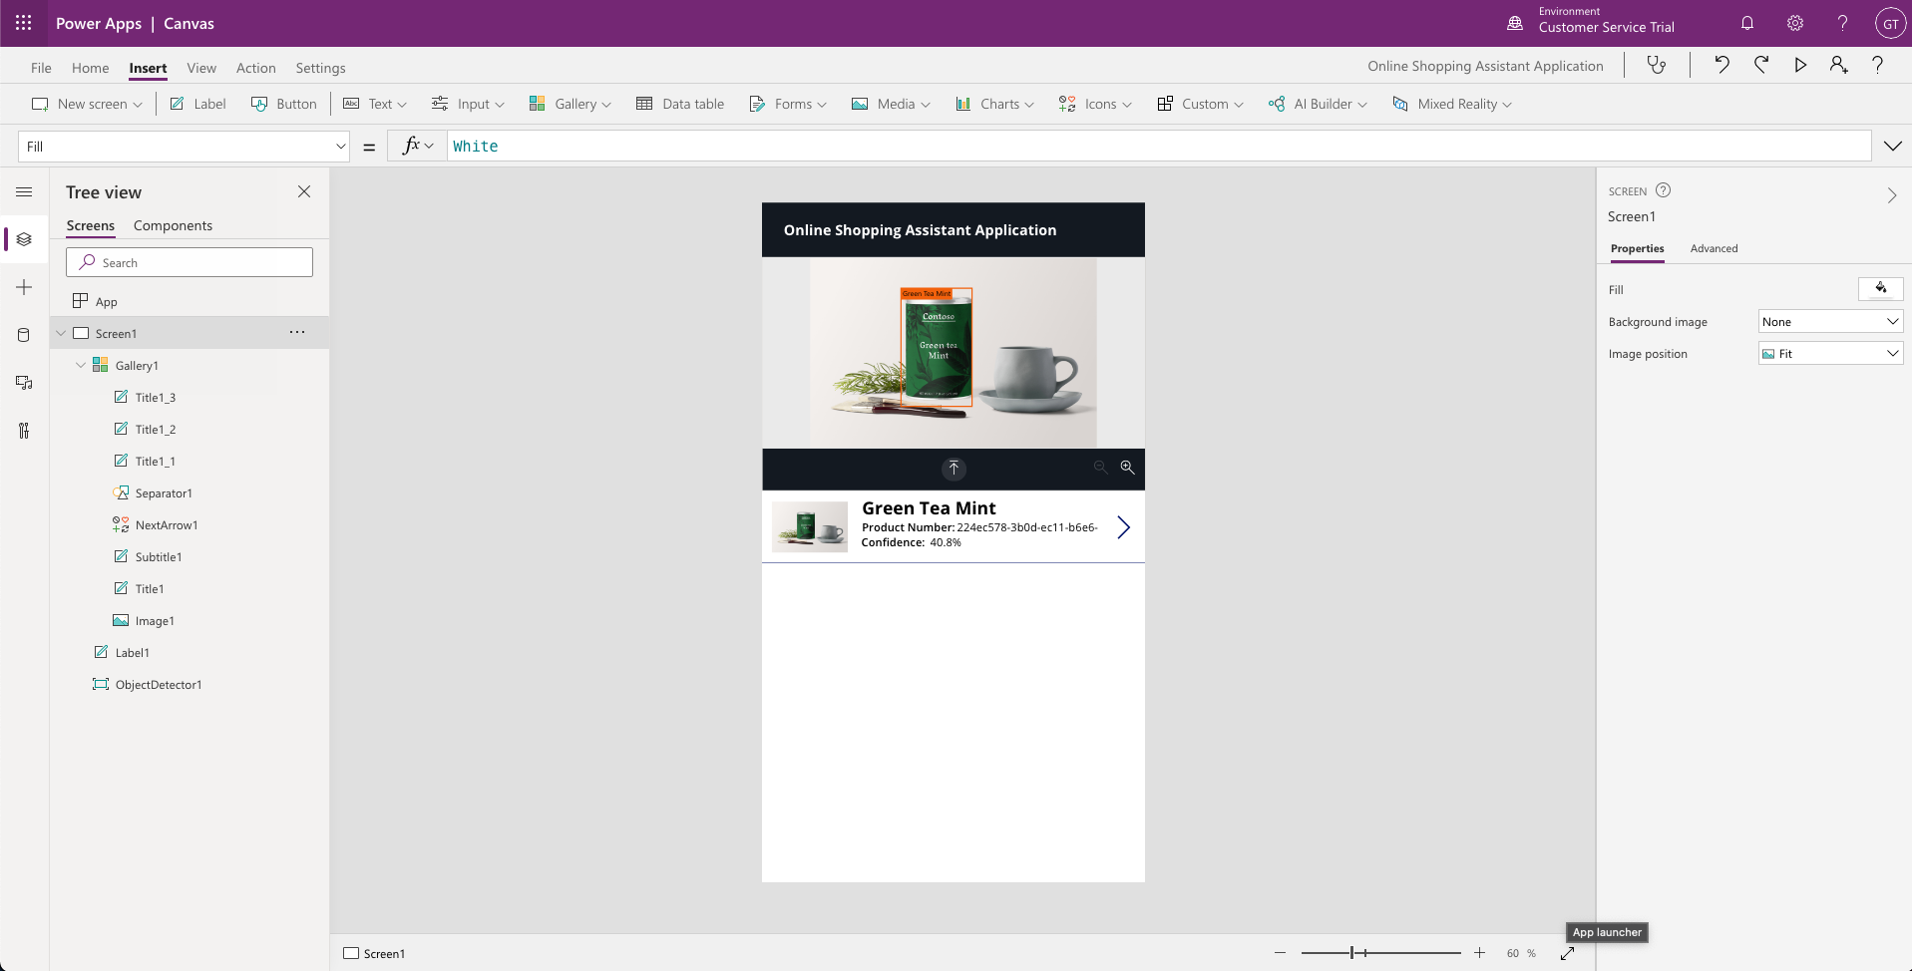

1. Click on the > component in the Gallery

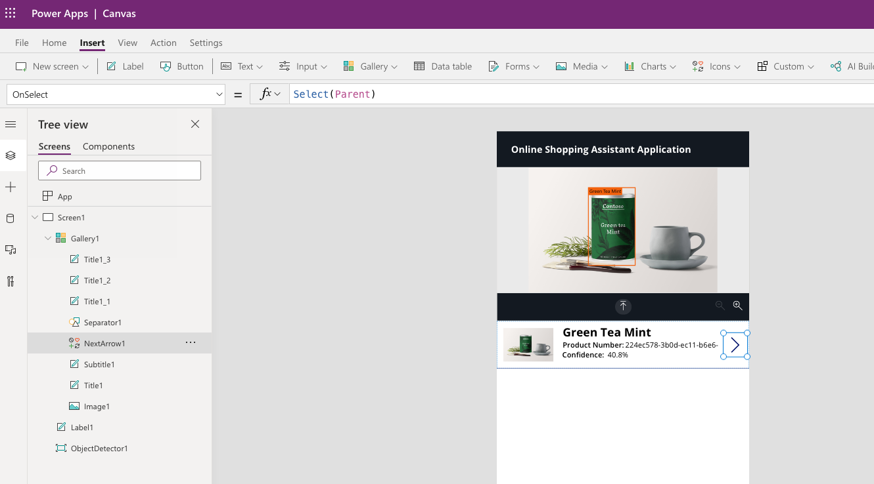

1. Change the Fx formula of OnSelect from Select(Parent) to Set(SelectedItem, ThisItem.TagName);

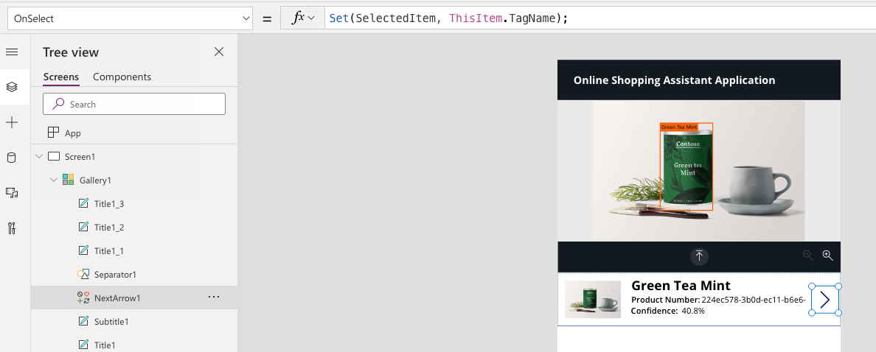

1. Add a button to the bottom of the application by clicking on “Button” on the top bar

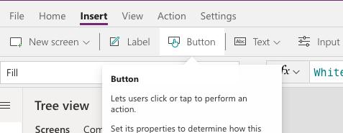

1. Change the background color of the button to match the rest of the application by changing the custom hex code to 131921.

Change the Text from “Chime” to “Shop on Amazon”

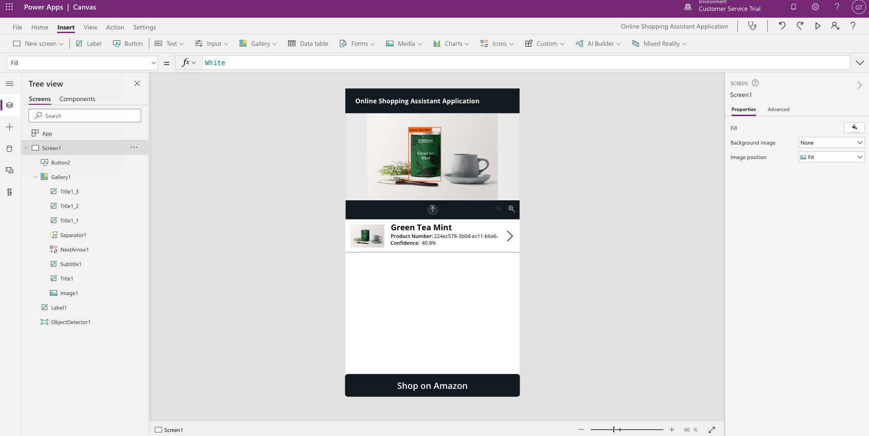

1. Click on the button and change the Fx code of the OnSelect from false to   
   Launch("https://www.amazon.com/s?k="&LookUp('Object Detection Products',Name=SelectedItem).Name)

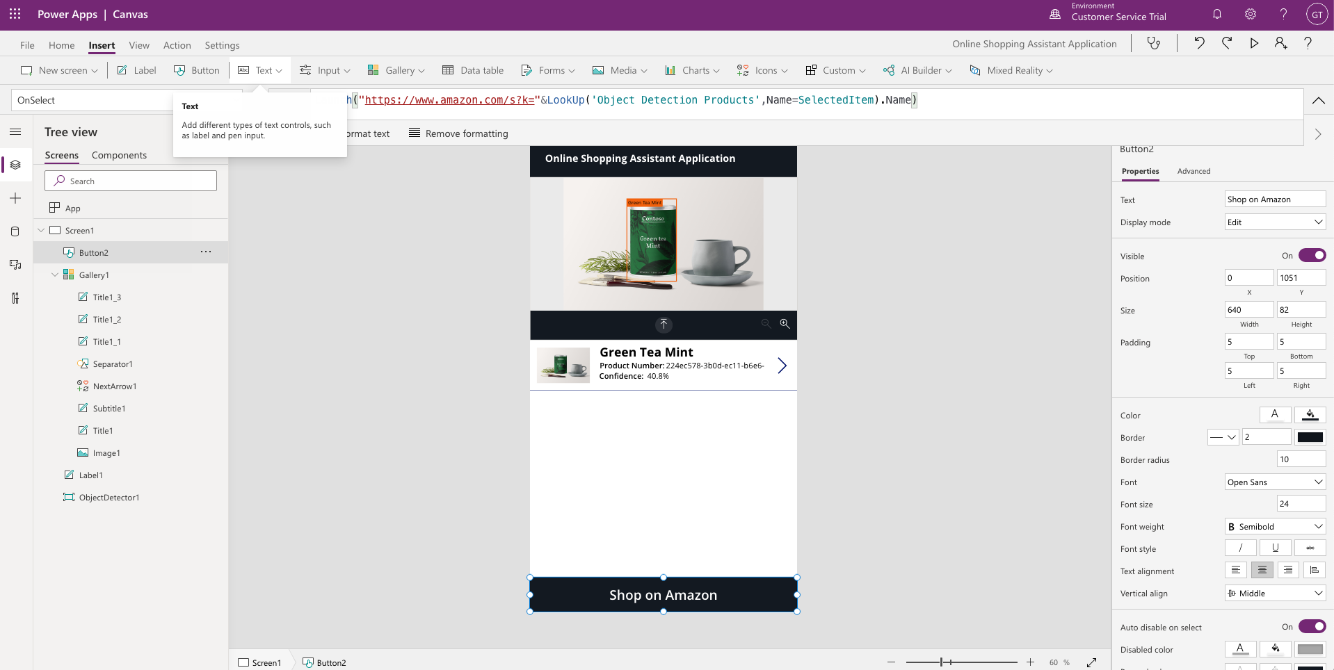

1. Add another label to the bottom of the Application between the Gallery and the Button.

Change the Fx code of Text from “Text” to SelectedItem

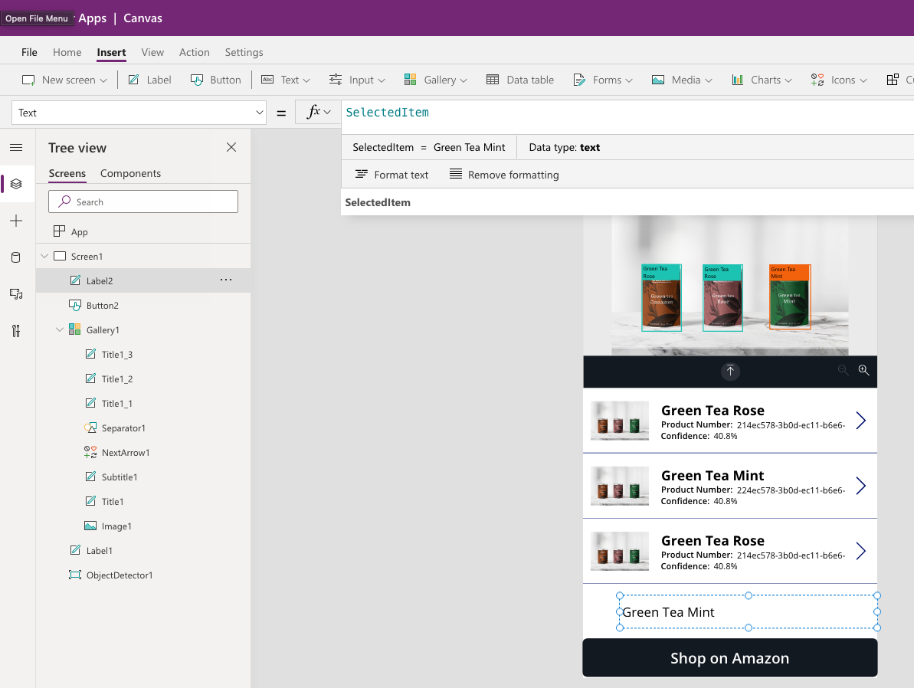

1. Arrange the labels neatly like the image below.

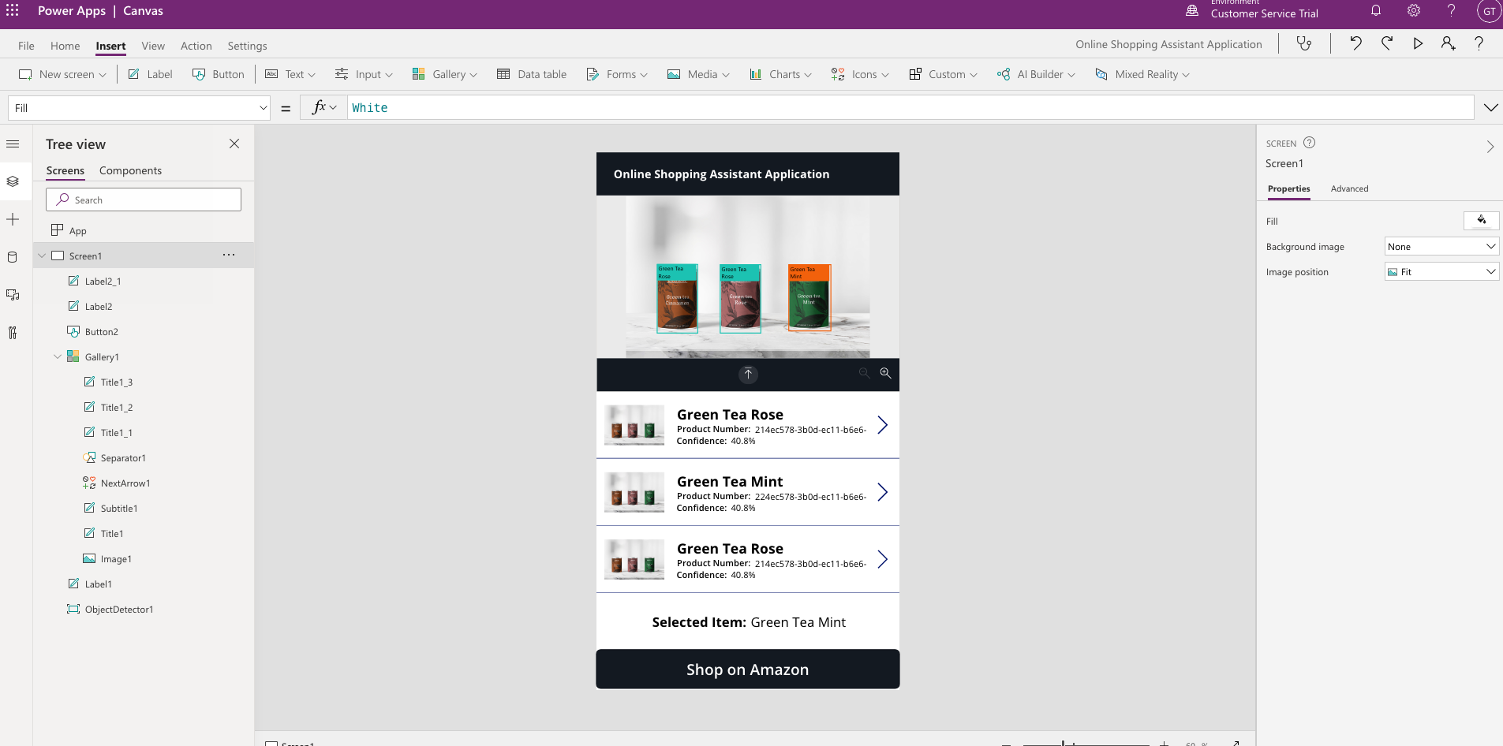

1. We’re ready to test out our App!

Click on Preview the App or Press F5

1. Pick an image from the test folder and drop it into the Object Detection component.

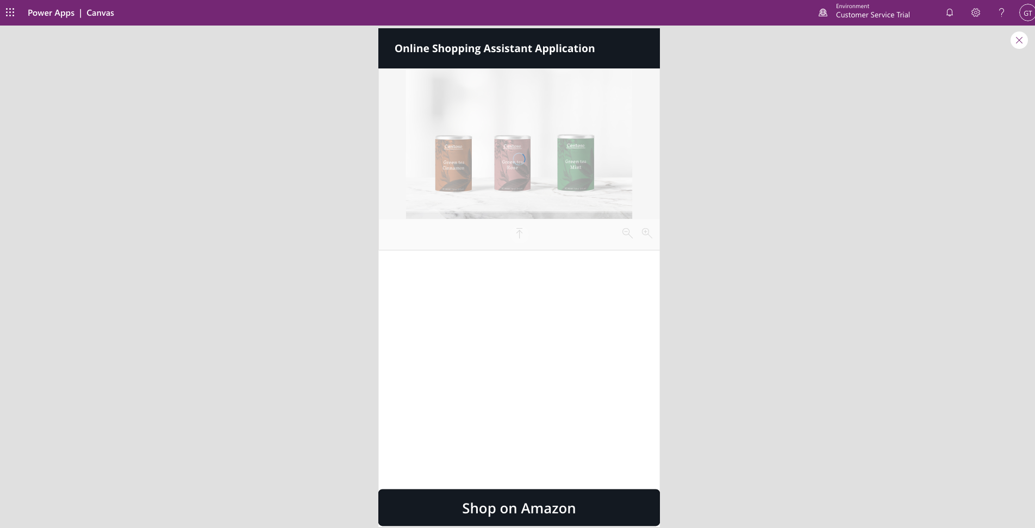

1. After a few seconds, the gallery will be populated with the objects detected. Click on the > button of Green Tea Rose.

The Selected Item label should reflect “Green Tea Rose”

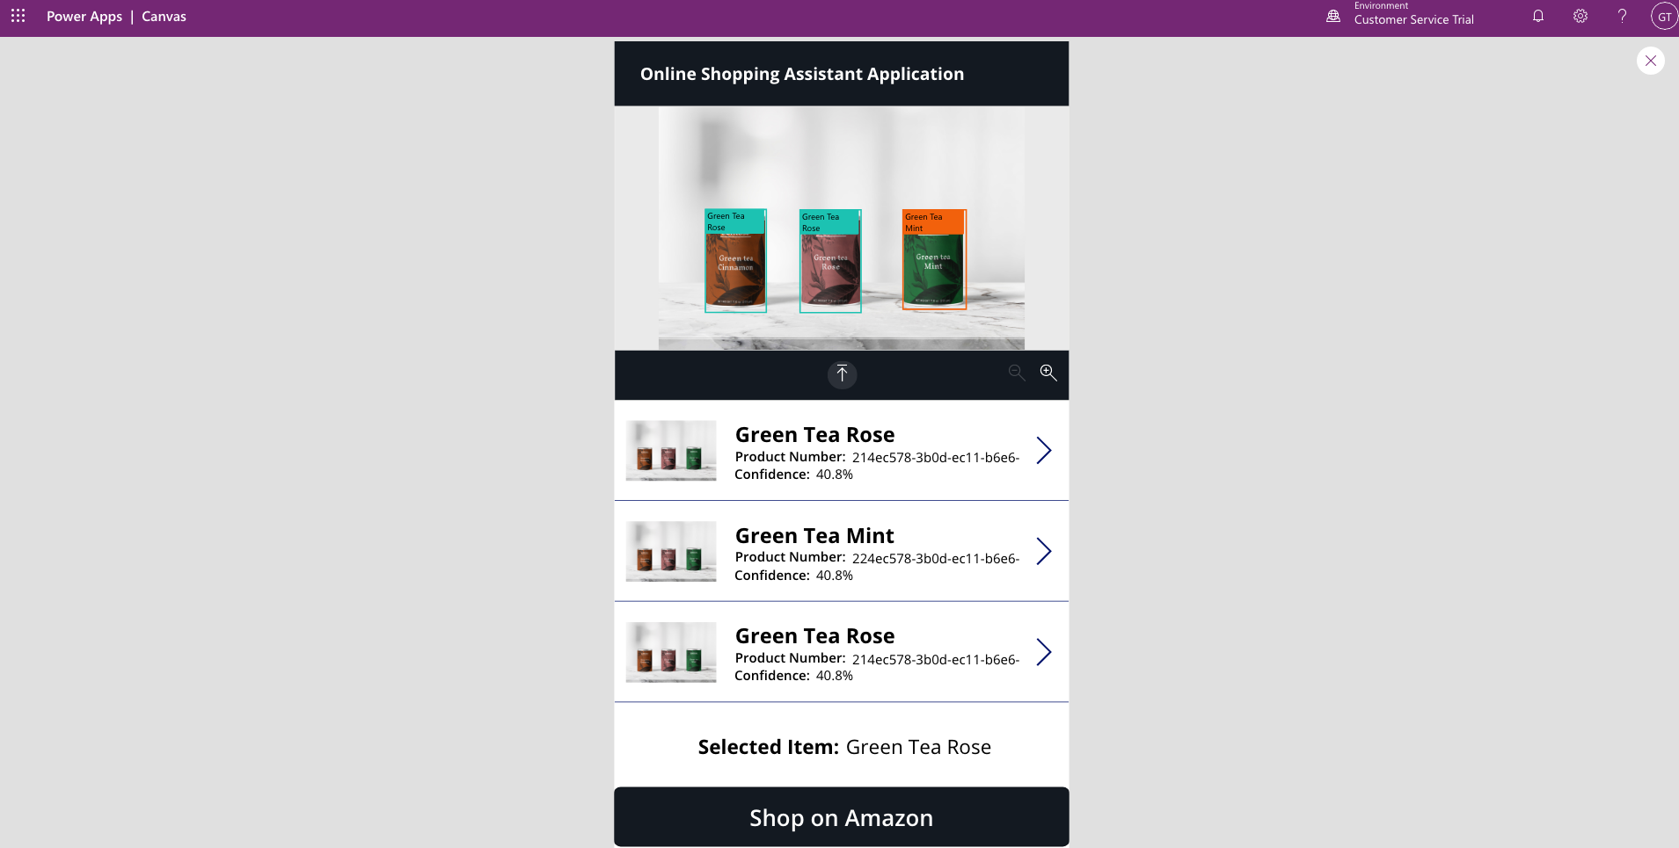

1. Click on the Button “Shop on Amazon” Below.

You will be brought to the Amazon site with the search results of Green Tea Rose.

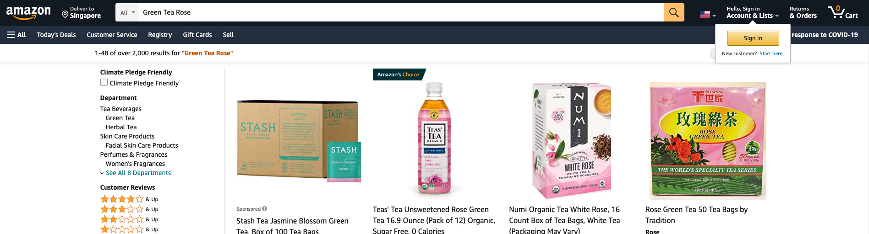

1. Navigate back to your application and click on the > button of Green Tea Mint.

The Selected Item label should reflect “Green Tea Mint”

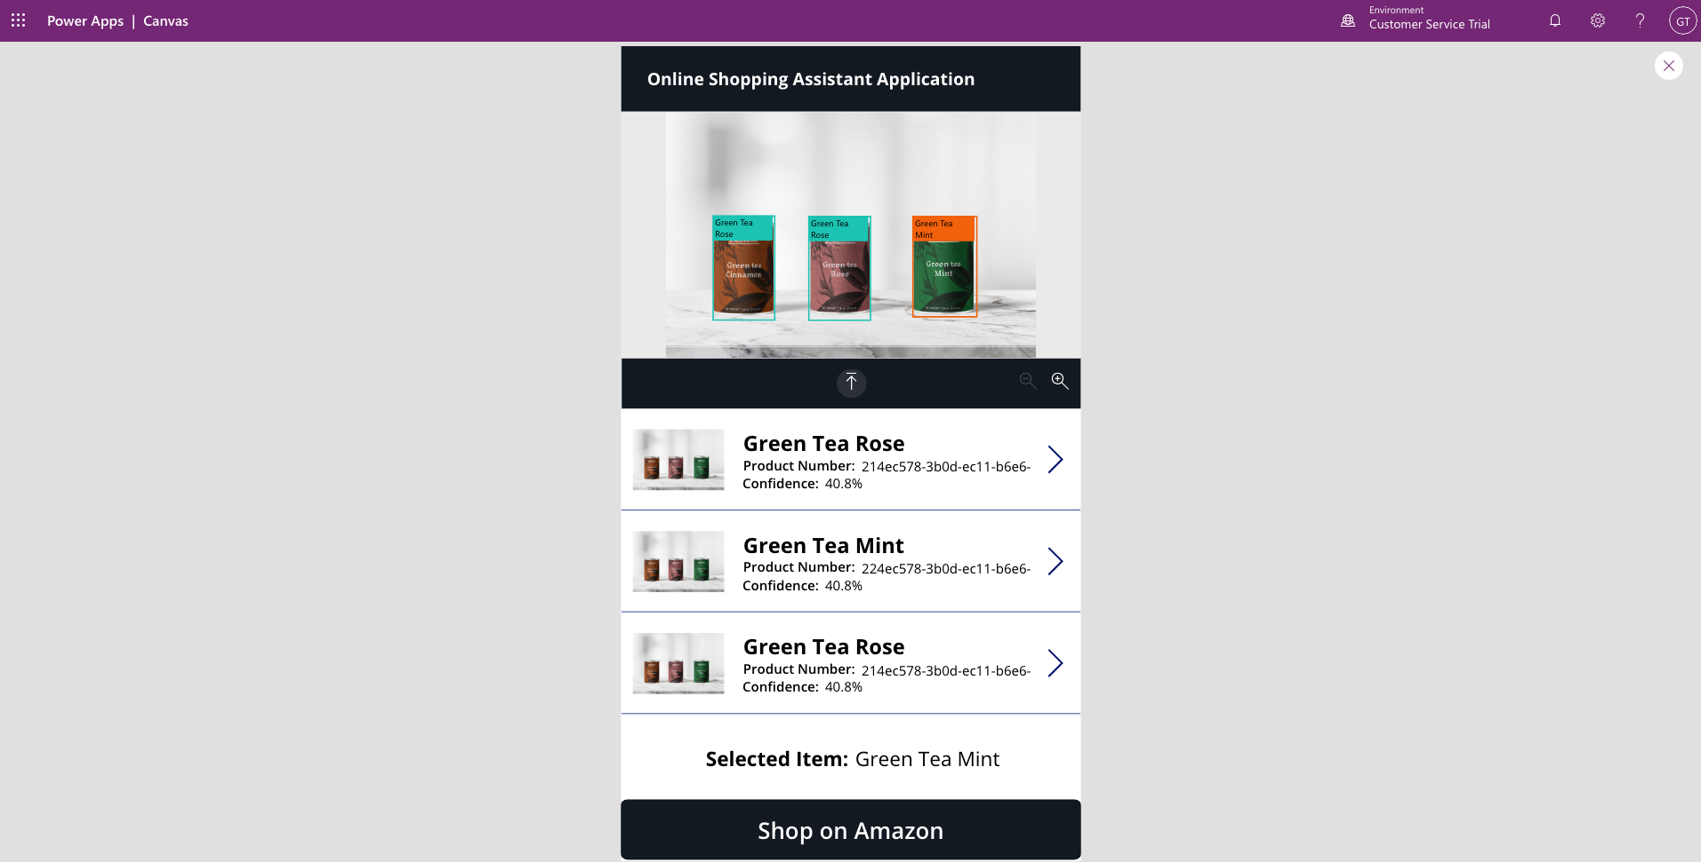

1. Click on the Button “Shop on Amazon” Below.

You will be brought to the Amazon site with the search results of Green Tea Mint!

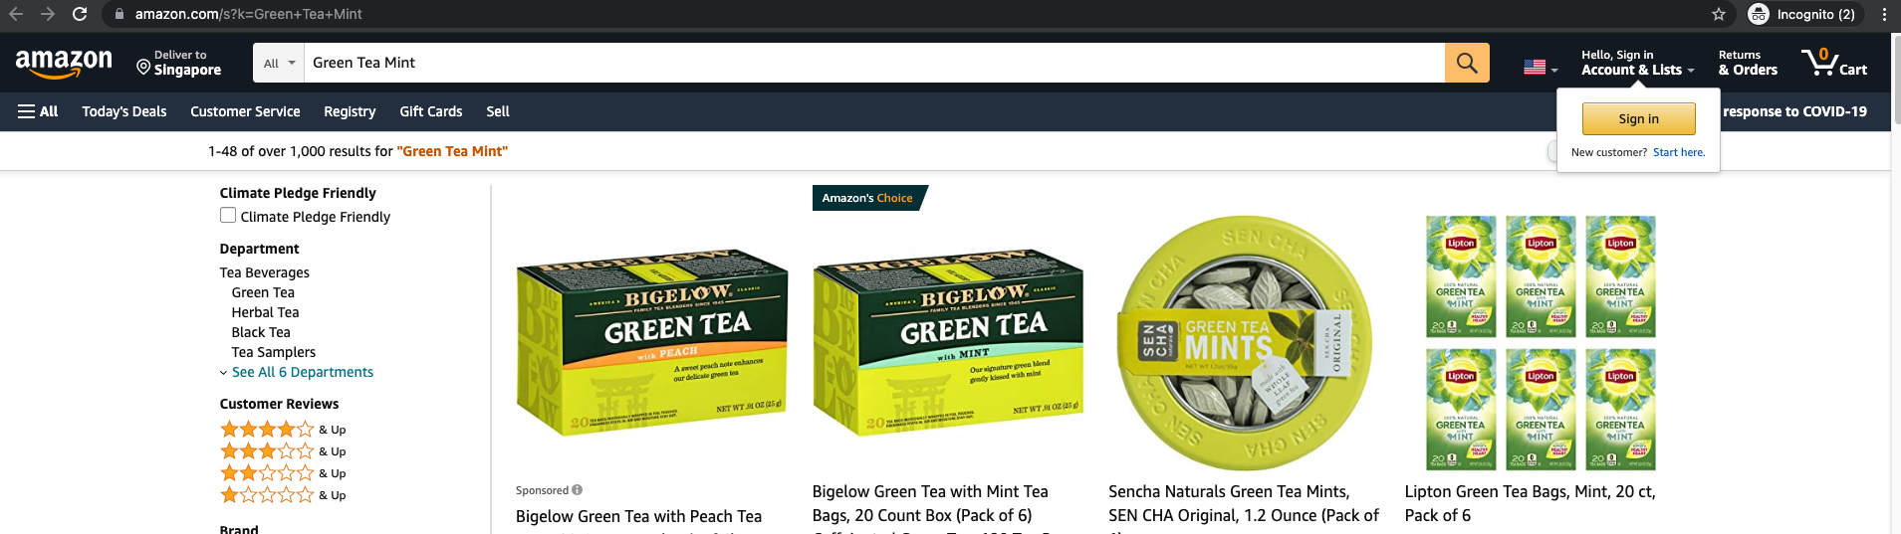

# Building a Digitalisation Tool using Form Processing Model

Similarly, we will now create a canvas app powered by the Form Processor Model we previously trained to create an automated workflow to digitalize invoice documents.

# End Product

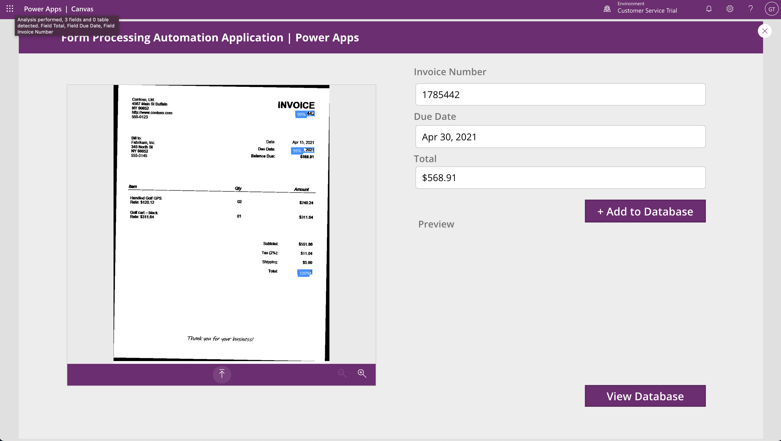

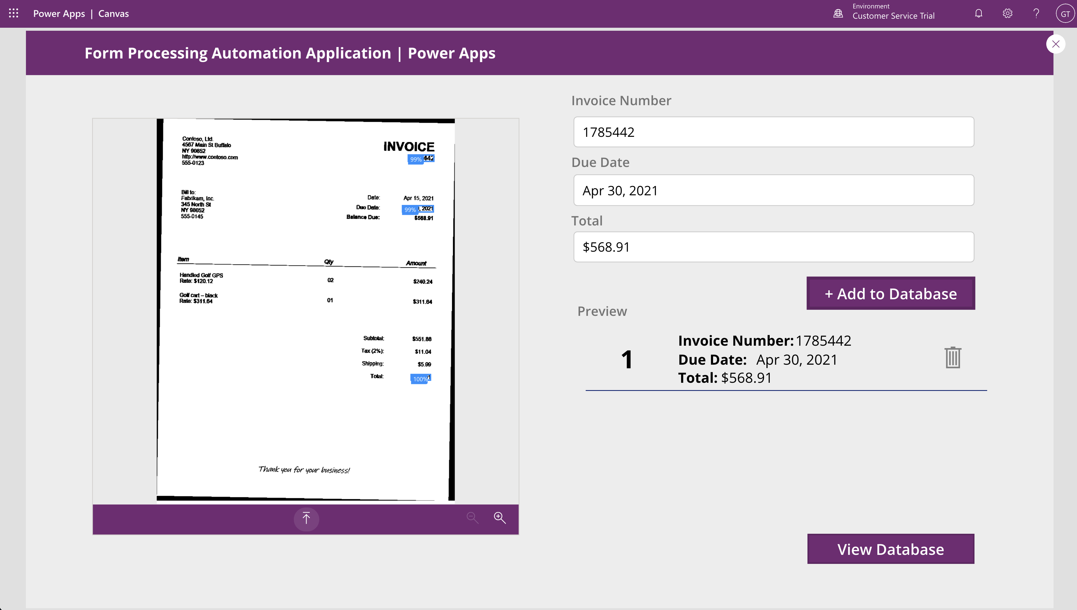

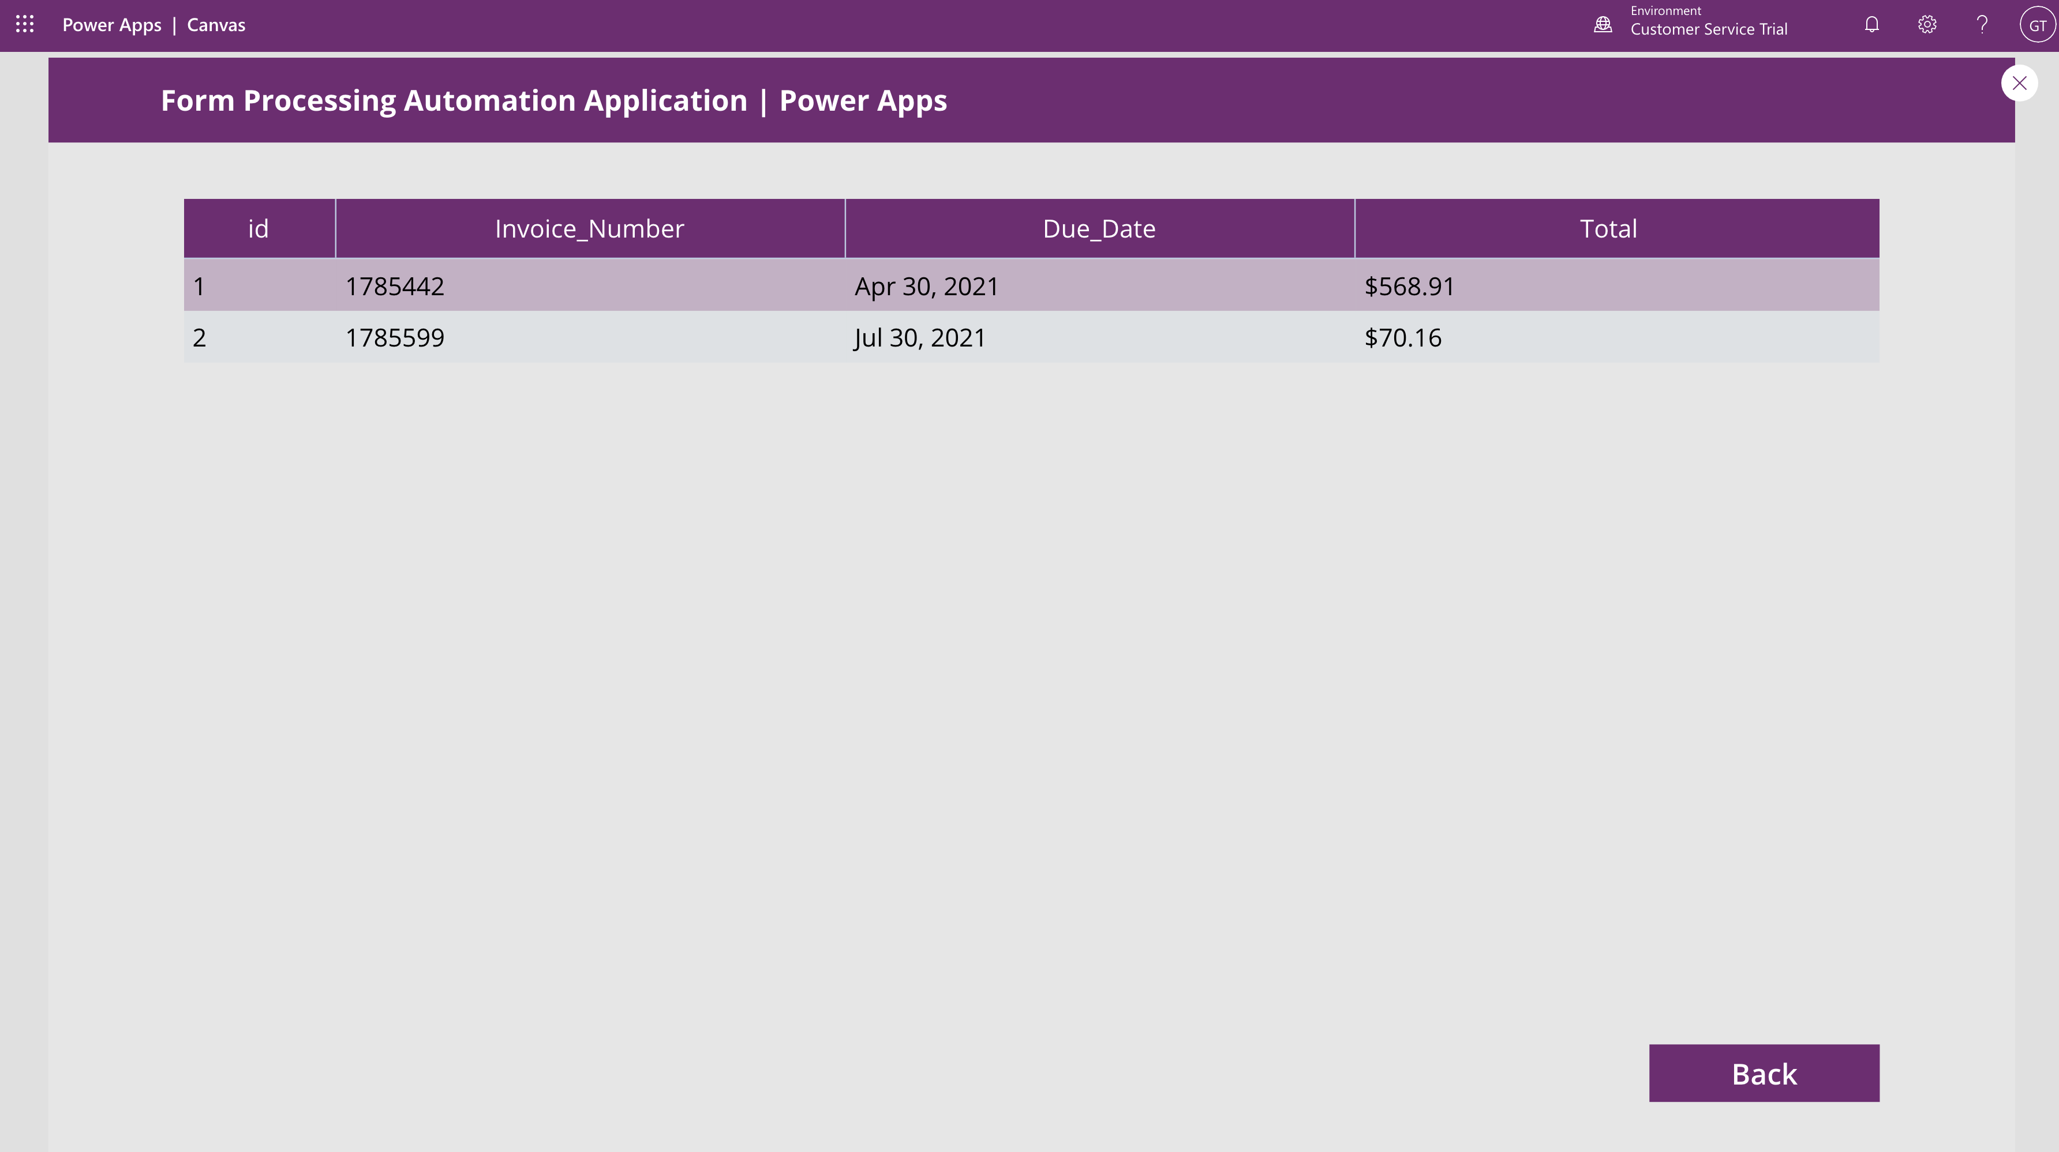

# Step by Step Instructions

1. Navigate to Apps, and select Create an app, then select Canvas. If asked, grant permission for the app to use your active CDS credentials.



1. Enter a name for your App and select the Tablet format.

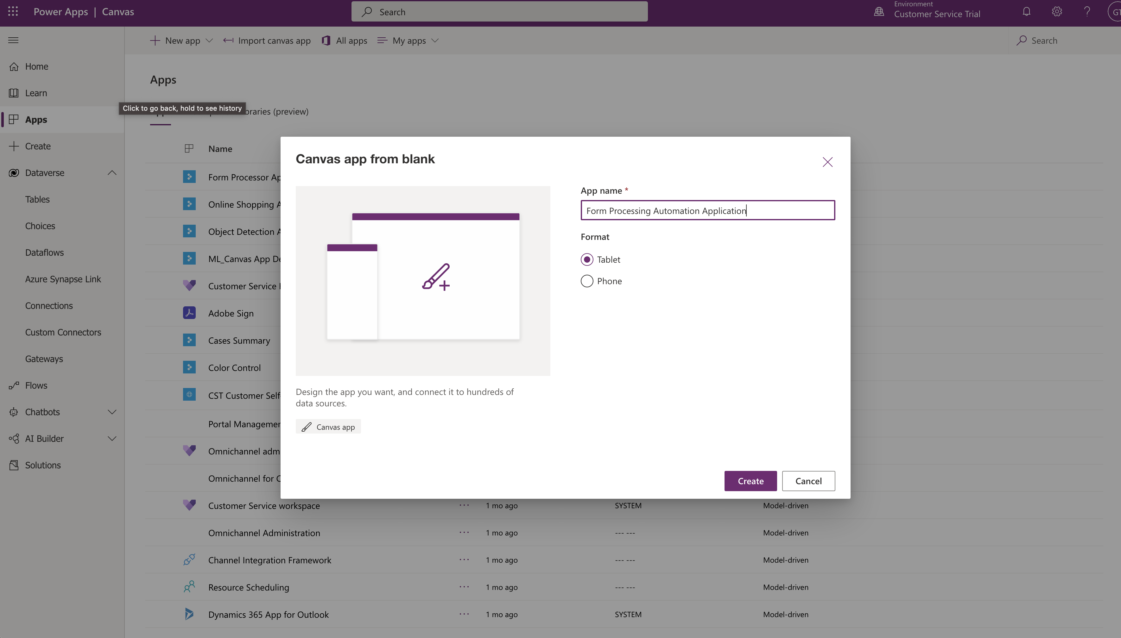

1. On the maker canvas, select the Insert tab in the ribbon and expand AI Builder. Select Form Processor to place this control on your app.

1. Select the AI model you built – Invoice Form Processing

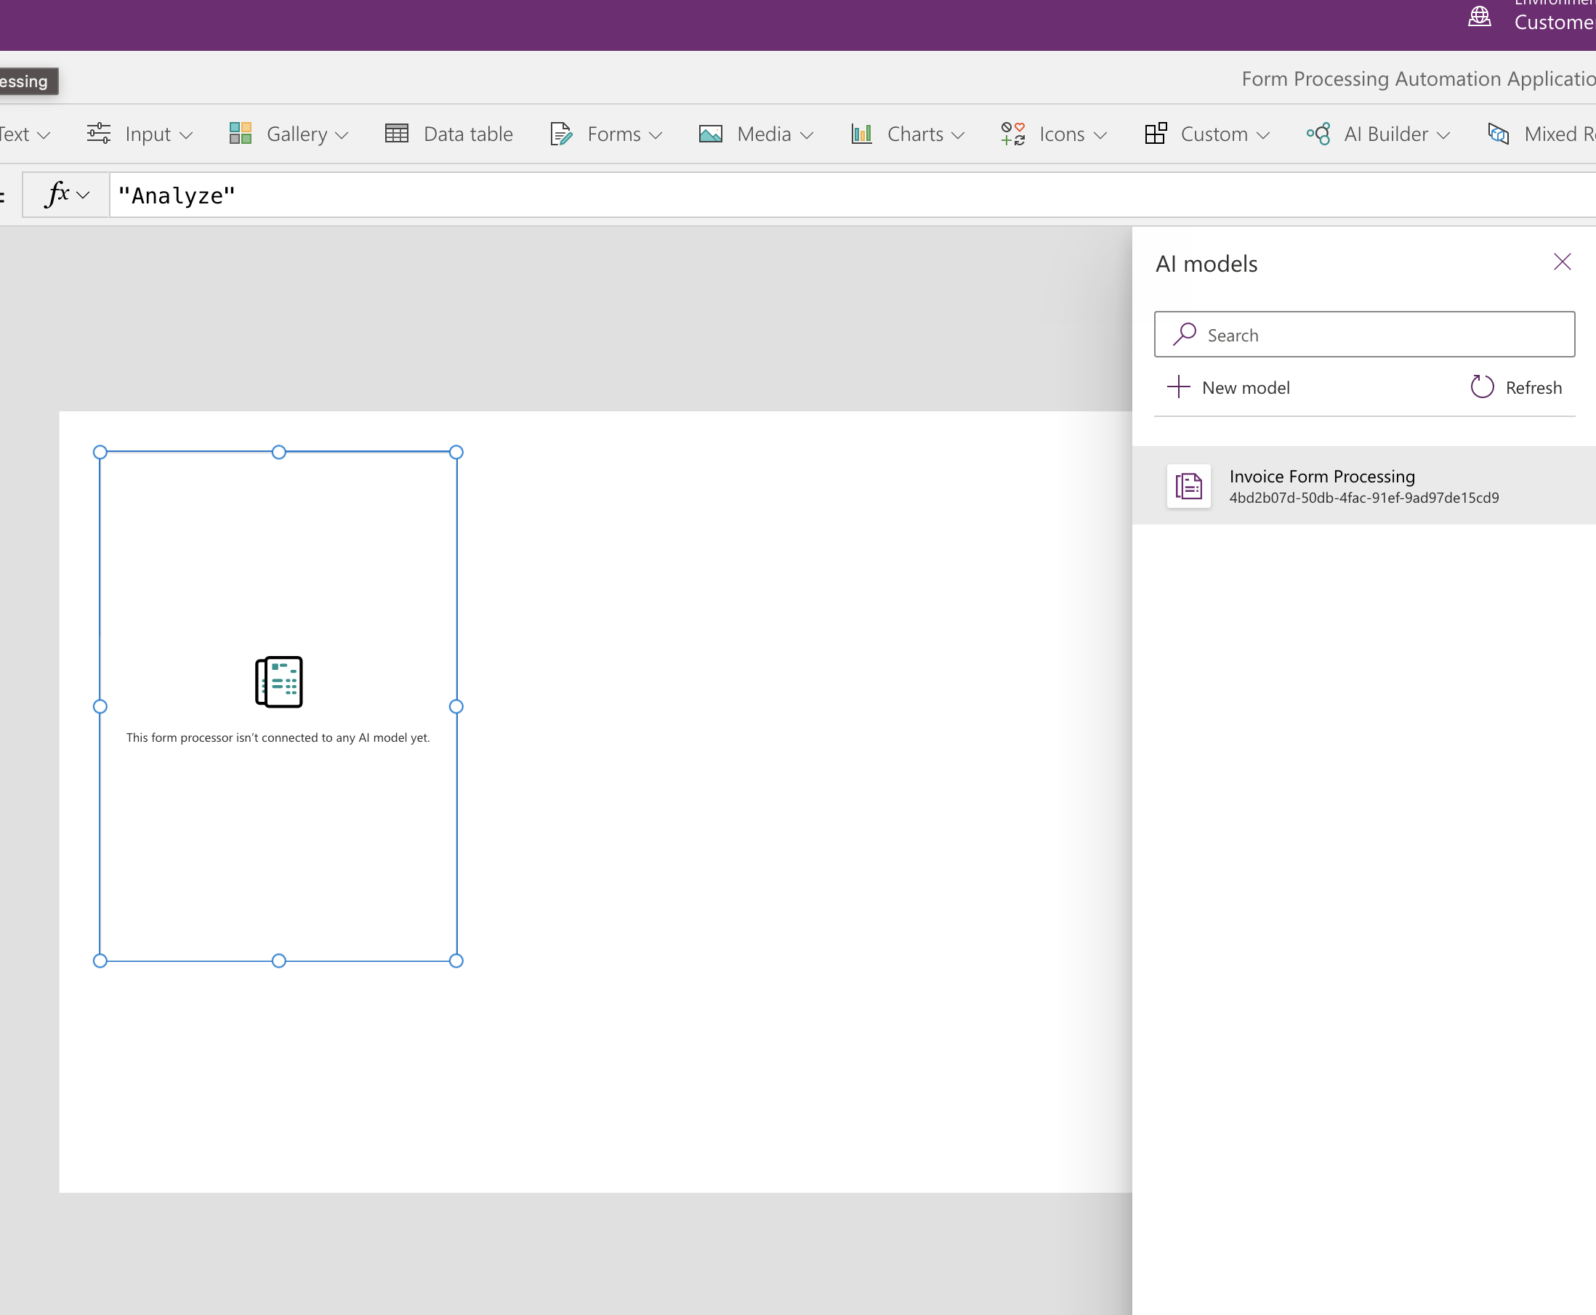

1. Resize the control to better use the space.

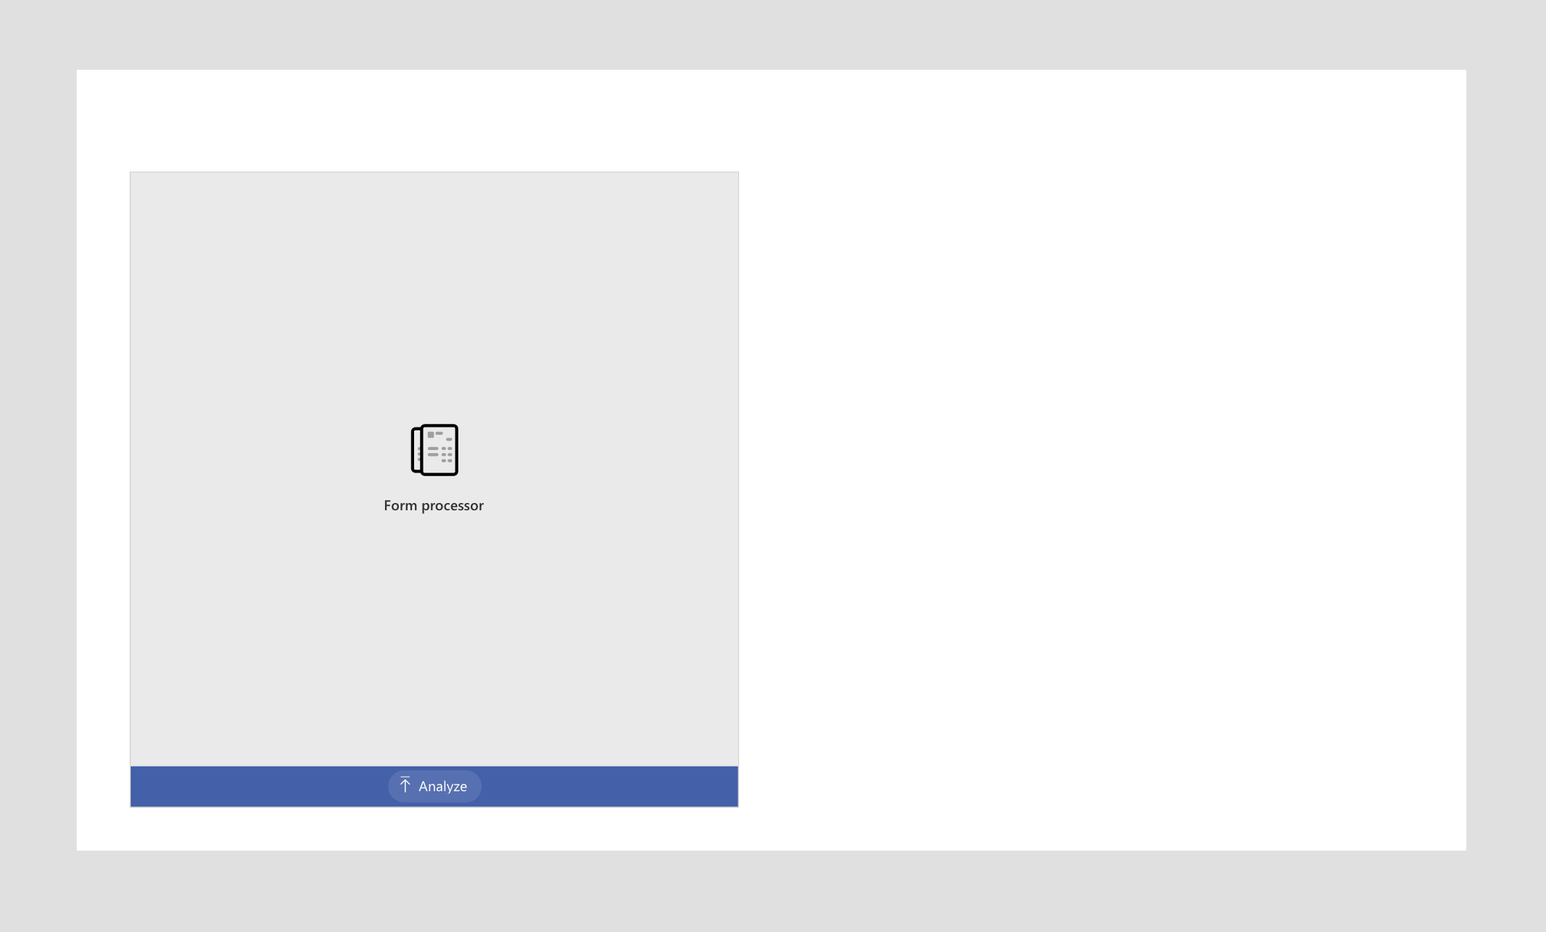

1. Change the background color of our Form Processing component by changing its custom hex value to 742774

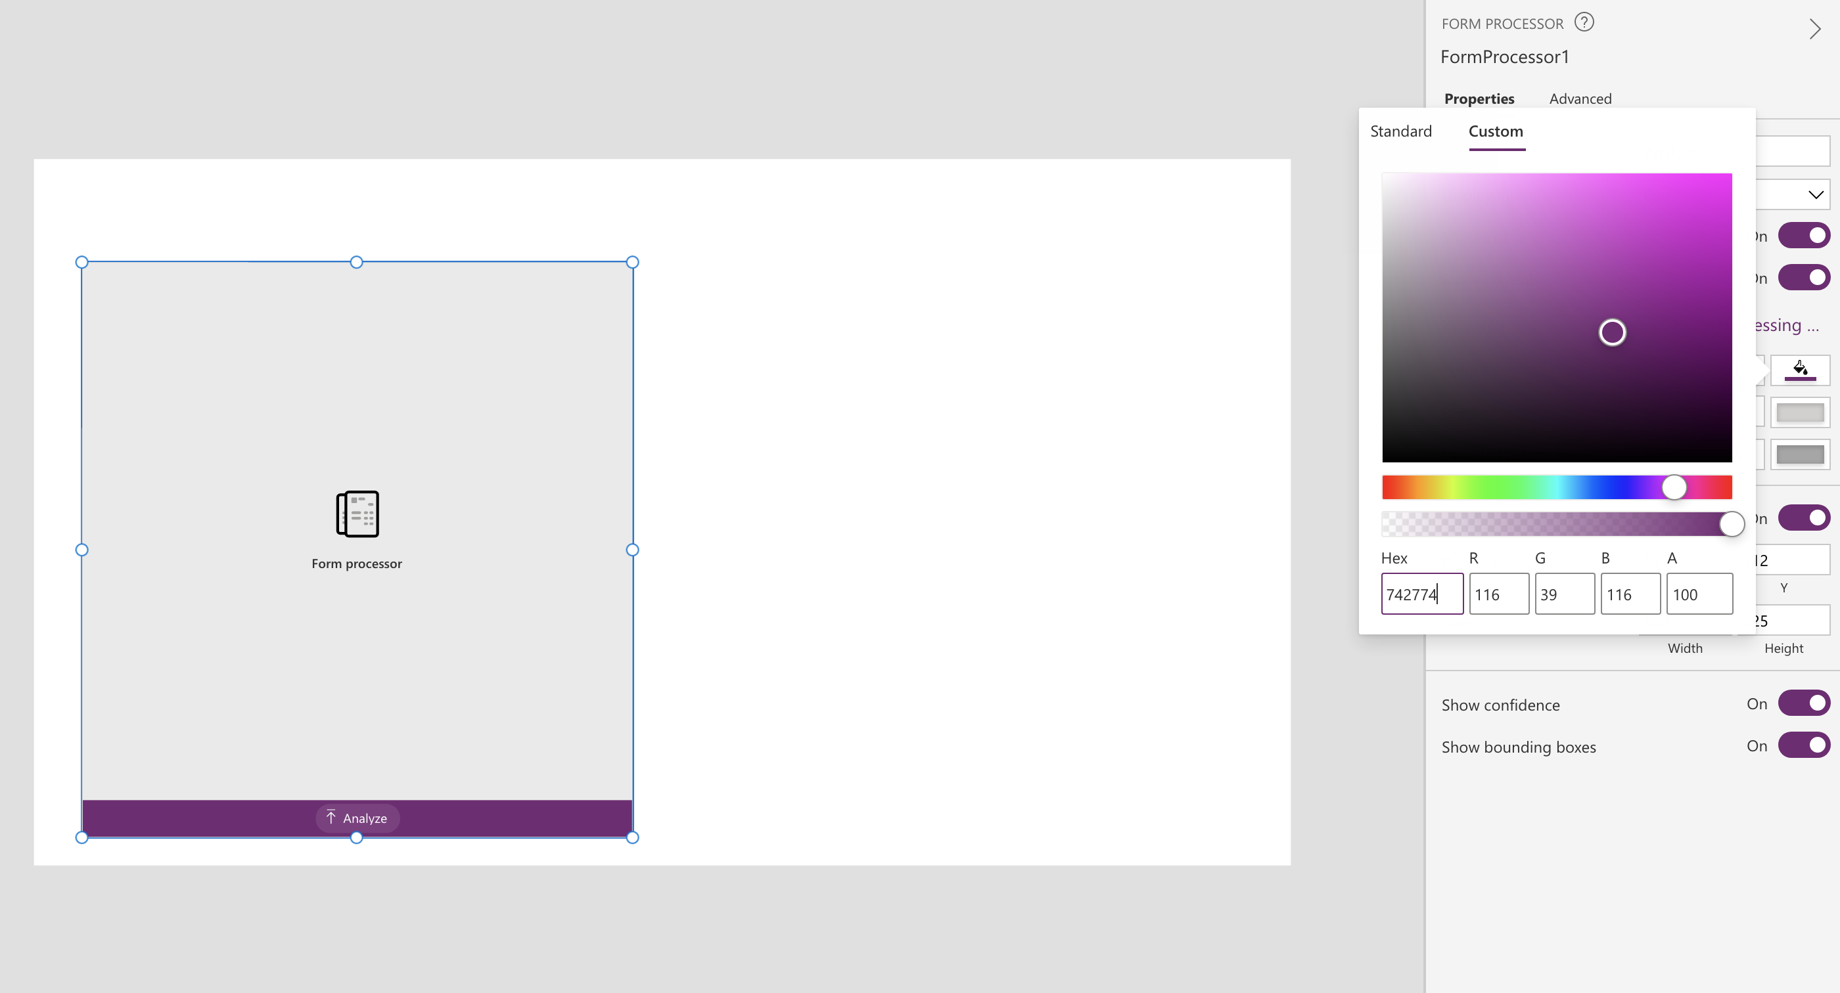

1. Create 3 labels and 3 text inputs by navigating to the Insert tab above.

Change the 3 texts fields to “Invoice Number”, “Due Date” and “Total” respectively.

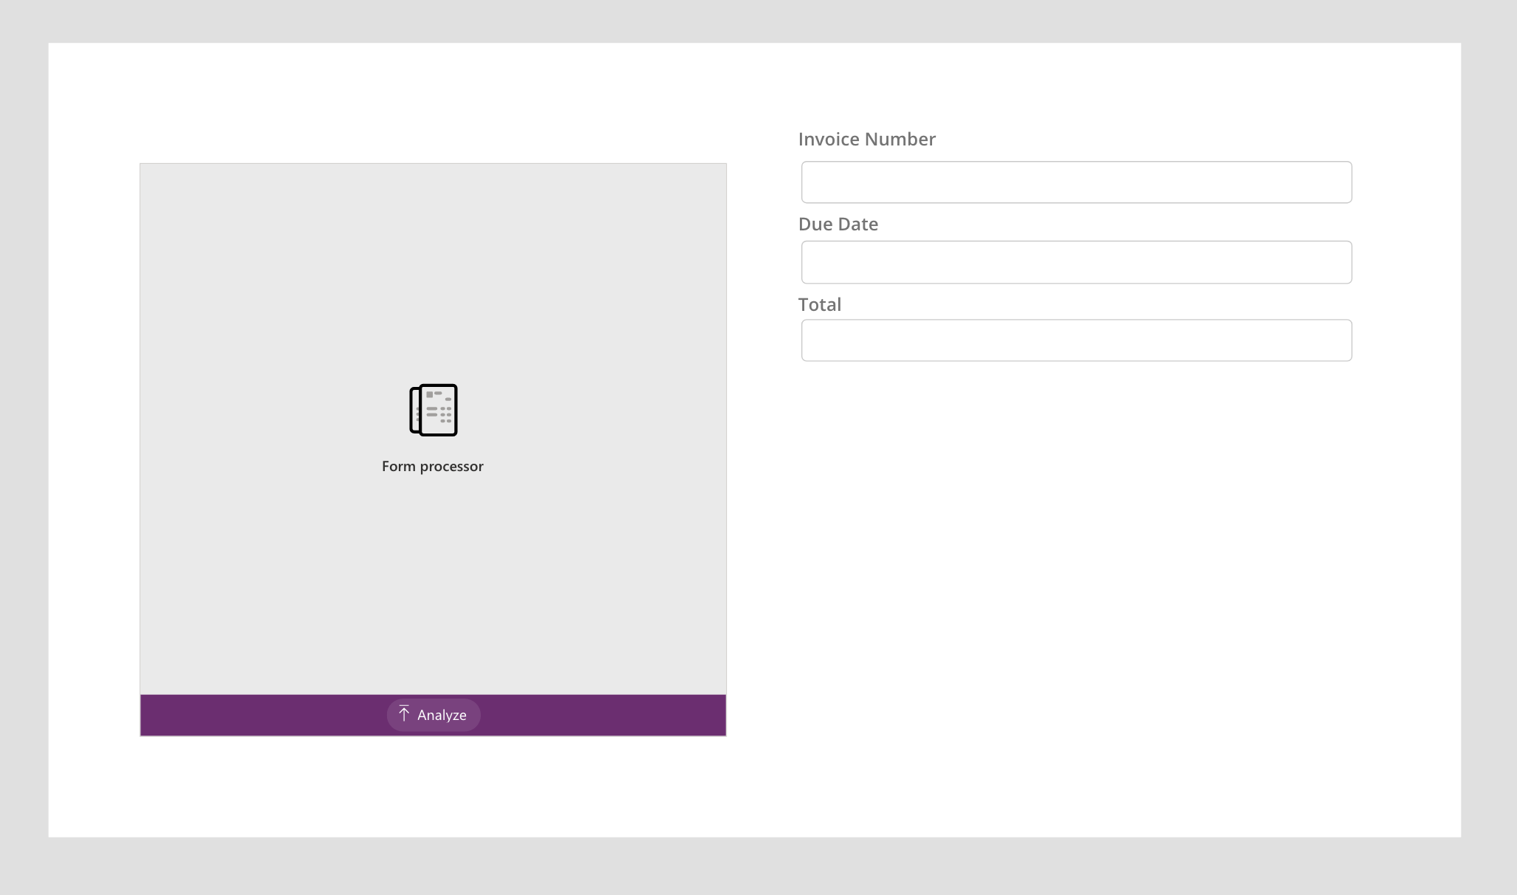

1. Change the name of the text inputs to “DueDateInput”, “TotalInput”, and “InvoiceInput”

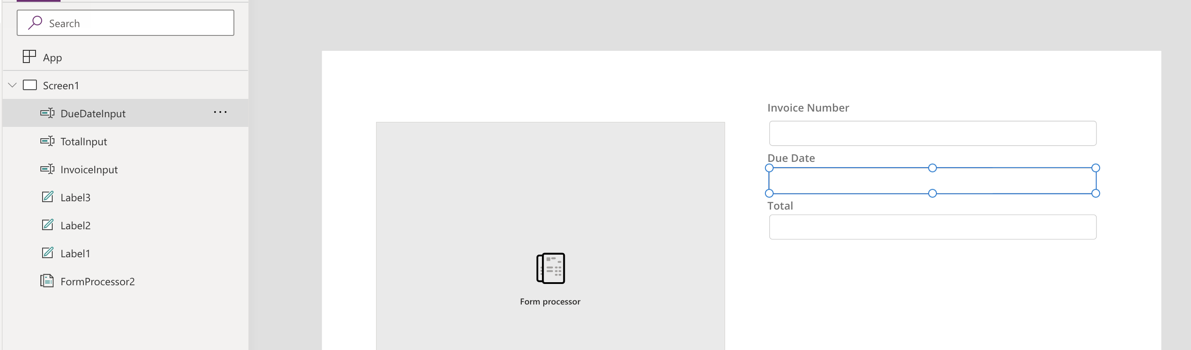

1. Change the Fx formula of the Default field for the InvoiceInput text input from “” to FormProcesor2.Fields.”Invoice Number”

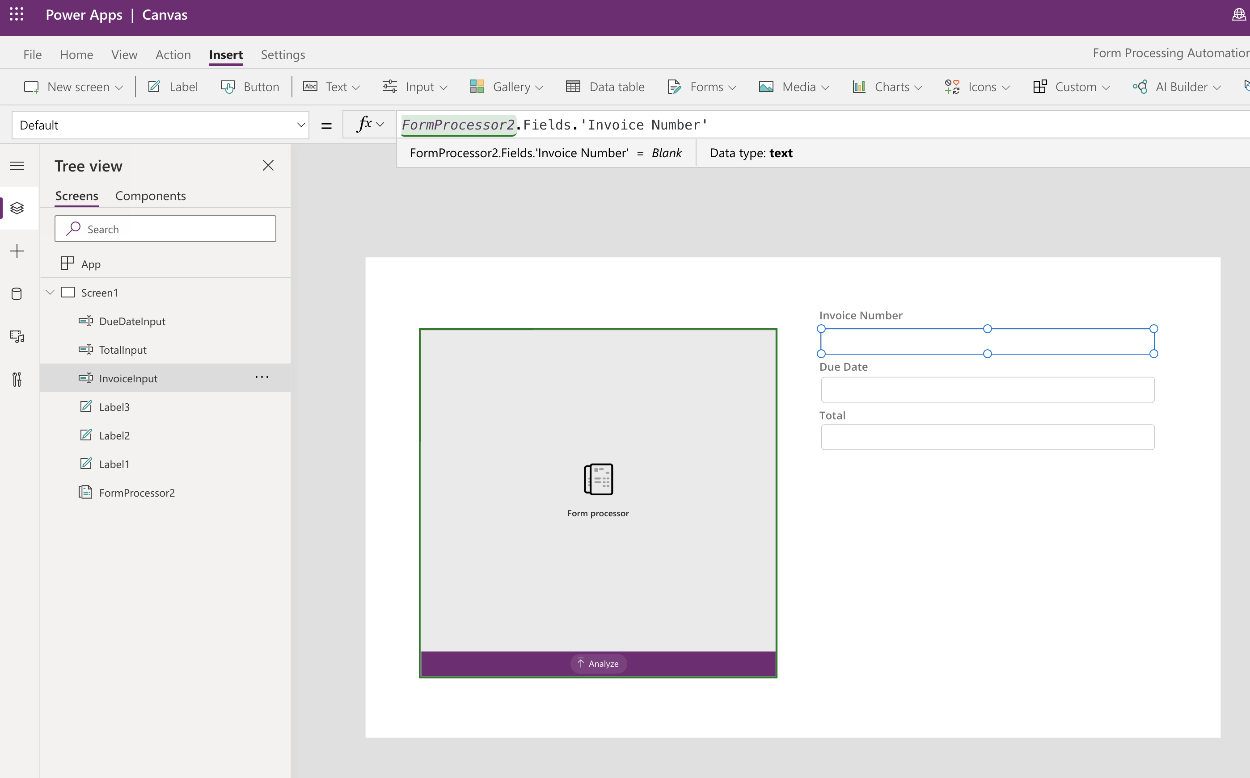

1. Similarly, repeat the same for the DueDateInput and TotalInput fields.

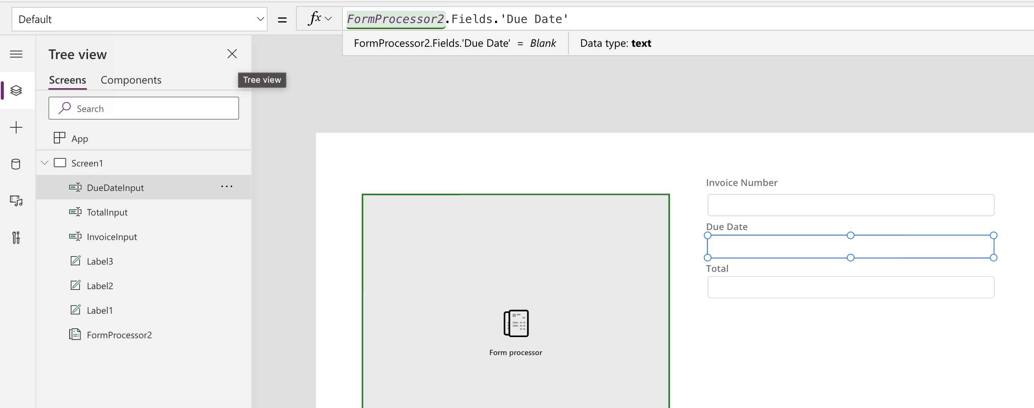

1. Add a Button component and change the looks of it to match the following image.

# 

1. Click on the newly created button. Change the Fx formula of the OnSelect field from false to the following code:

Collect(

Invoices,

{

id: CountRows(Invoices) + 1,

Invoice_Number: InvoiceInput.Text,

Due_Date:DueDateInput.Text,

Total:TotalInput.Text

}

)

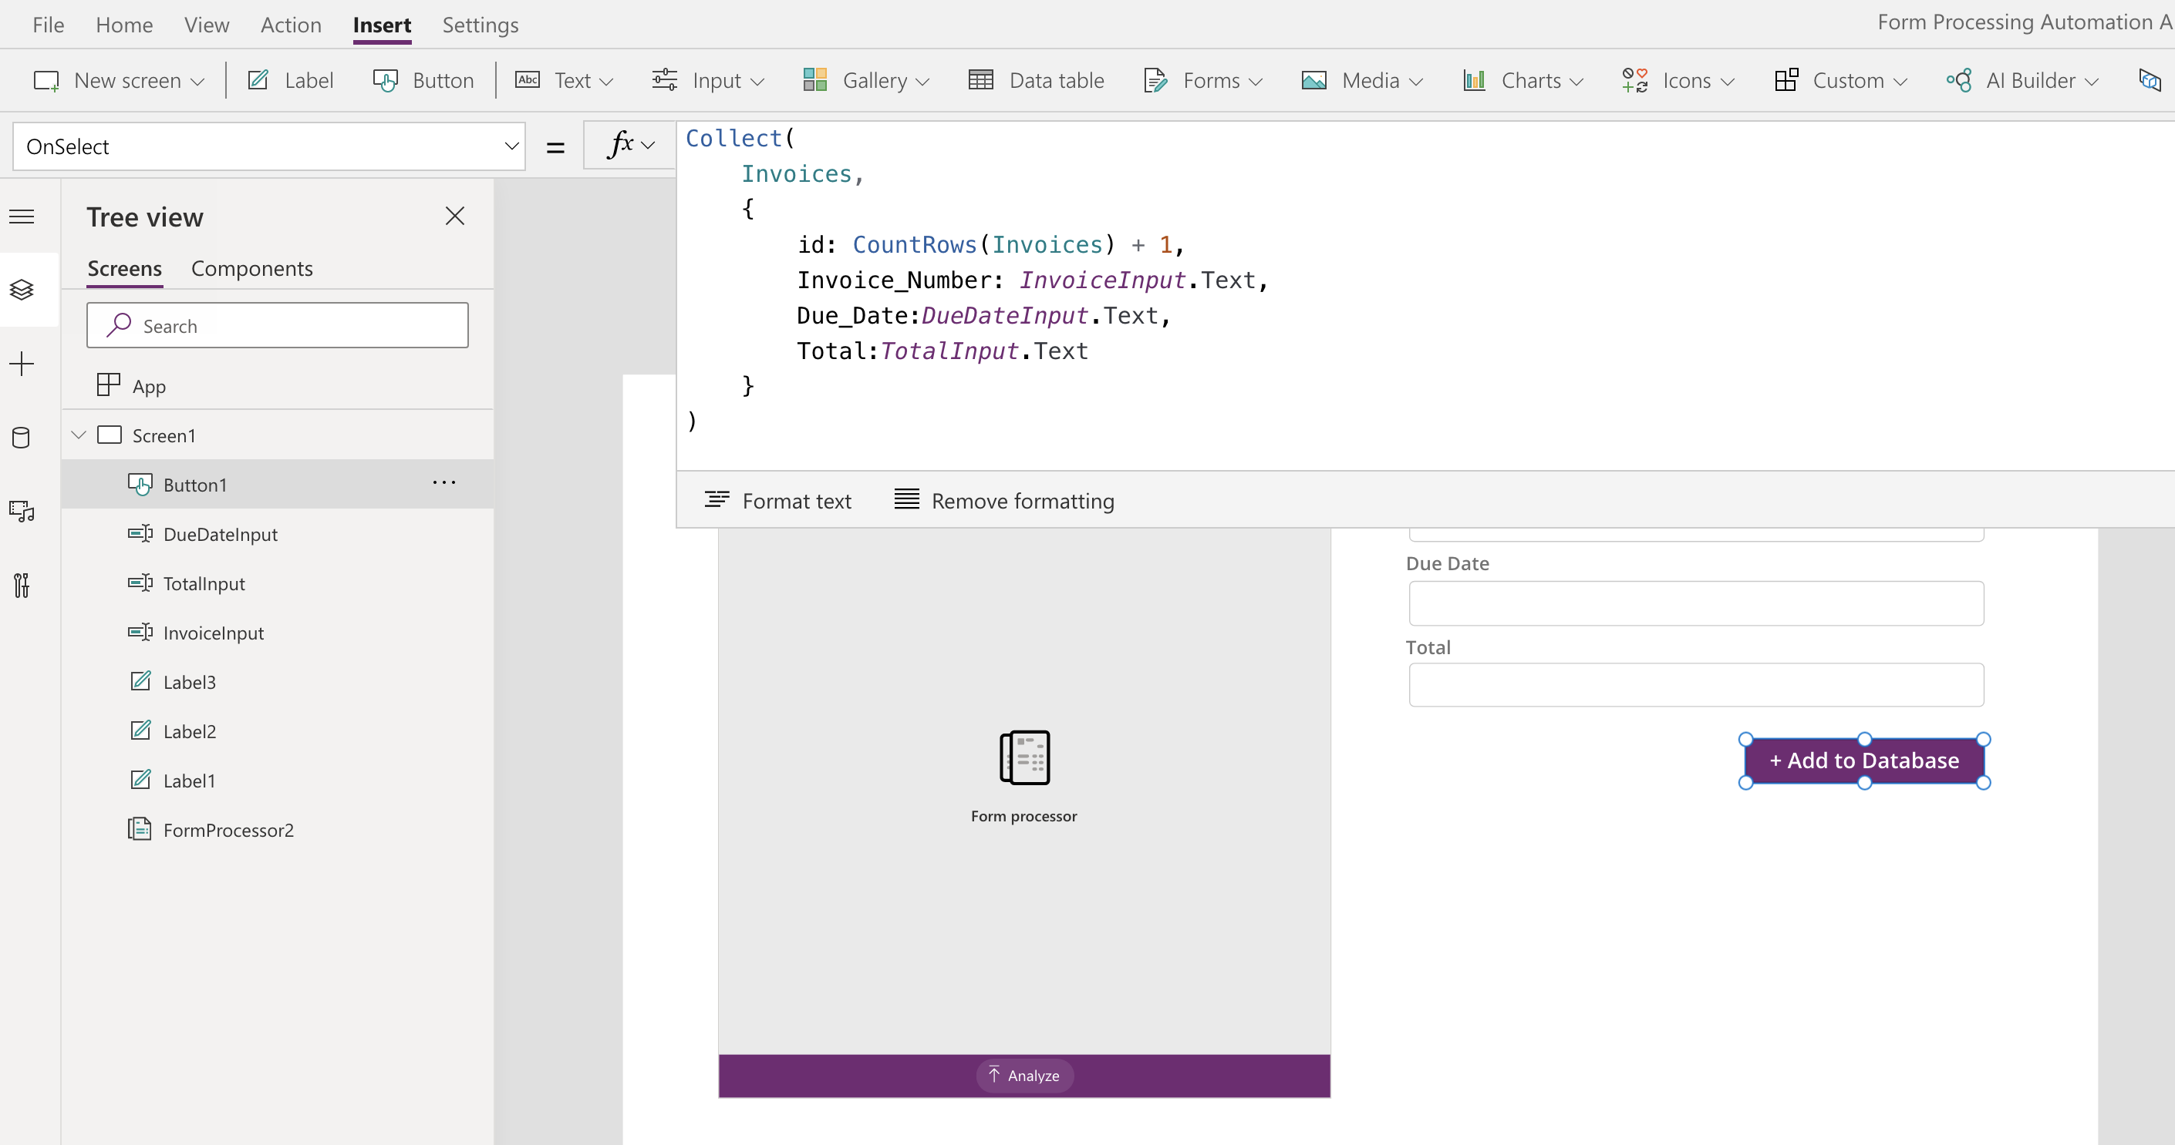

1. Add a Gallery by navigating to Gallery > Vertical.

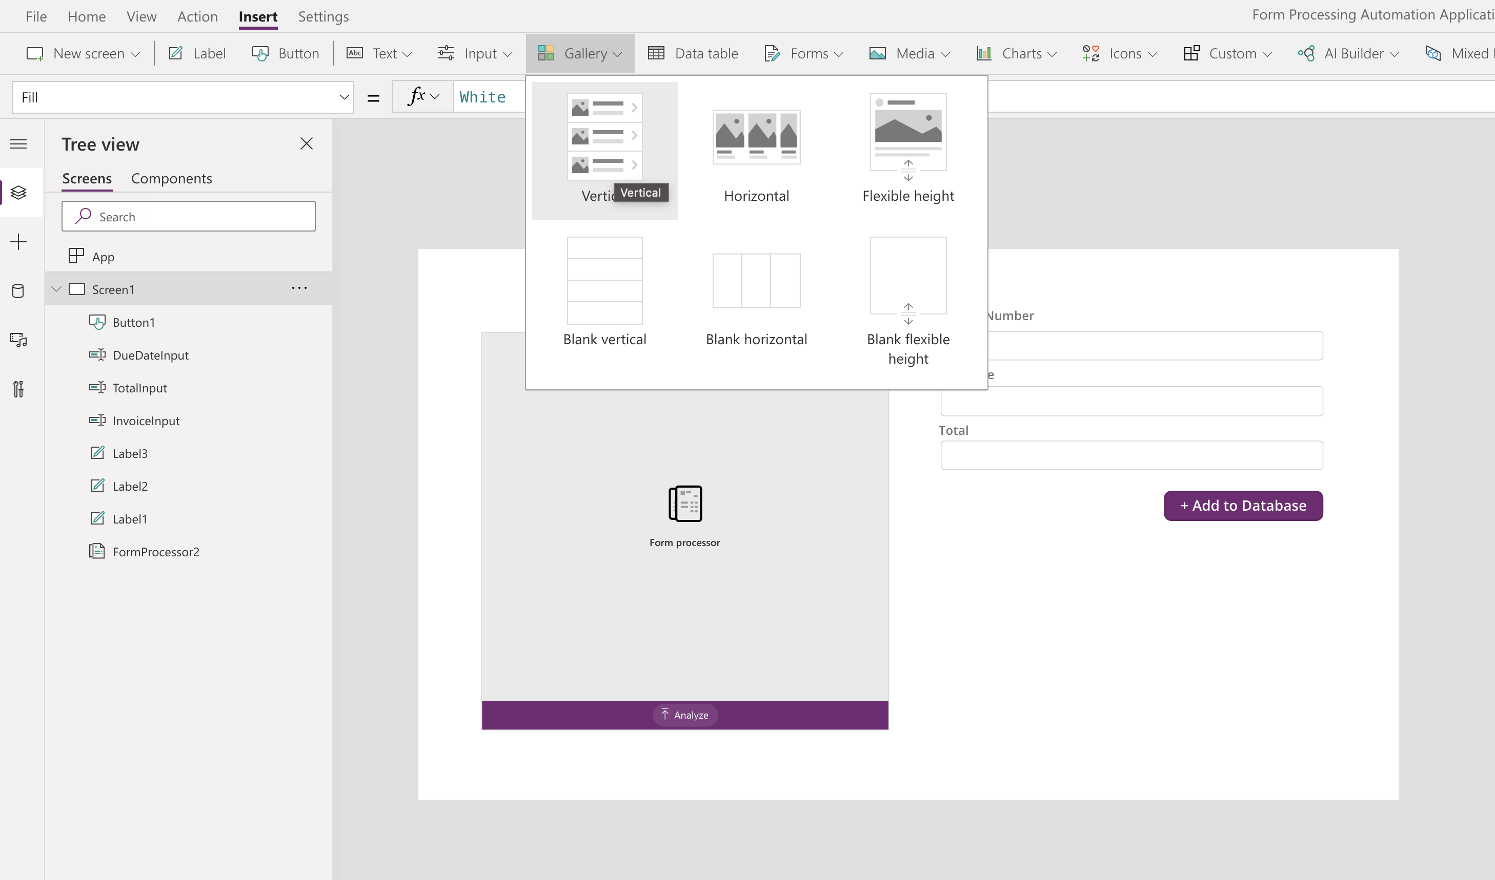

1. Connect your created Gallery to the Invoices collection.

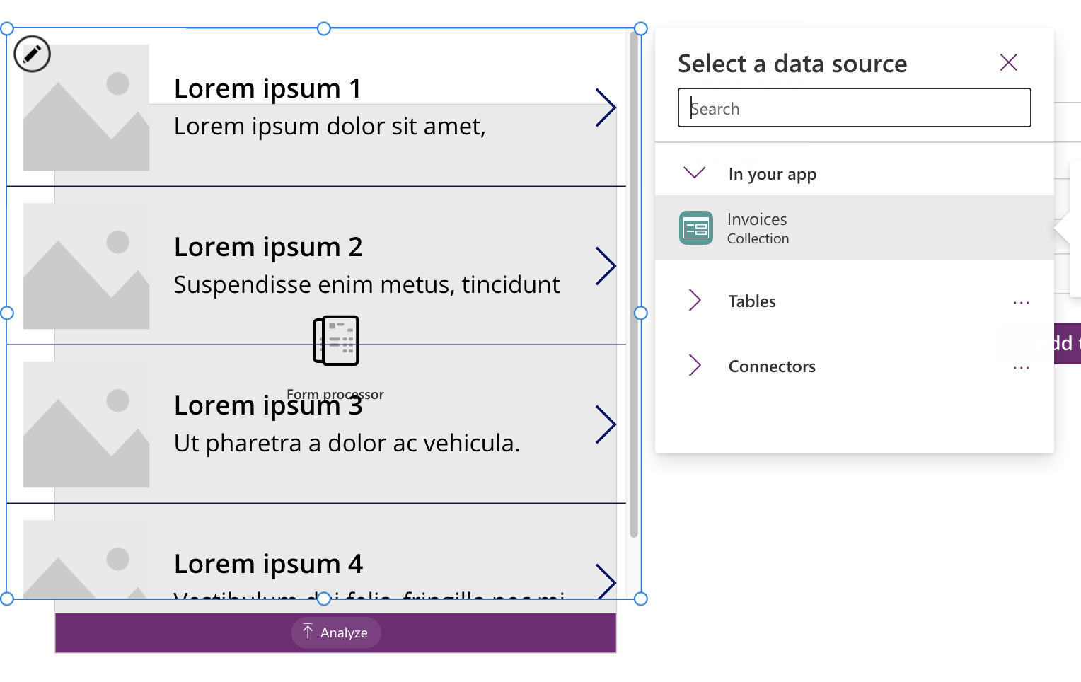

1. Upload a sample invoice into the Form Processor application and click on “+ Add to Database”.

Your Gallery should be populated as follows.

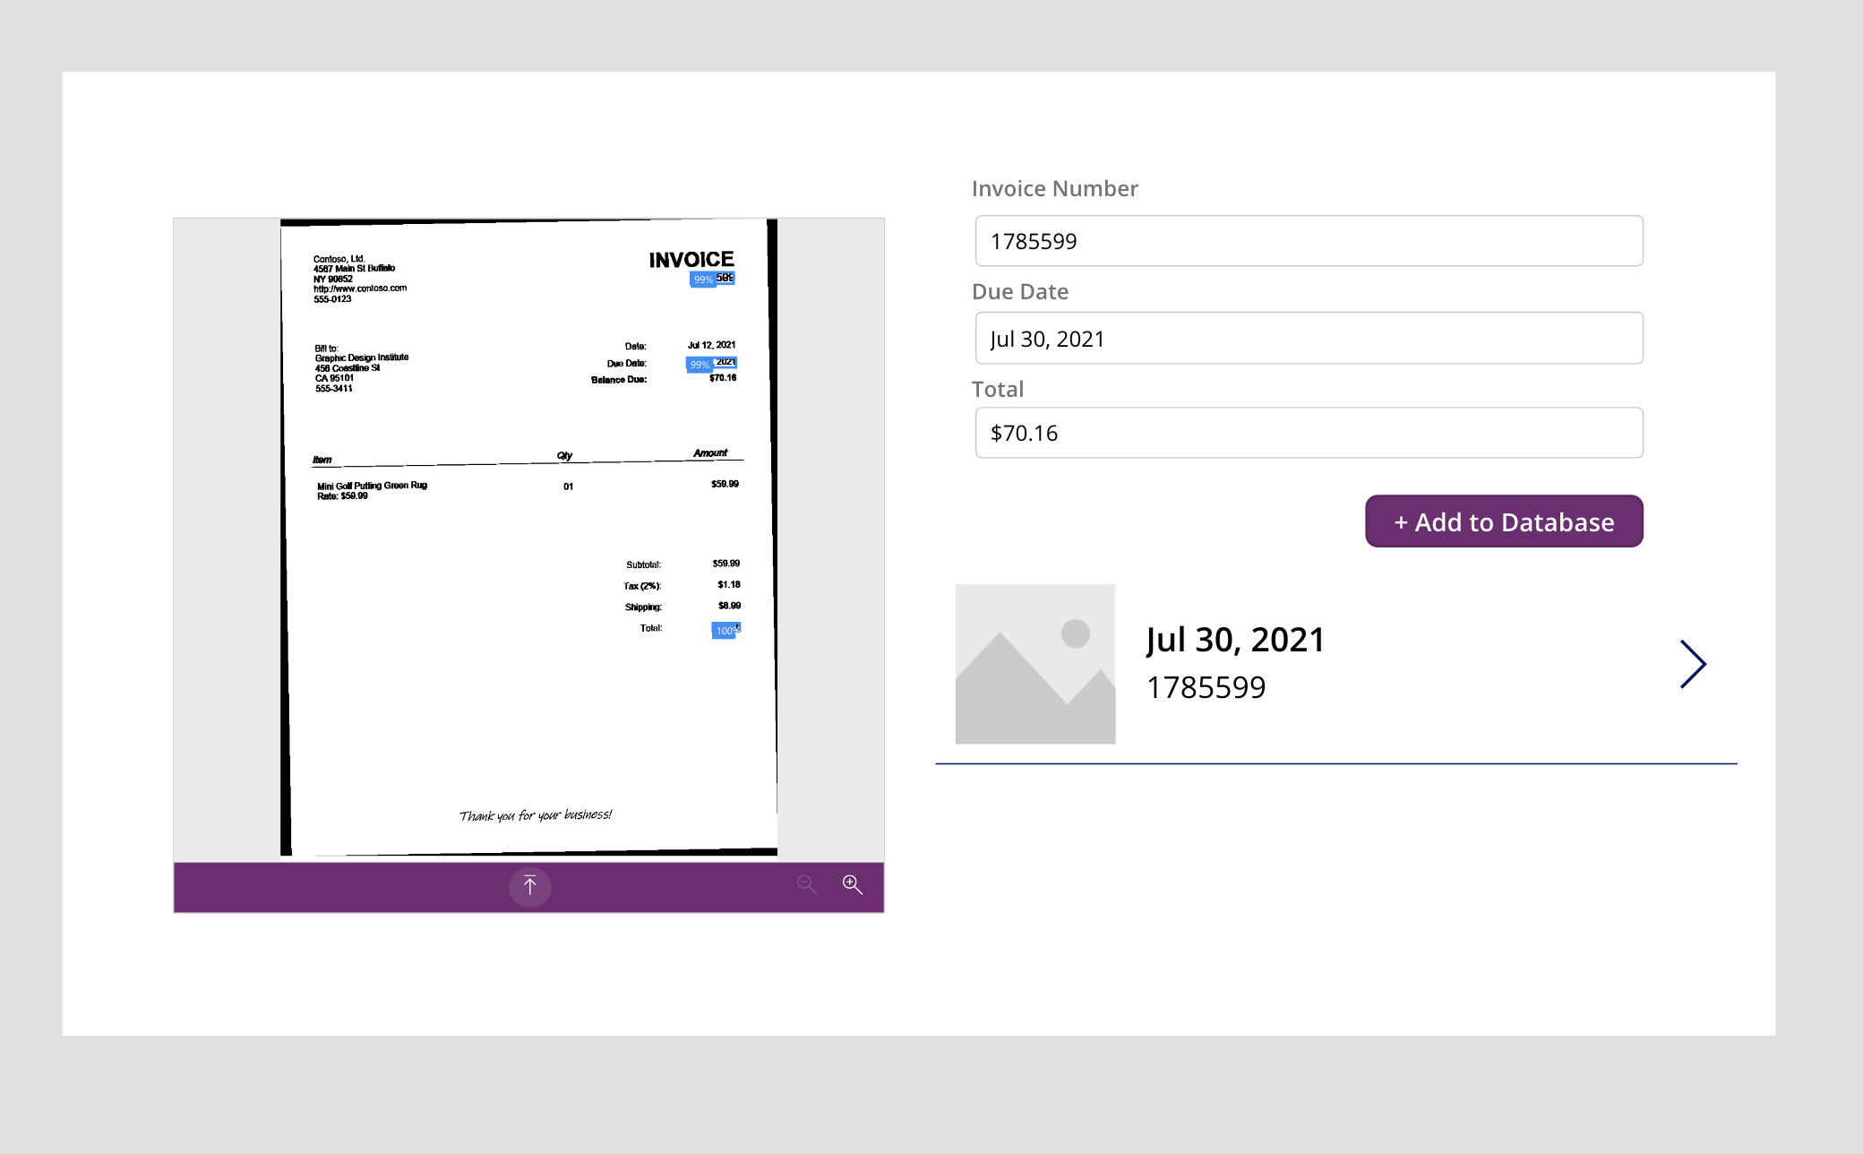

1. Create 3 text fields in the Gallery by changing the Fx code of Text to ThisItem.’Invoice Number’, ThisItem.’Due Date’ and ThisItem.Total

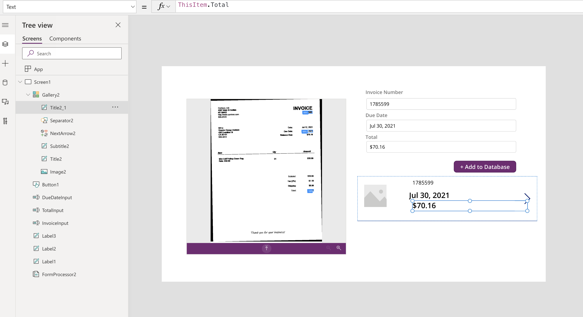

1. Arrange the components neatly in the gallery similar to the image below.

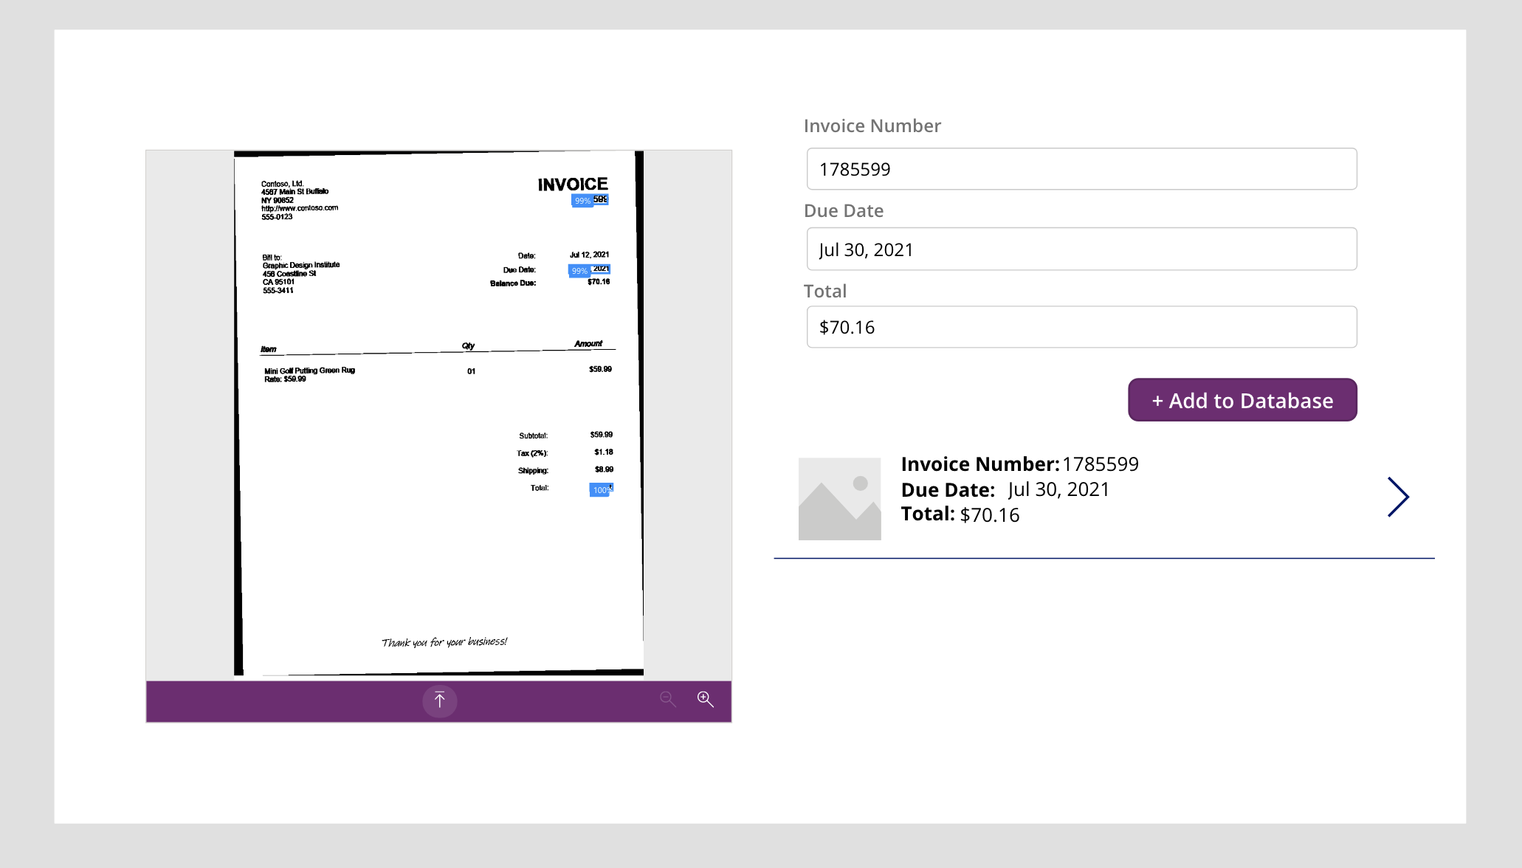

1. Create an additional text field and change its Text Fx formula from “Text” to ThisItem.id

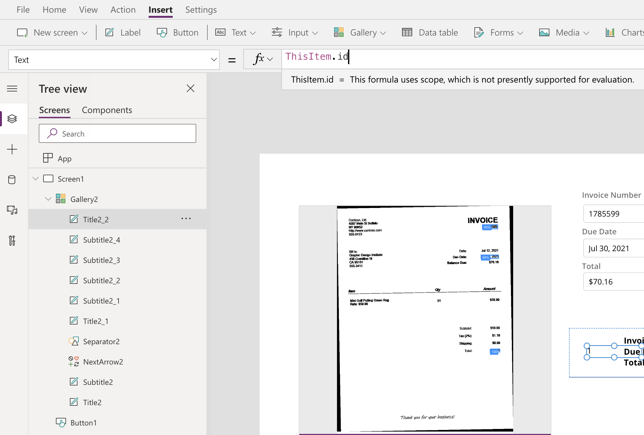

1. Change the size of the text label to match the following appearance.

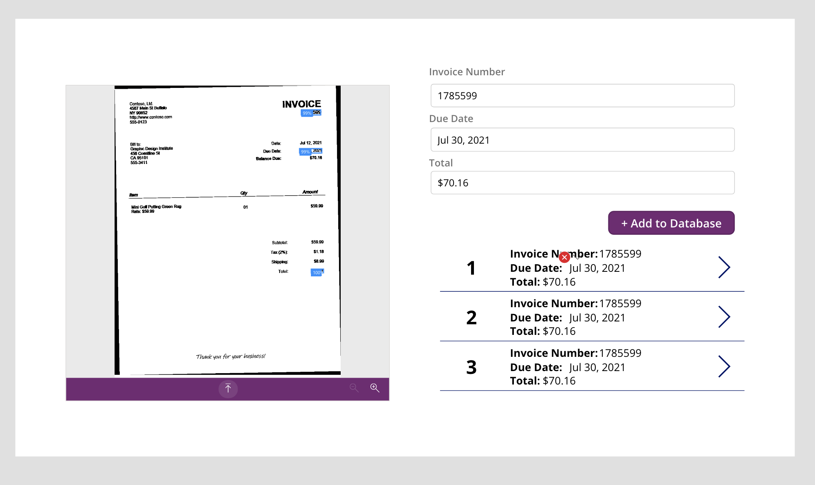

1. Create a Navigation Bar by adding a Label to the top of the application. Change the background color of the label and text color to match the rest of our application.

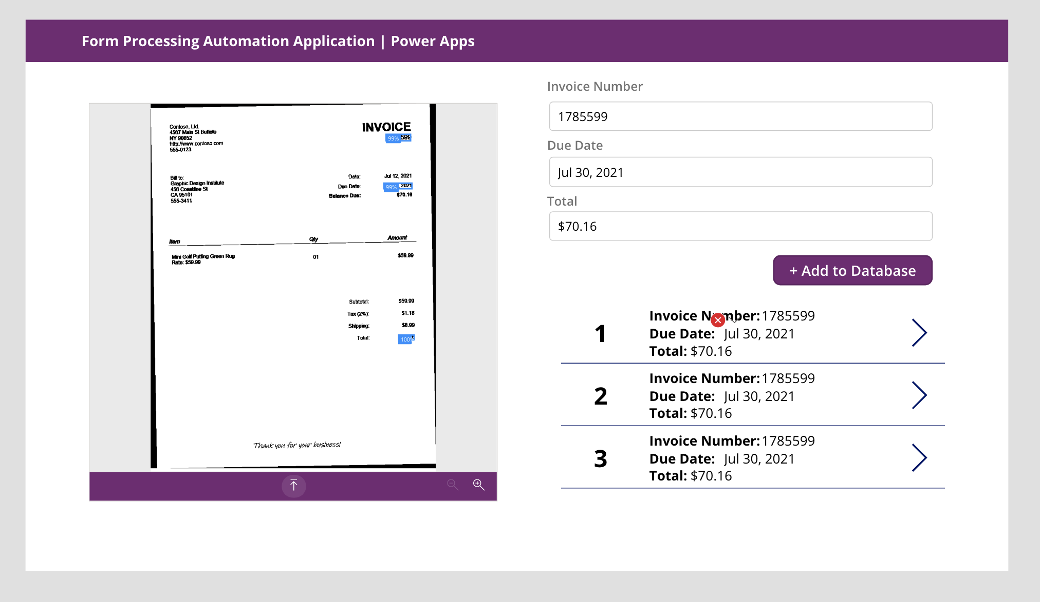

1. Create another Screen into the application by navigating to New Screen > Blank.

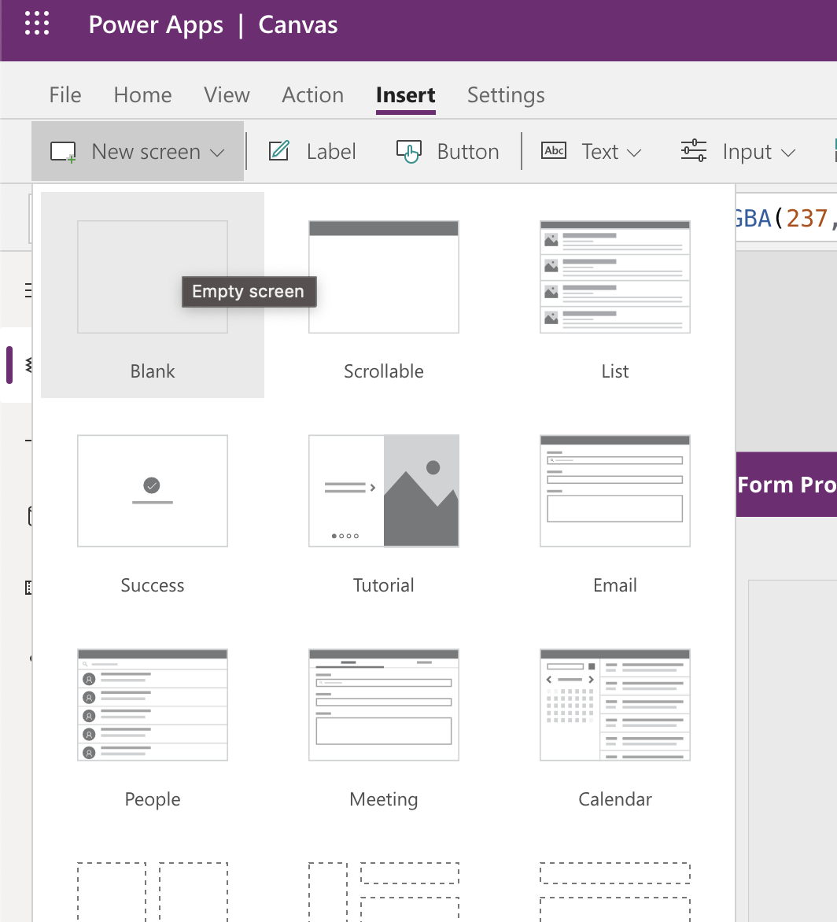

1. In the new screen, replicate the Navigation bar from the previous screen.

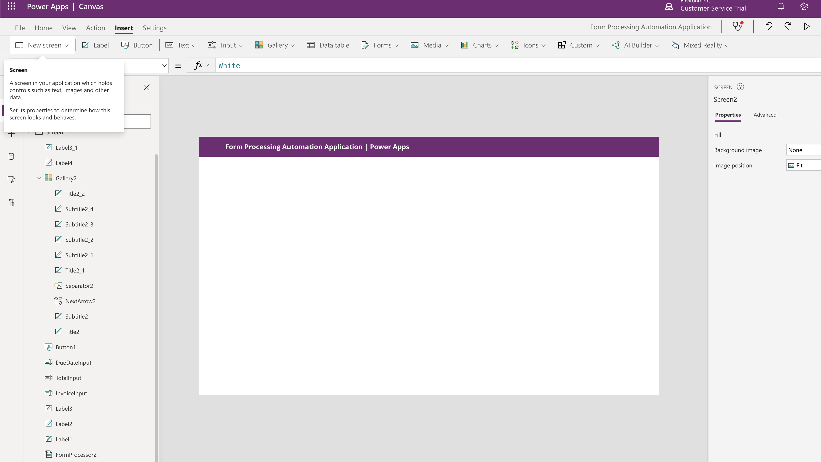

1. Add a Data Table by navigating to “Data Table” in the top ribbon

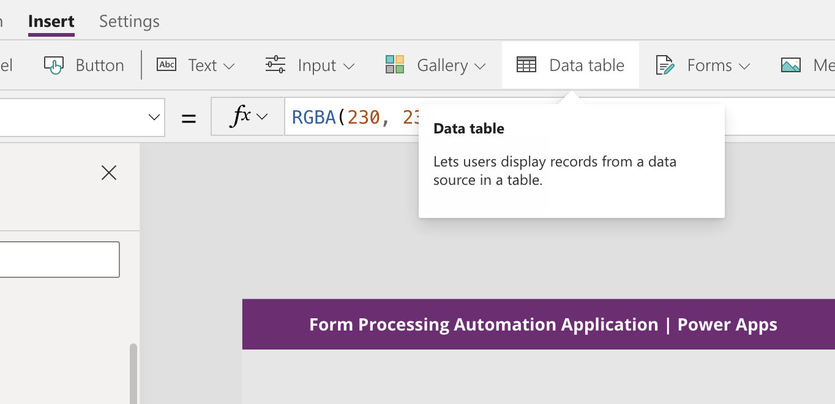

1. Collect the newly created data table to the invoices collection

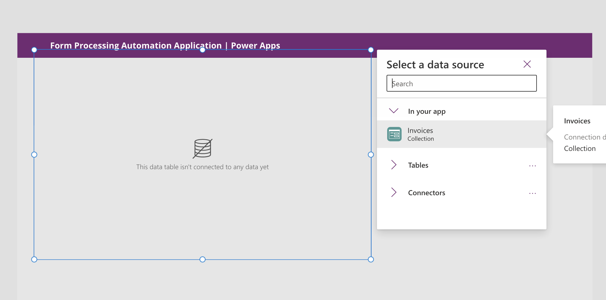

1. Click on Edit Fields

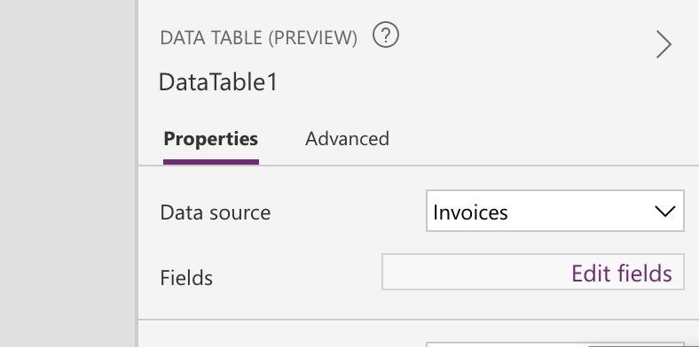

1. Click on Add Field

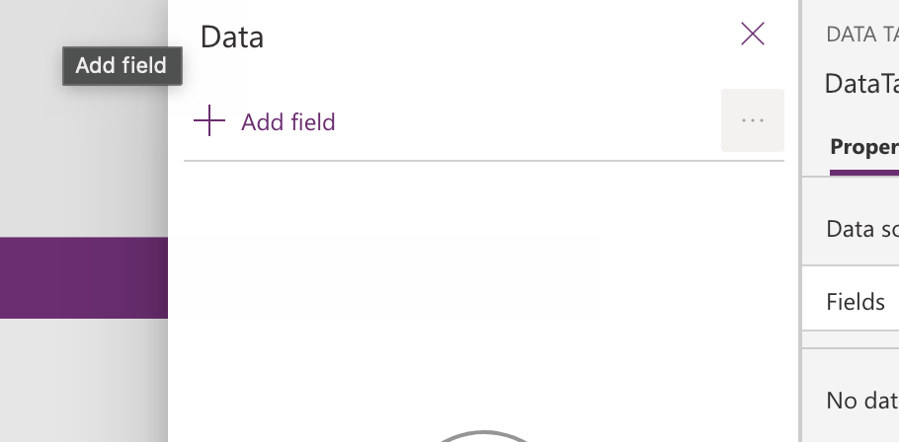

1. Select all the fields in the Invoices collection and click on Add

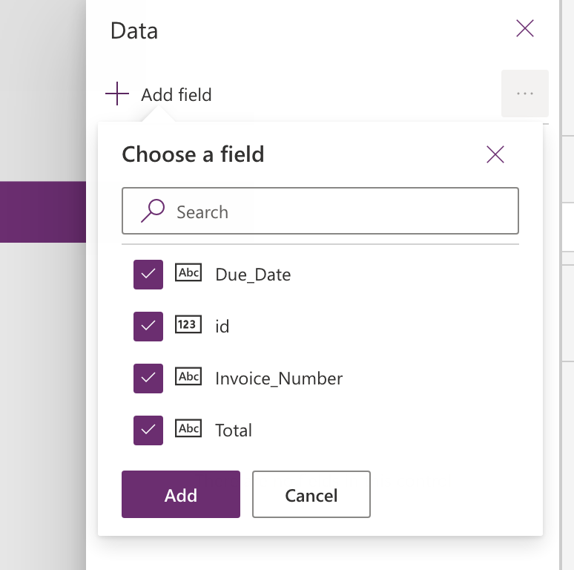

1. Your data table will be populated as follows

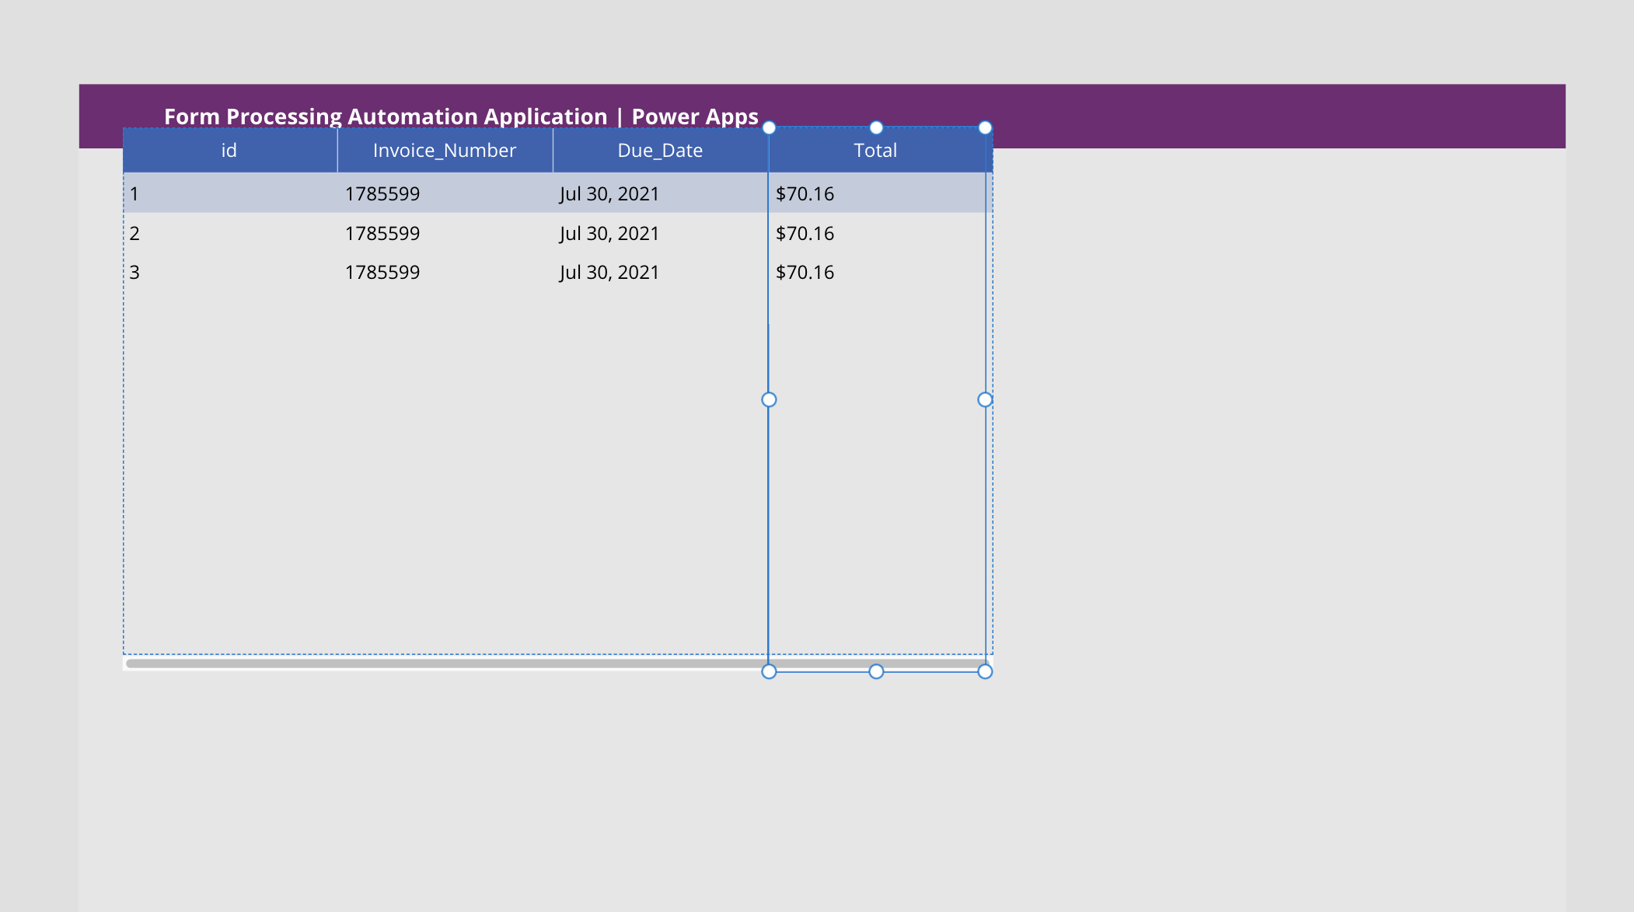

1. Arrange the table and change the color of the table to match the look and feel of the rest of our application. Your screen should look like this now.

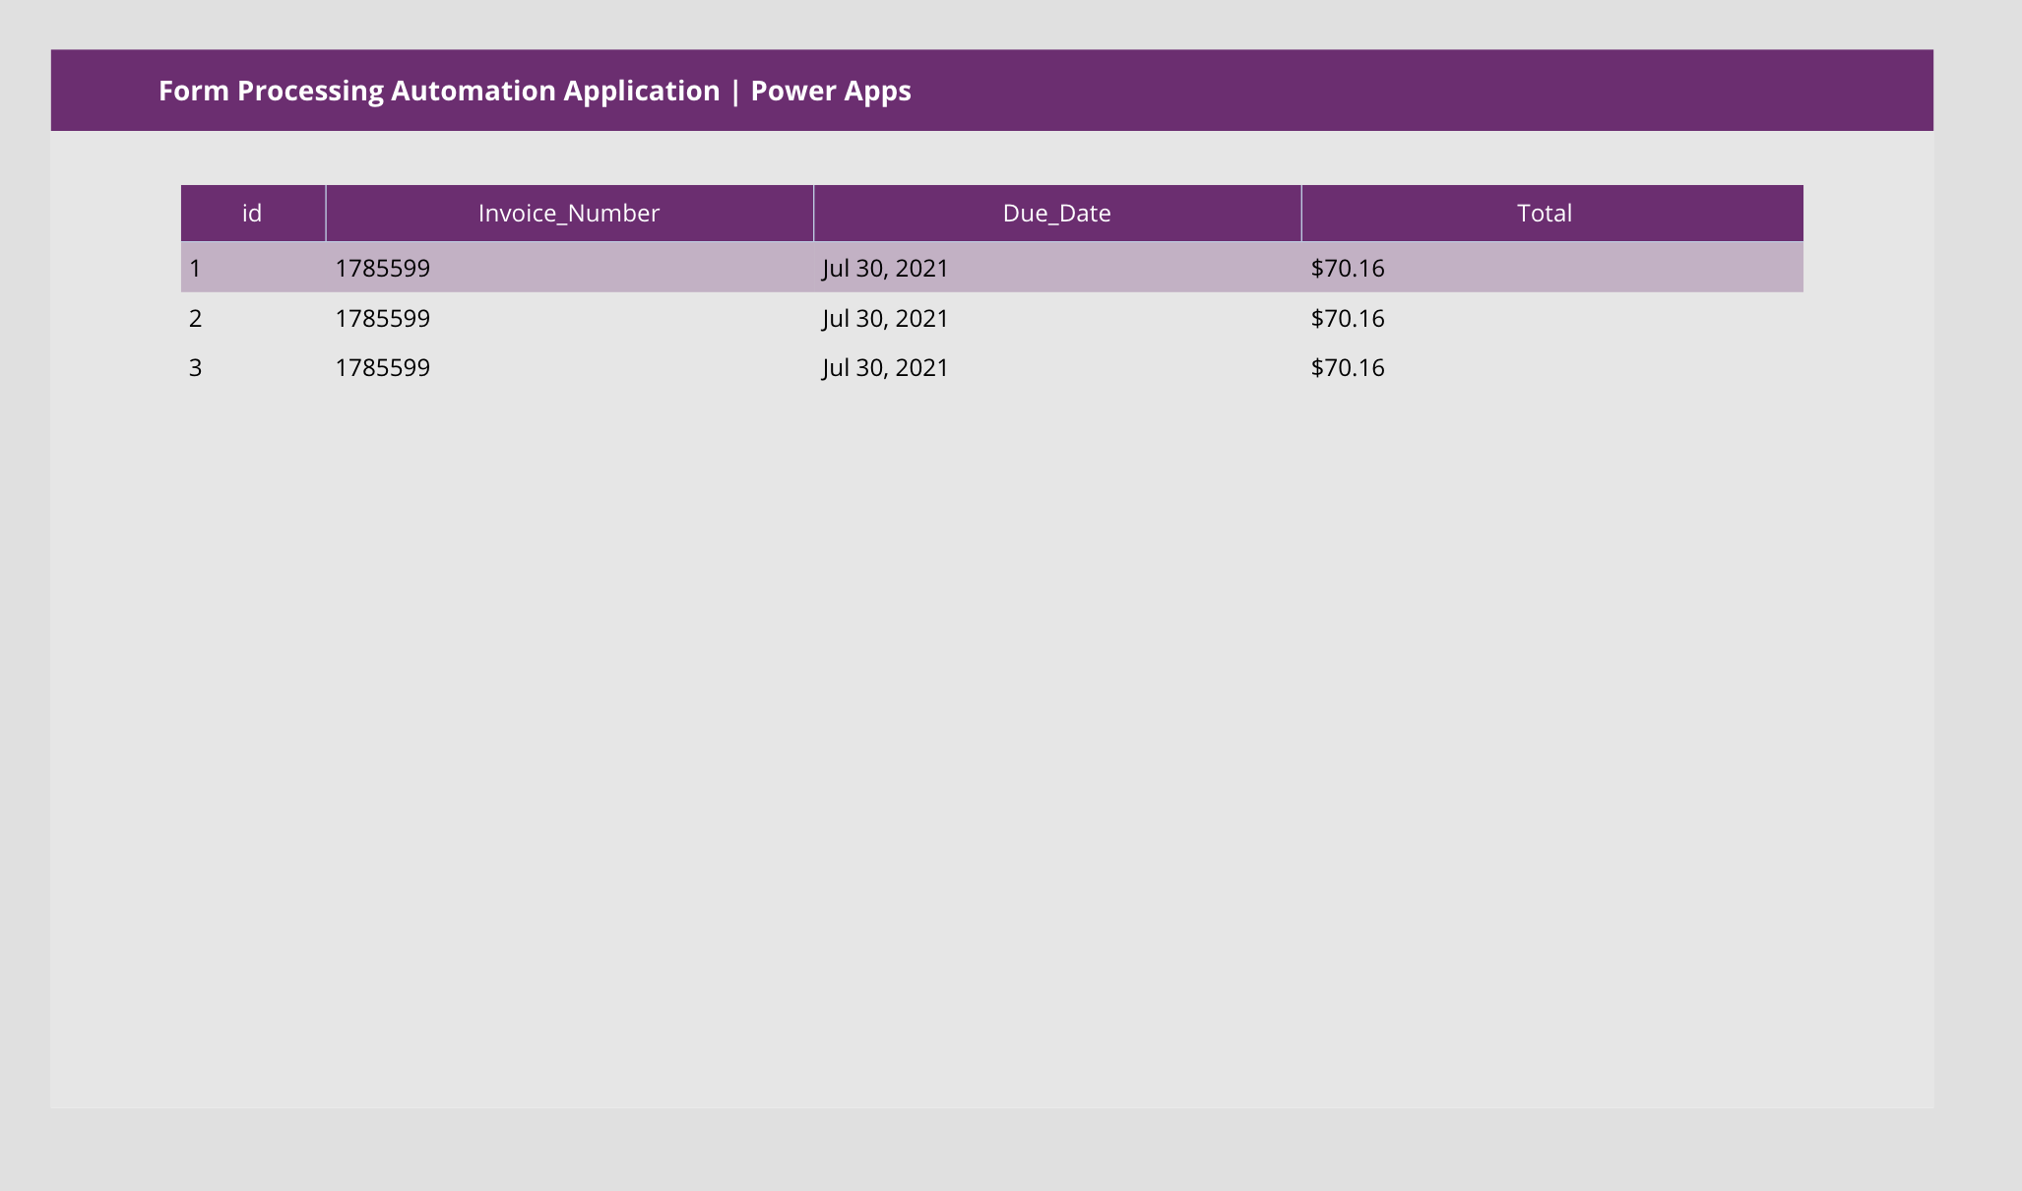

1. Add in a Button to the page. Change its background color and change its text from “Text” to “Back”.

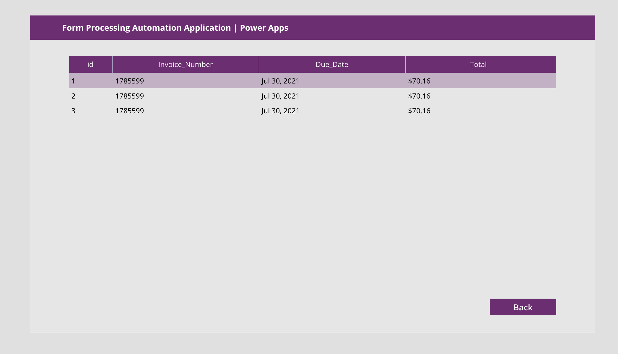

1. Change the OnSelect Fx formula of the button from false to Navigate(Screen1, ScreenTransition.Fade)

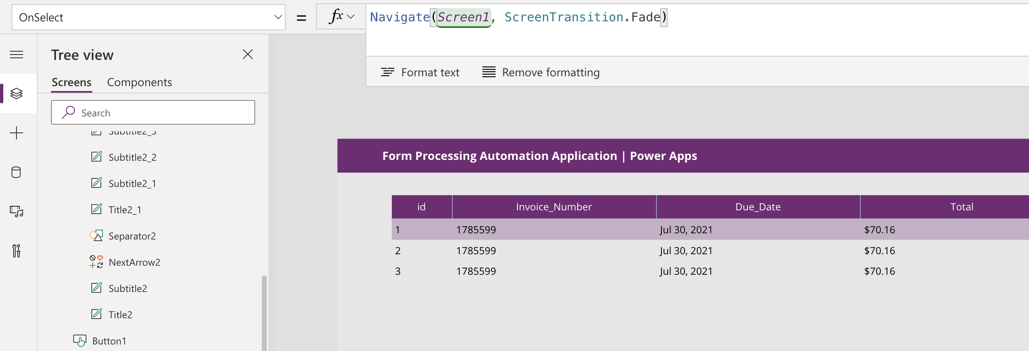

1. Similarly, add an additional button “View Database” to Screen1, and change the onSelect Fx code from false to Navigate(Screen2, ScreenTransition.Fade)

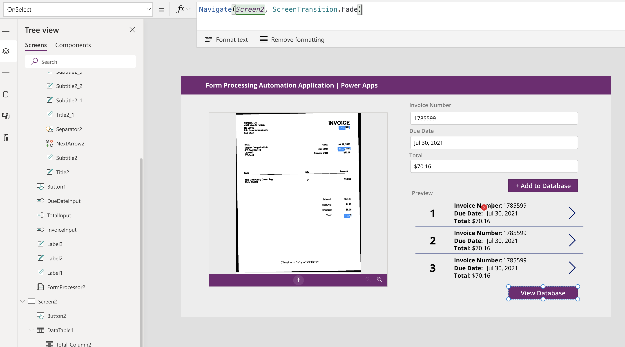

1. Back in the Gallery, add in “Thrash” icon and arrange it to the right of the Gallery listing.

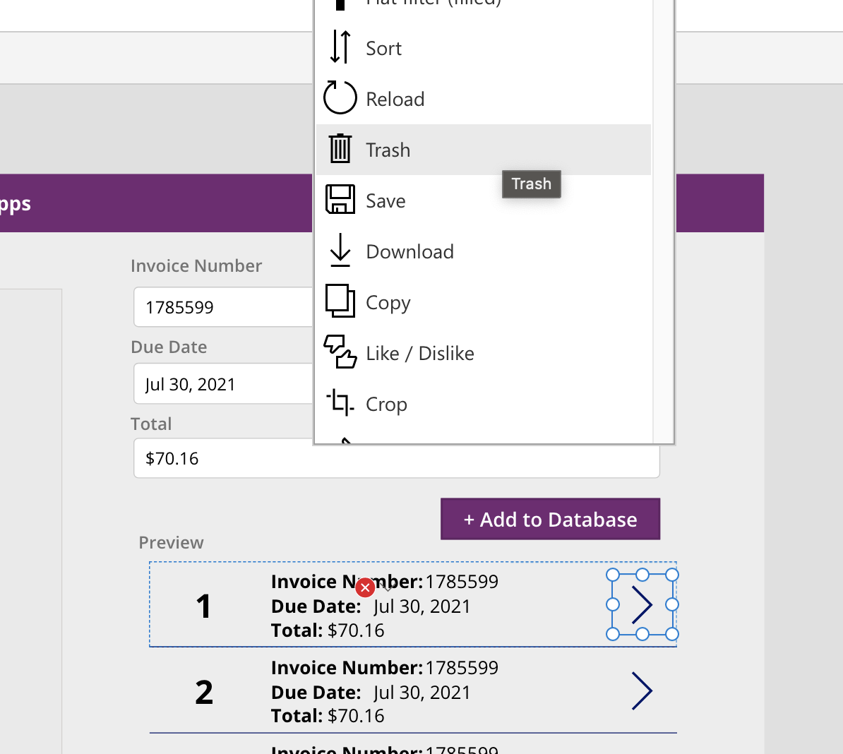

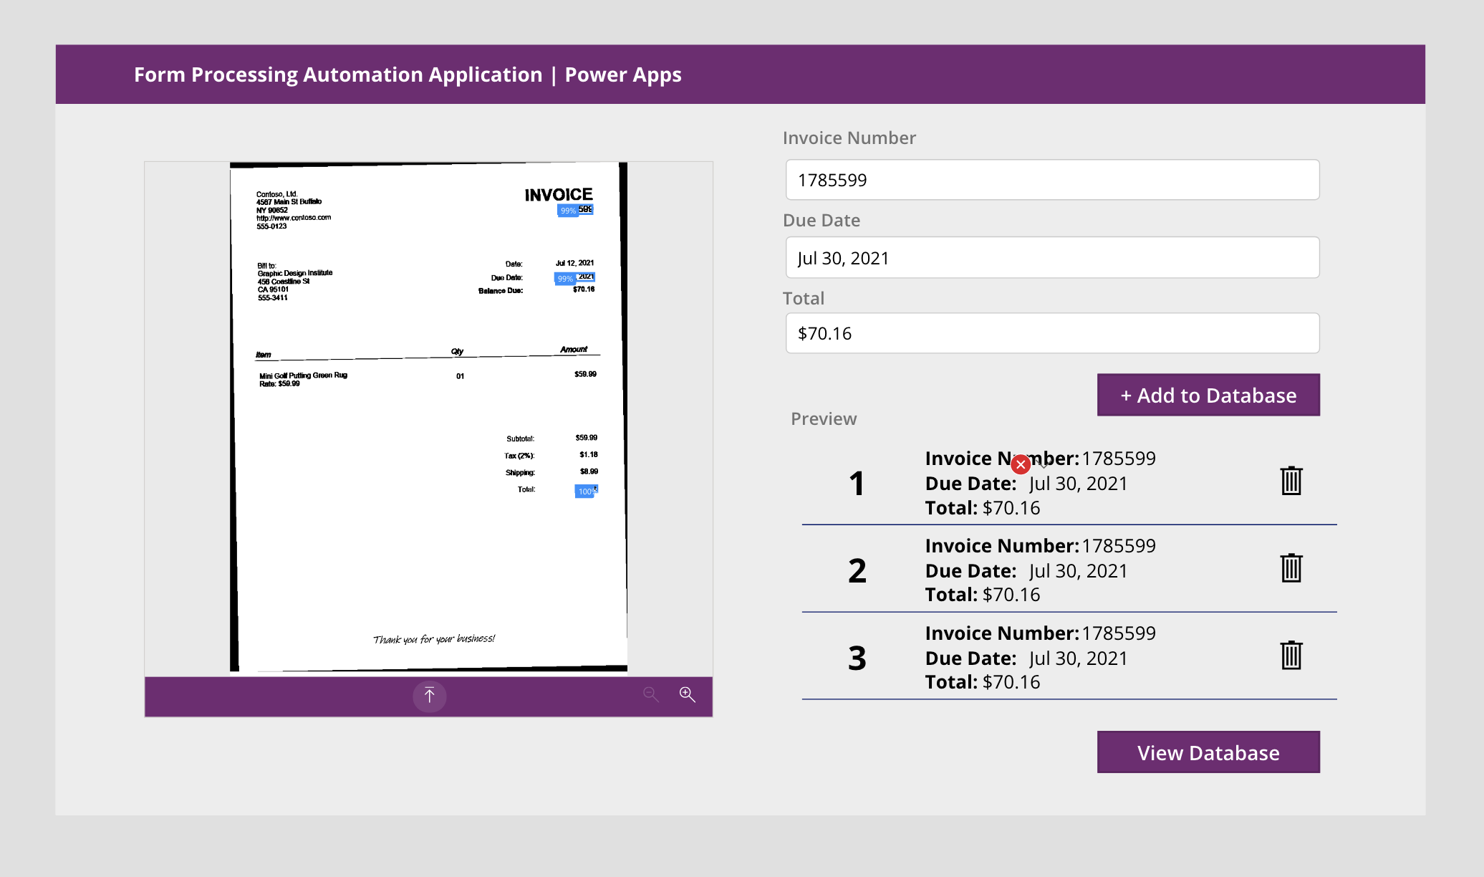

1. Change the onSelect Fx formula of the garbage component to “Remove(Invoices, ThisItem)”.

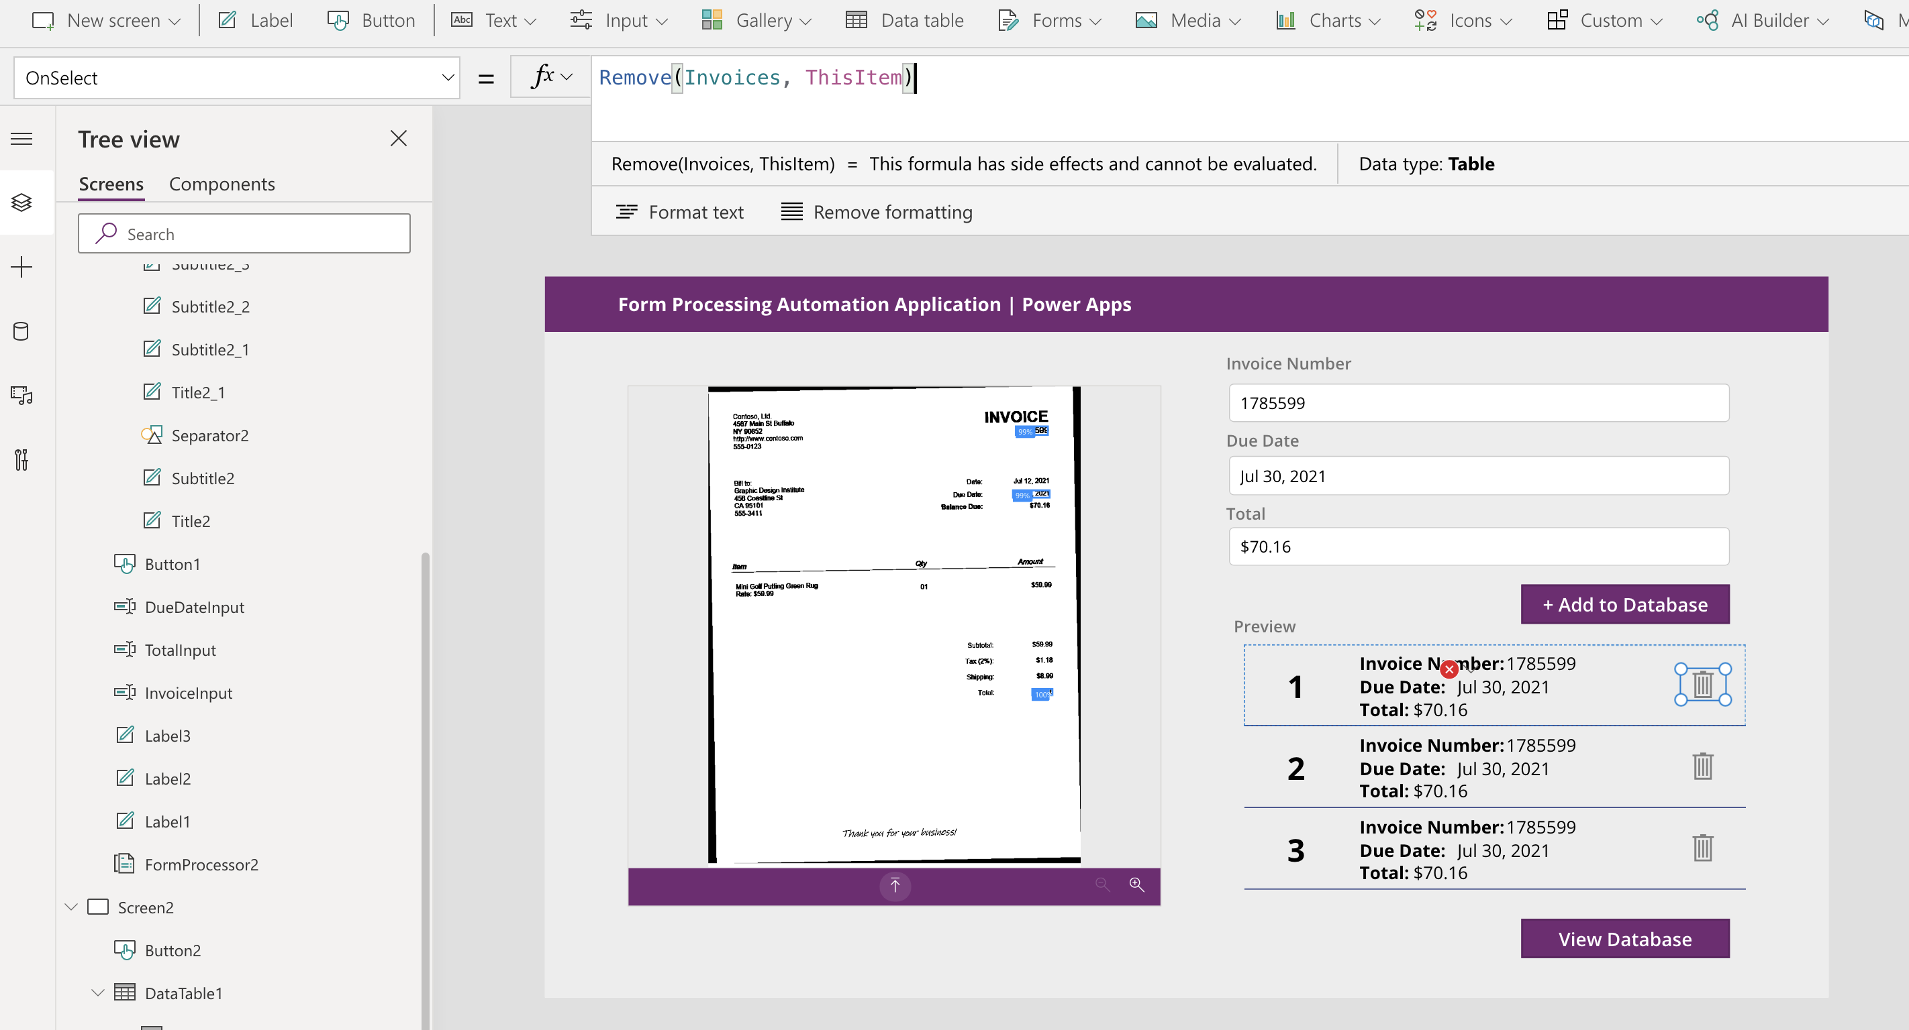

1. We’re ready to test out our App! Click on Preview the App or Press F5

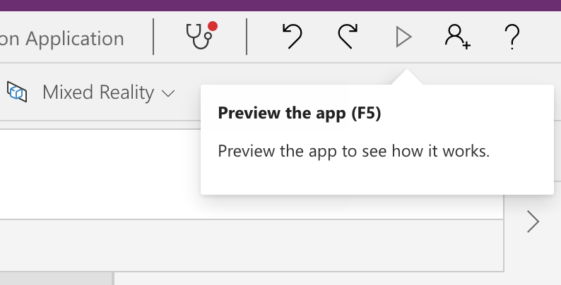

1. Start by uploading an invoice pdf file from the test folder

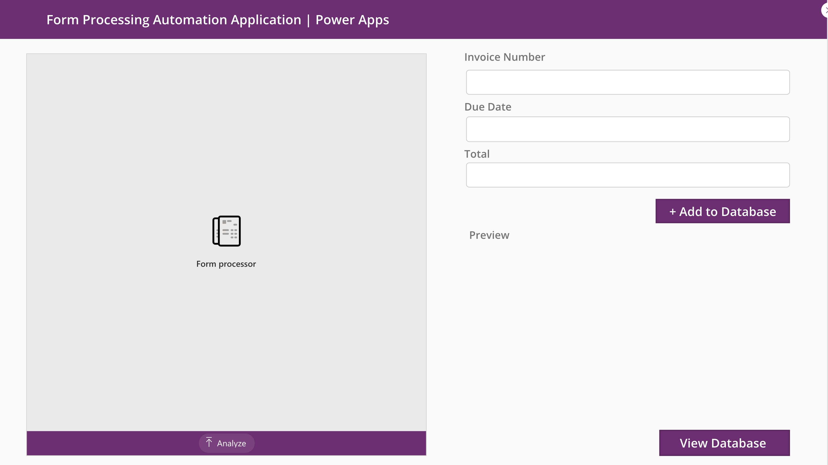

1. The invoice number, due date and total fields will be populated.

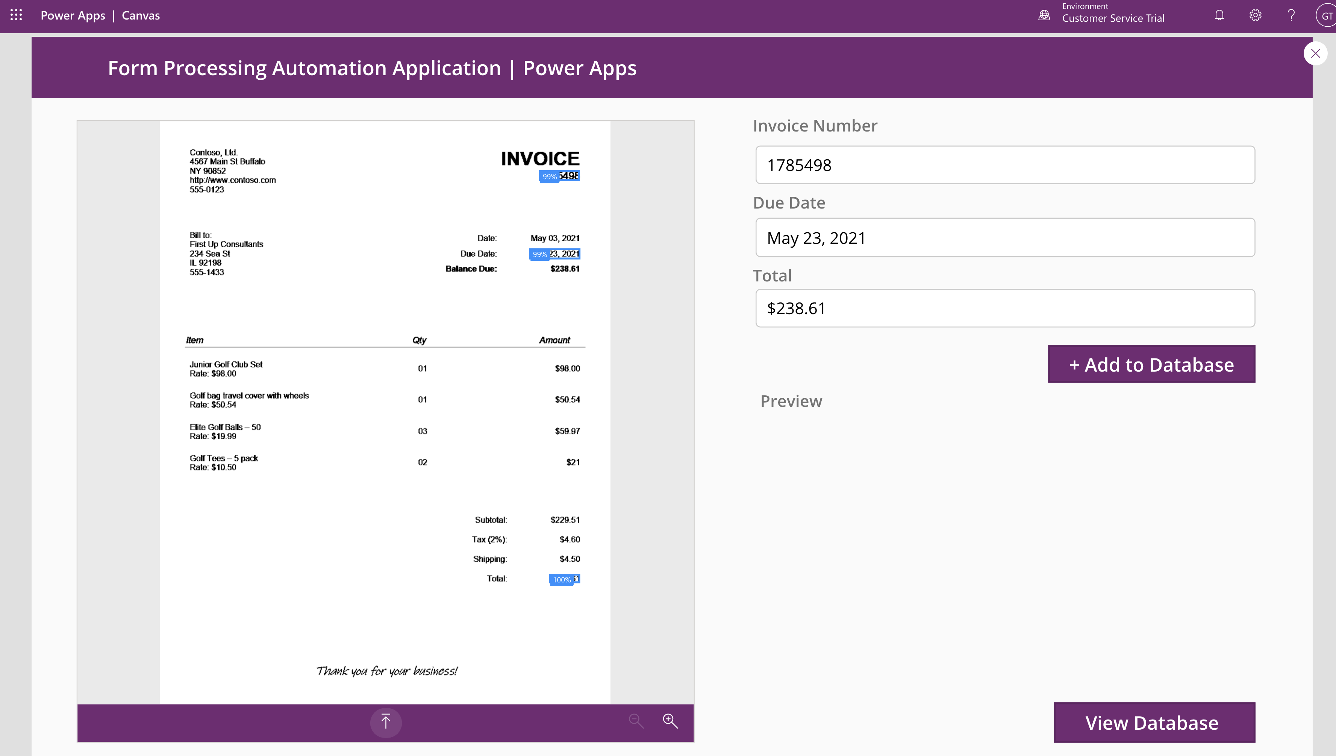

1. Click “+ Add to Database”. The Preview gallery will be populated.

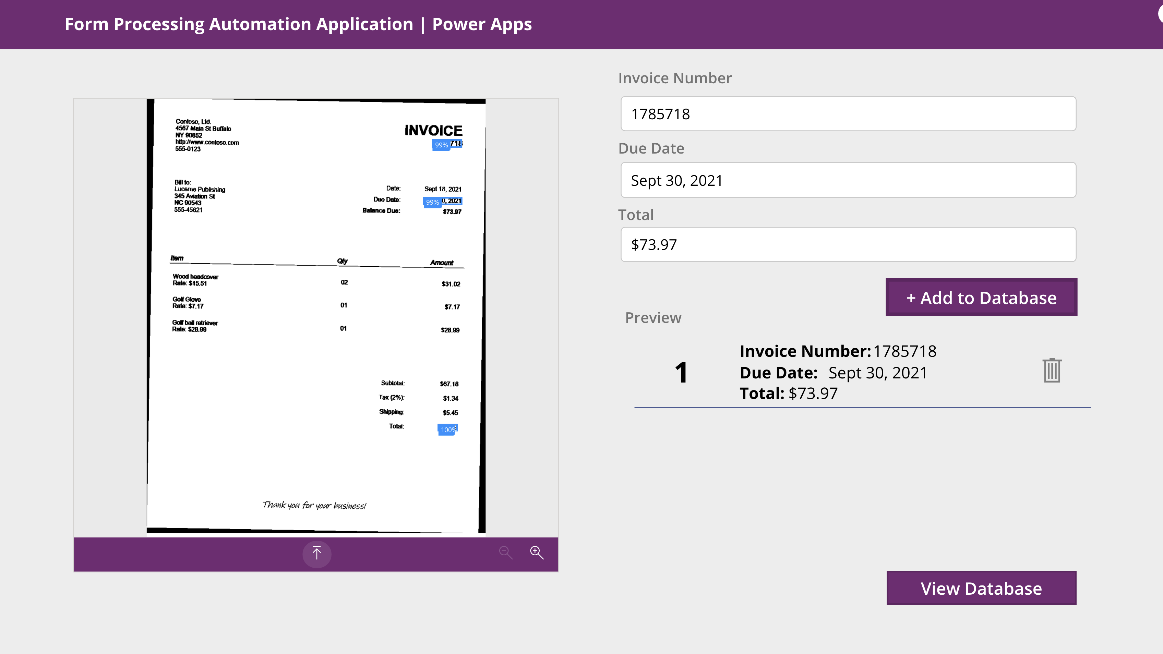

1. Repeat this process with 2-3 more invoices.

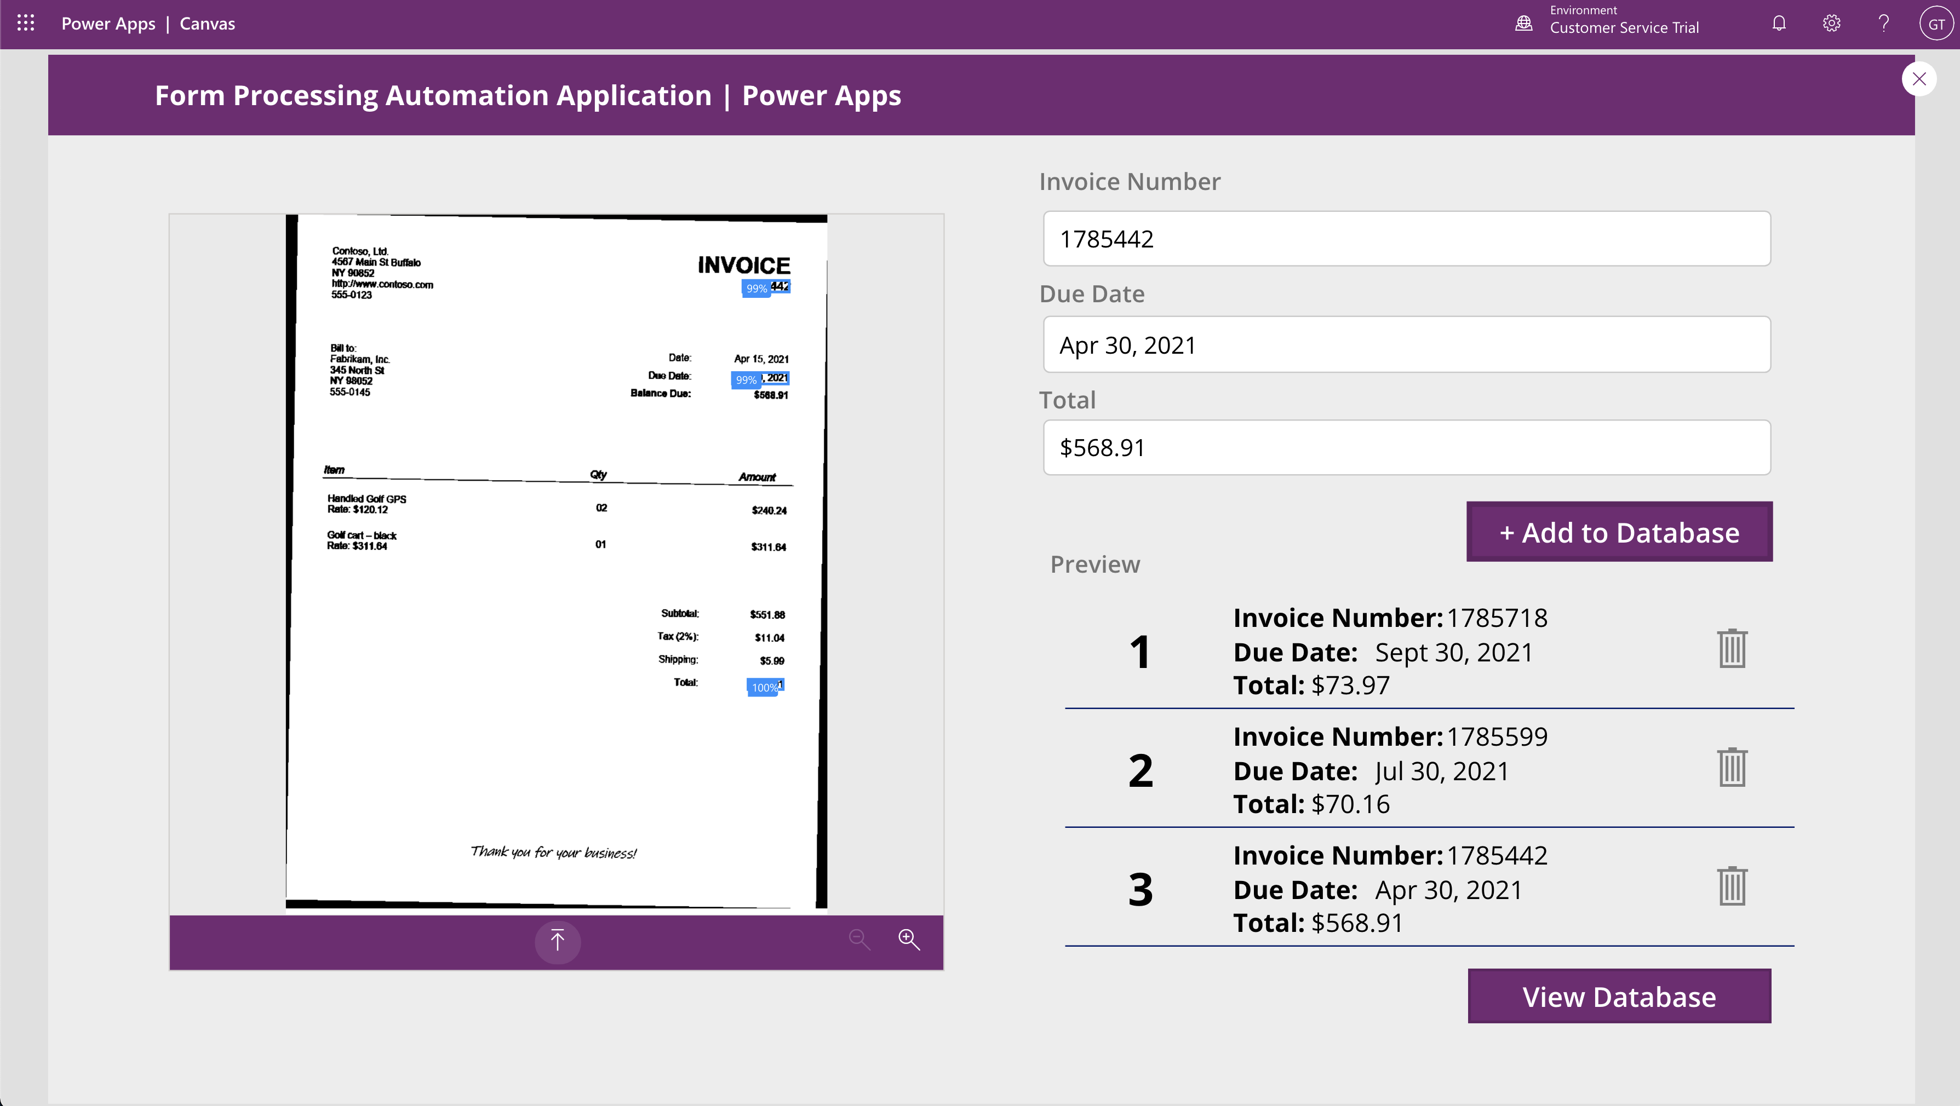

1. Click on “View Database”. You can see that the data fields has been populated in our database.

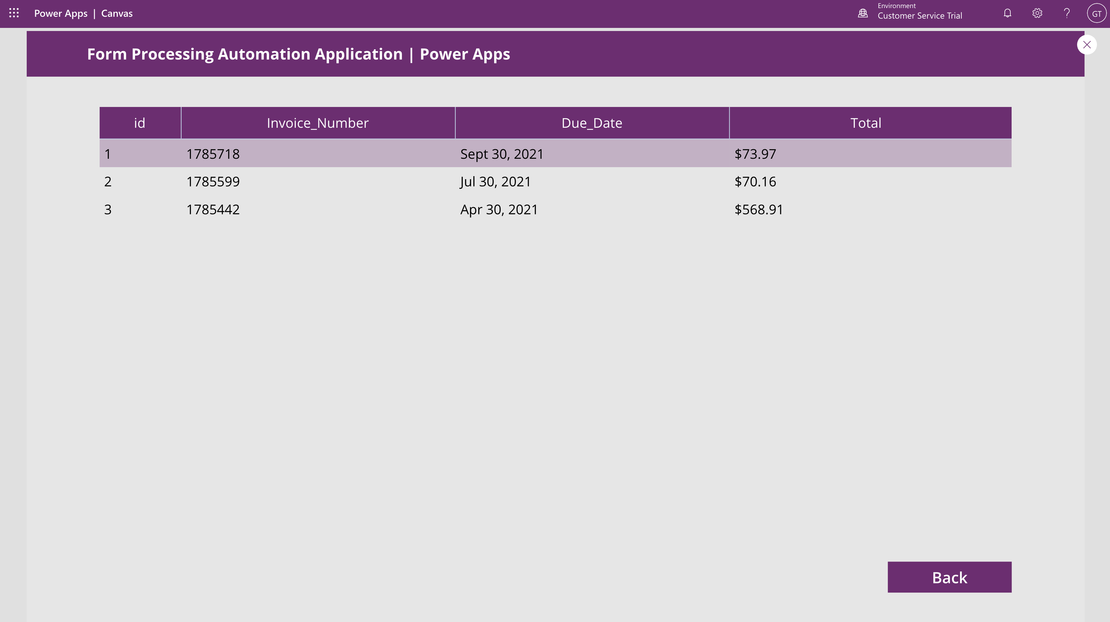

# Resources

* <https://powerusers.microsoft.com/t5/Building-Power-Apps/serial-number-in-gallery/m-p/326704#M93898>
* https://docs.microsoft.com/en-us/powerapps/maker/canvas-apps/create-update-collection